PRACTICAL NO 1

**Q.) Write a program to implement to create a simple web service that converts the temperature from Fahrenheit to Celsius and vice a versa.**

**Step 1) Create a Project and add ASP.NET Web Application**

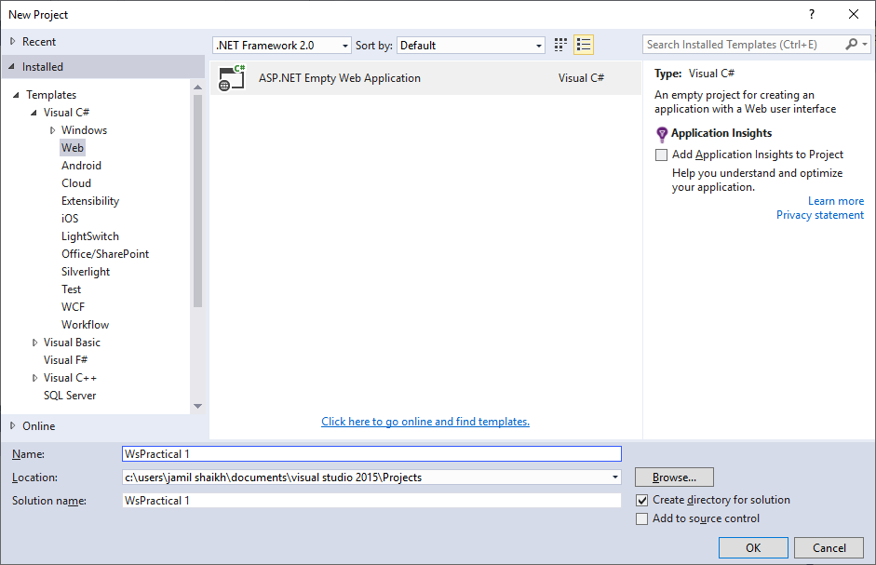

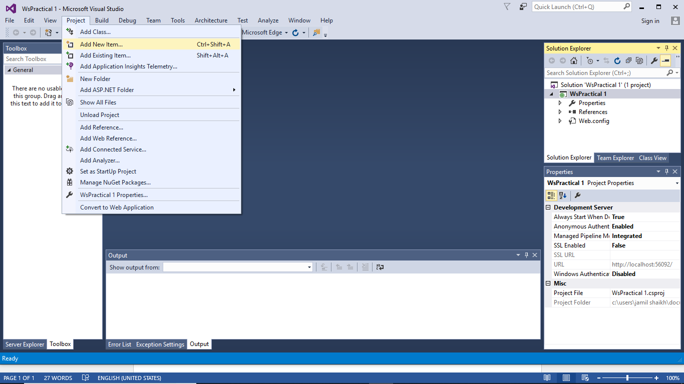

**Step 2) Add Web Service(ASMX) file**

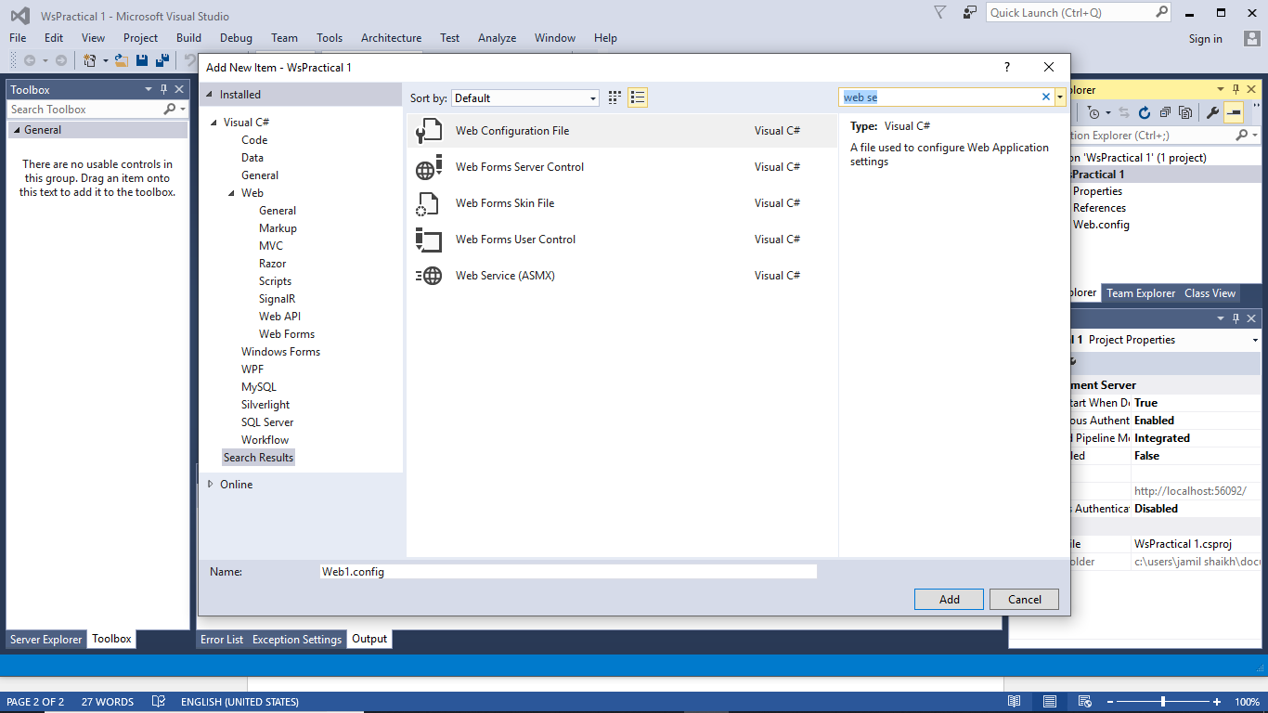

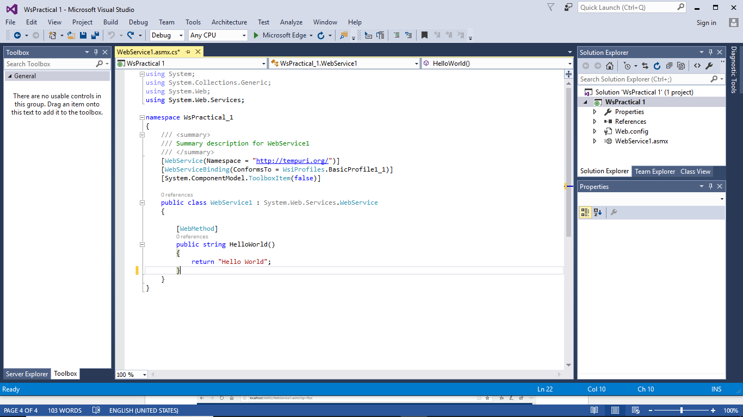

**Step 3) Write the following code inside webform1.asmx.cs file :**

using System;

using System.Collections.Generic;

using System.Web;

using System.Web.Services;

namespace WsPractical_1

{

[WebService(Namespace = "http://tempuri.org/")]

[WebServiceBinding(ConformsTo = WsiProfiles.BasicProfile1_1)]

[System.ComponentModel.ToolboxItem(false)]

public class WebService1 : System.Web.Services.WebService

{

[WebMethod]

public string HelloWorld()

{

return "Hello World";

}

[WebMethod]

public double ctof(double c)

{

return ((c * 1.8) + 32);

}

[WebMethod]

public double ftoc(double f)

{

return ((f - 32) + 1*8);

}

}

}

**Step 4) Run the program you will see :**

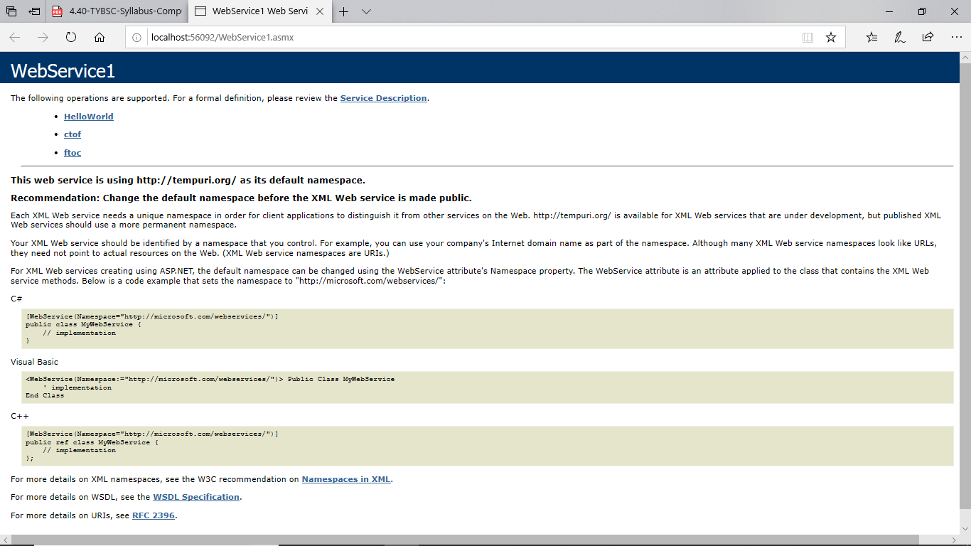

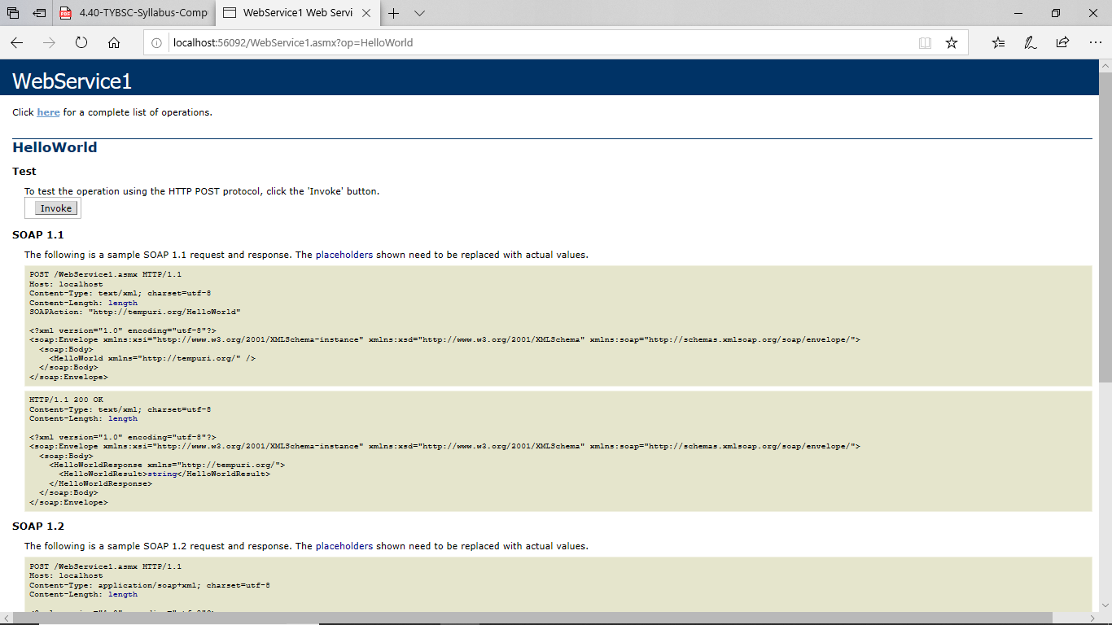

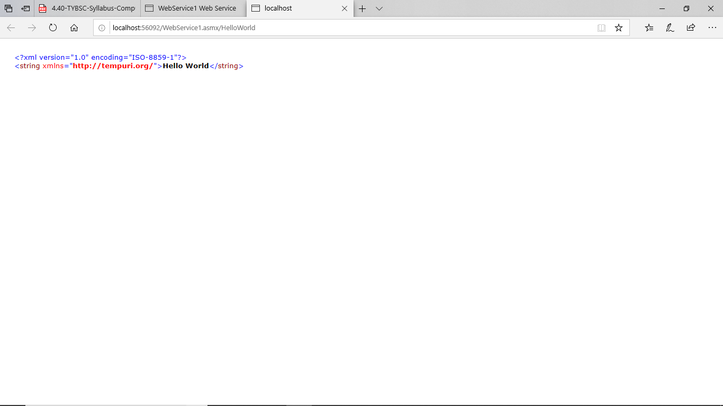



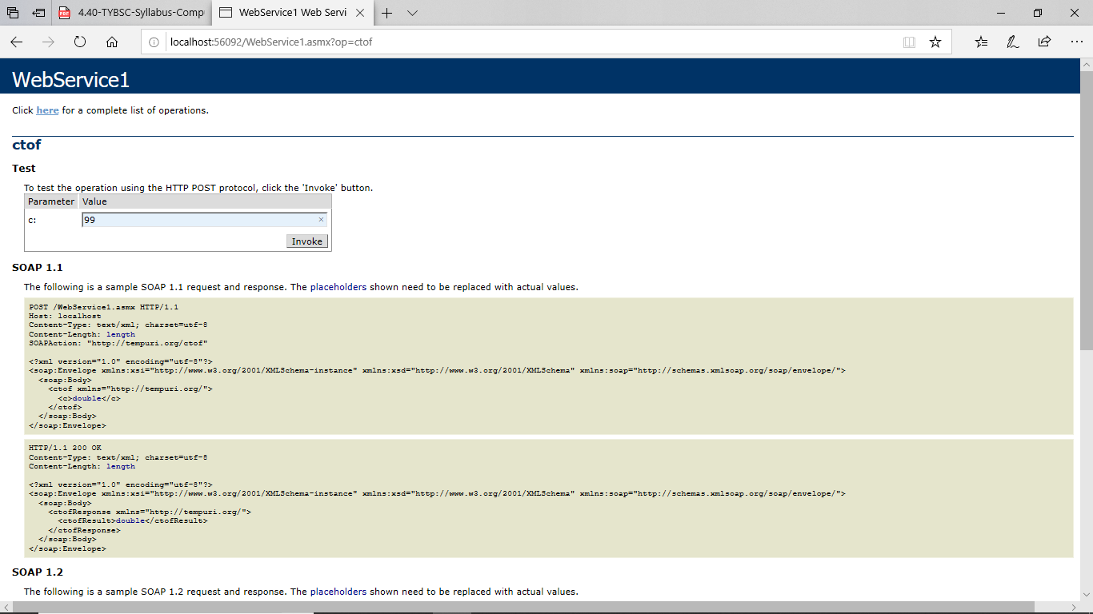

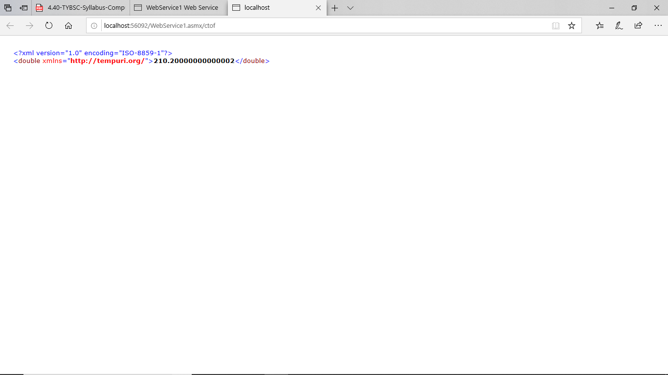

’

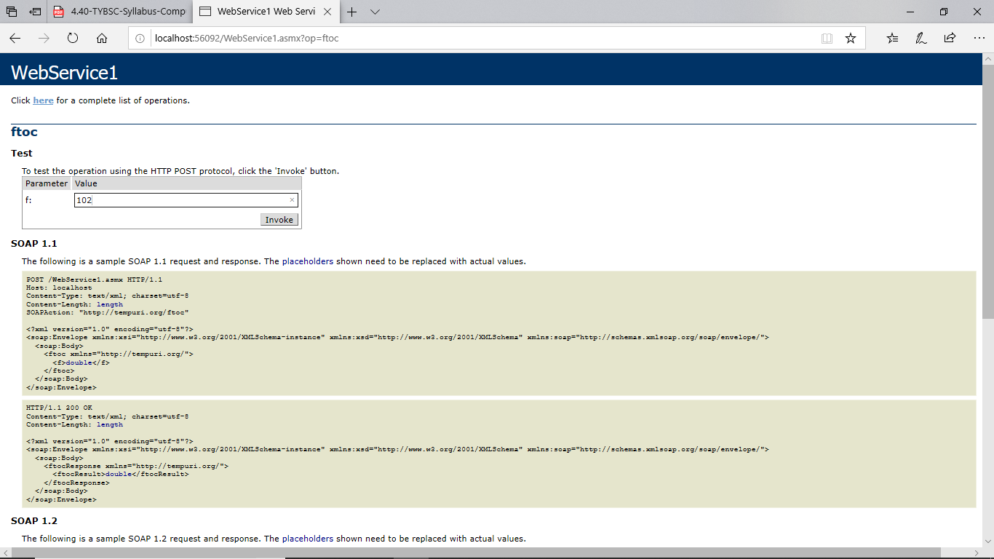

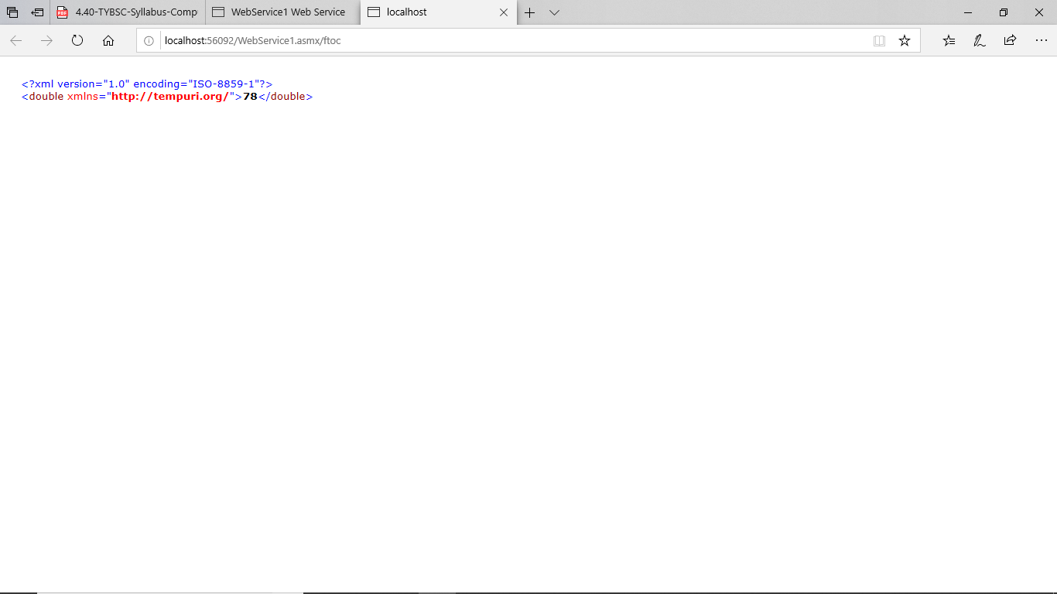

**Step 5) Add Web Form into the Project**

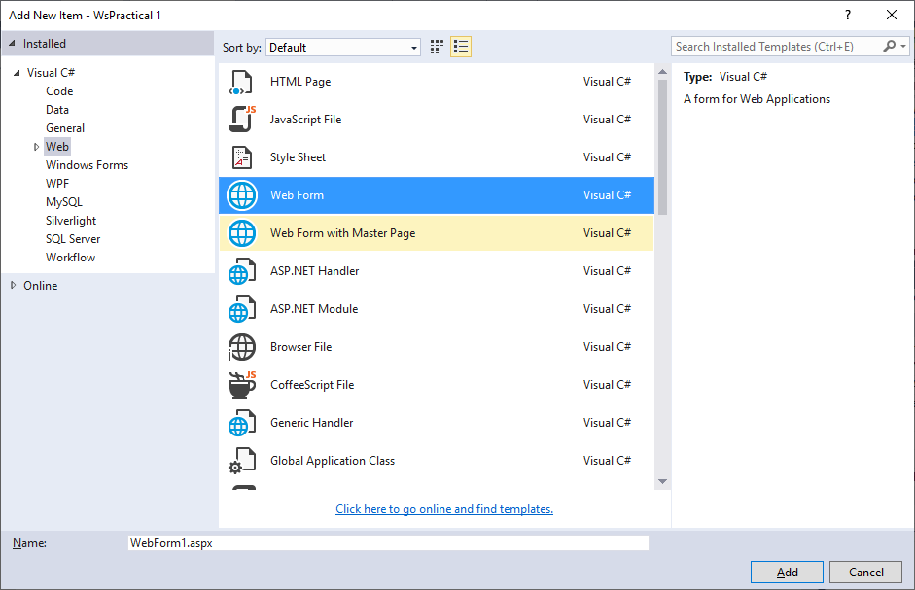

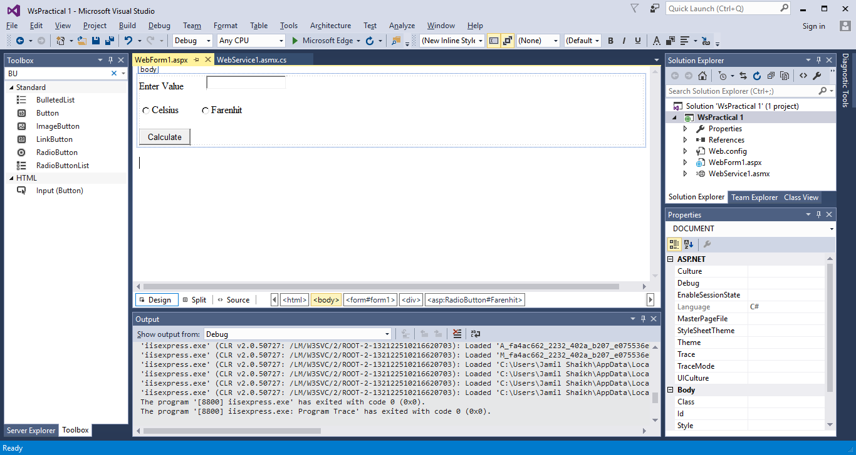

**Step 6) Add Web Reference**

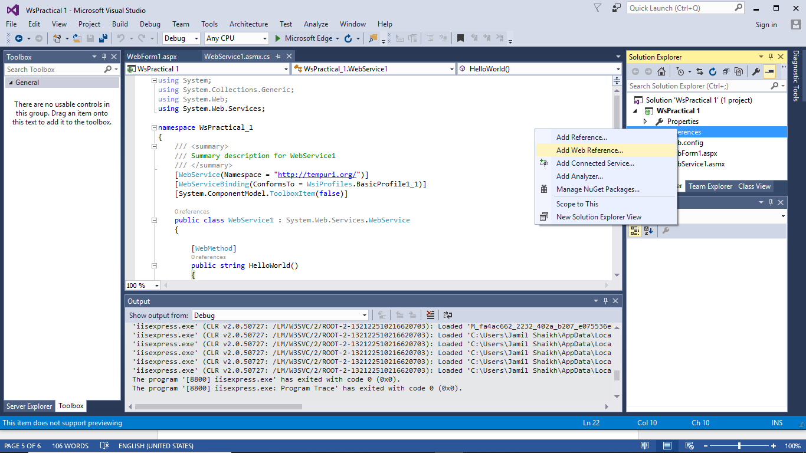

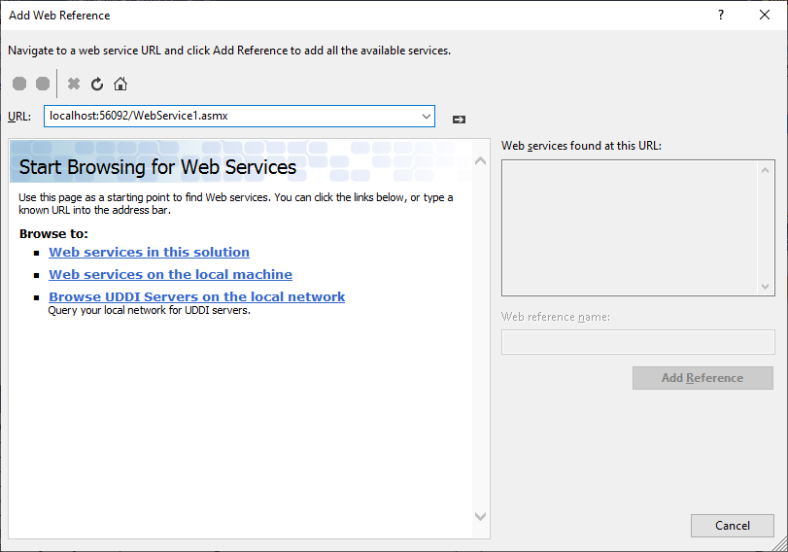

**Step 7) Add url to the web service**

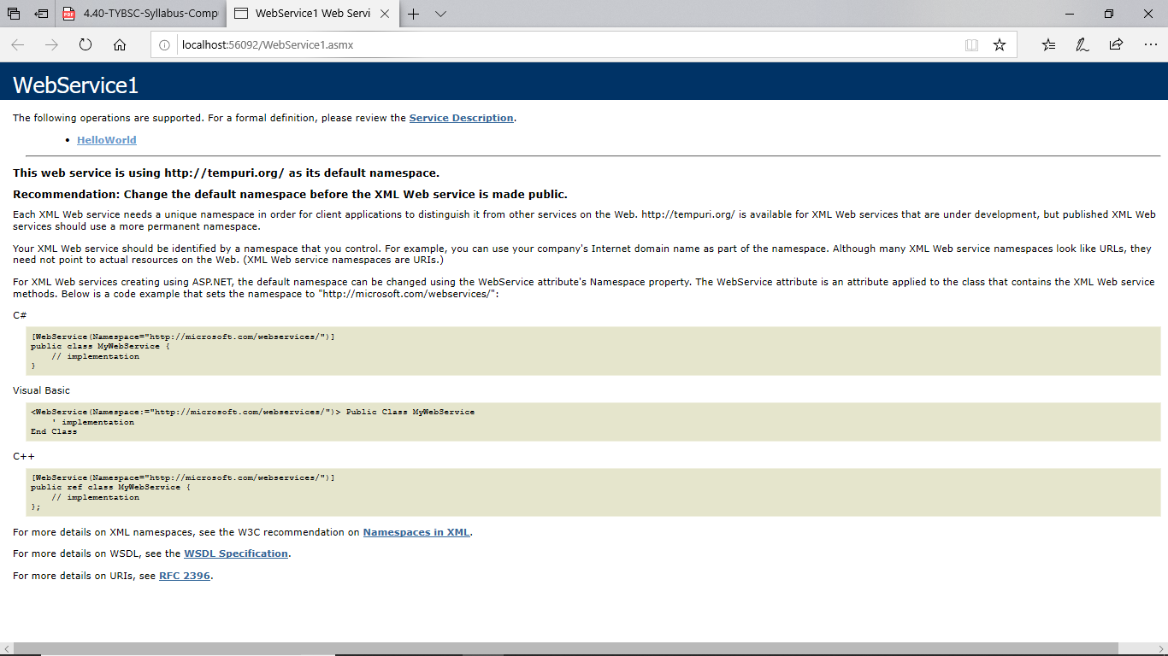

Add following code on button :

using System;

using System.Collections.Generic;

using System.Web;

using System.Web.UI;

using System.Web.UI.WebControls;

namespace WsPractical1

{

public partial class WebForm1 : System.Web.UI.Page

{

protected void Page_Load(object sender, EventArgs e)

{

}

protected void Button1_Click(object sender, EventArgs e)

{

WebService1 ws = new WebService1();

if (Celsius.Checked)

{

TextBox2.Text = ws.ctof(Convert.ToDouble(TextBox1.Text)).ToString();

}

else if (Farenhit.Checked)

{

TextBox2.Text = ws.ftoc(Convert.ToDouble(TextBox1.Text)).ToString();

}

}

}

}

**OUTPUT:**

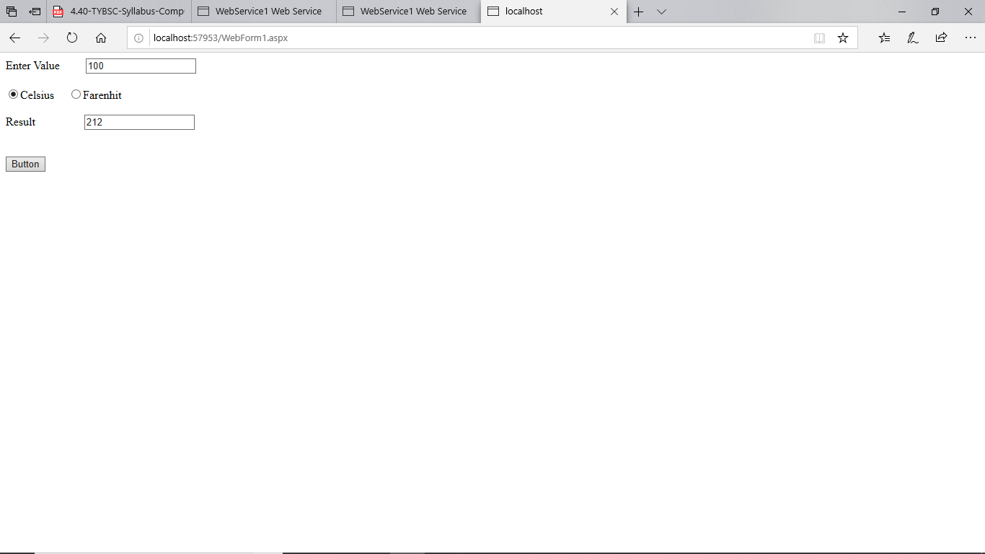

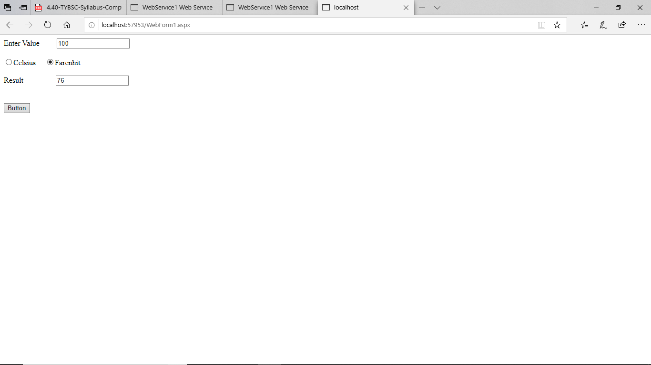

PRACTICAL NO 2

**Q.)Write a program to implement the operation can receive request and will return a response in two ways**

**a)One way operation**

**b)Request and Response**

**Step 1) Create a new Project > WCF Service Application.**

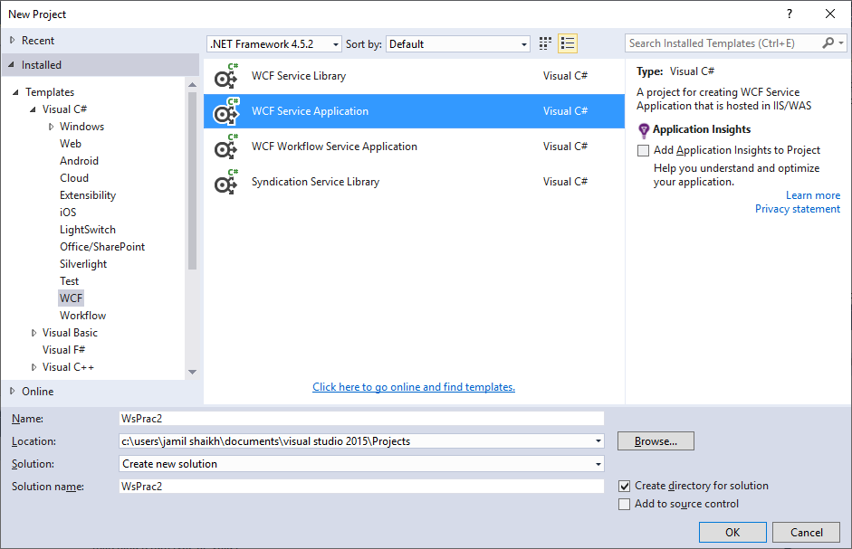

**Steps 2) Two files are auto-generated IService1.cs and Service1.svc.cs**

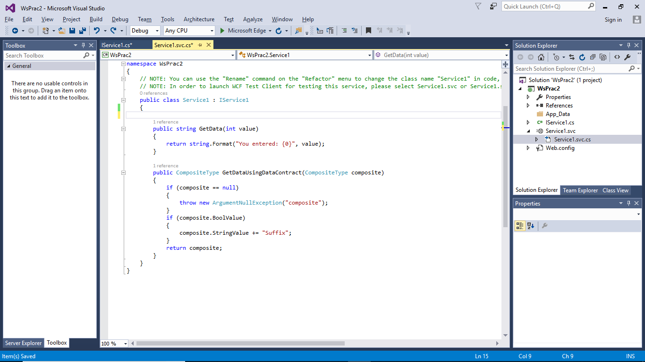

**Step 3) In IService1.cs file write the following code :**

using System;

using System.Collections.Generic;

using System.Linq;

using System.Runtime.Serialization;

using System.ServiceModel;

using System.ServiceModel.Web;

using System.Text;

namespace WsPrac2

{

// NOTE: You can use the "Rename" command on the "Refactor" menu to change the interface name "IService1" in both code and config file together.

[ServiceContract]

public interface IService1

{

[OperationContract(IsOneWay = true)]

void Add(double n1, double n2);

[OperationContract(IsOneWay = true)]

void Subtract(double n1, double n2);

[OperationContract(IsOneWay = true)]

void Multiply(double n1, double n2);

[OperationContract(IsOneWay = true)]

void Divide(double n1, double n2);

[OperationContract]

string SayHello(string name);

[OperationContract]

string GetData(int value);

[OperationContract]

CompositeType GetDataUsingDataContract(CompositeType composite);

// TODO: Add your service operations here

}

// Use a data contract as illustrated in the sample below to add composite types to service operations.

[DataContract]

public class CompositeType

{

bool boolValue = true;

string stringValue = "Hello ";

[DataMember]

public bool BoolValue

{

get { return boolValue; }

set { boolValue = value; }

}

[DataMember]

public string StringValue

{

get { return stringValue; }

set { stringValue = value; }

}

}

}

**Step 4) Inside Services1.svc.cs write the following code :**

using System;

using System.Collections.Generic;

using System.Linq;

using System.Runtime.Serialization;

using System.ServiceModel;

using System.ServiceModel.Web;

using System.Text;

namespace WsPrac2

{

public class Service1 : IService1

{

public void Add(double n1, double n2)

{

double result = n1 + n2;

Console.WriteLine("Addition({0},{1})= {2}", n1, n2, result);

}

public void Subtract(double n1, double n2)

{

double result = n1 - n2;

Console.WriteLine("Subtract({0},{1})= {2}", n1, n2, result);

}

public void Multiply(double n1, double n2)

{

double result = n1 * n2;

Console.WriteLine("Multiply({0},{1})= {2}", n1, n2, result);

}

public void Divide(double n1, double n2)

{

double result = n1 / n2;

Console.WriteLine("Divide({0},{1})= {2}", n1, n2, result);

}

public string SayHello(string name)

{

Console.WriteLine("SayHello({0})", name);

return "Hello " + name;

}

public string GetData(int value)

{

return string.Format("You entered: {0}", value);

}

public CompositeType GetDataUsingDataContract(CompositeType composite)

{

if (composite == null)

{

throw new ArgumentNullException("composite");

}

if (composite.BoolValue)

{

composite.StringValue += "Suffix";

}

return composite;

}}}

**Step 5) Run the Project and see the output:**

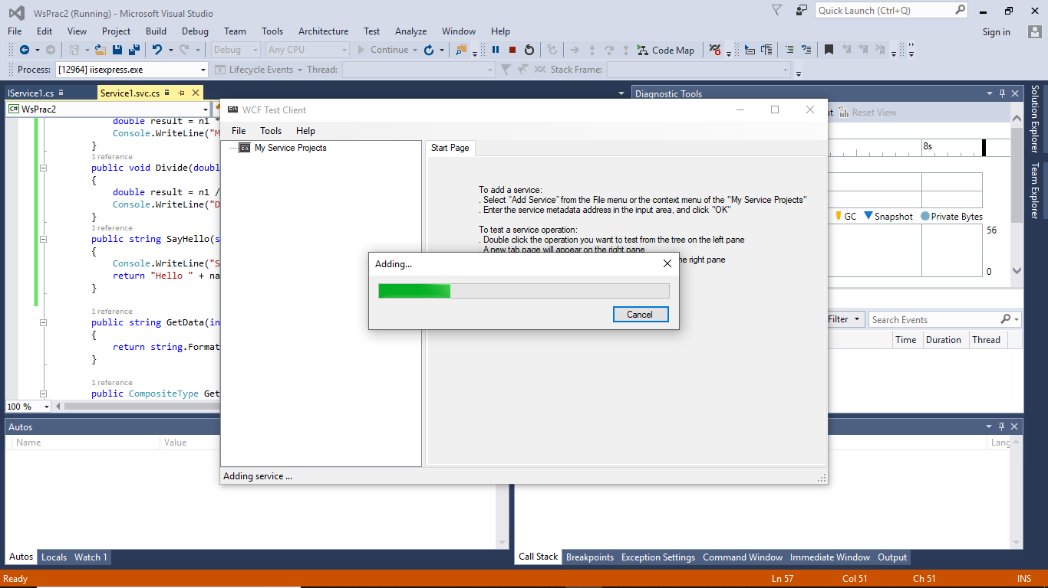

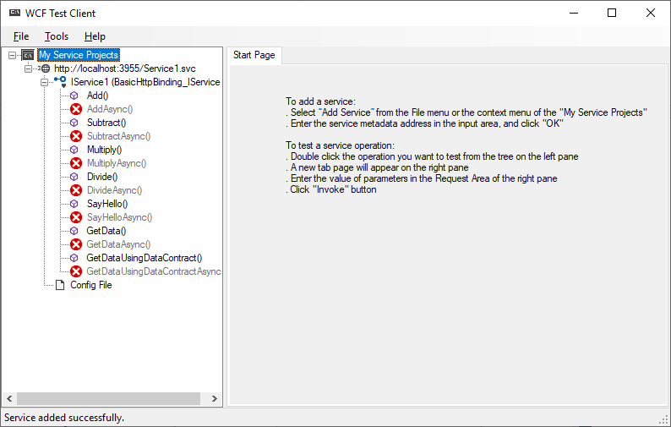

**1)One way Opeartion :**

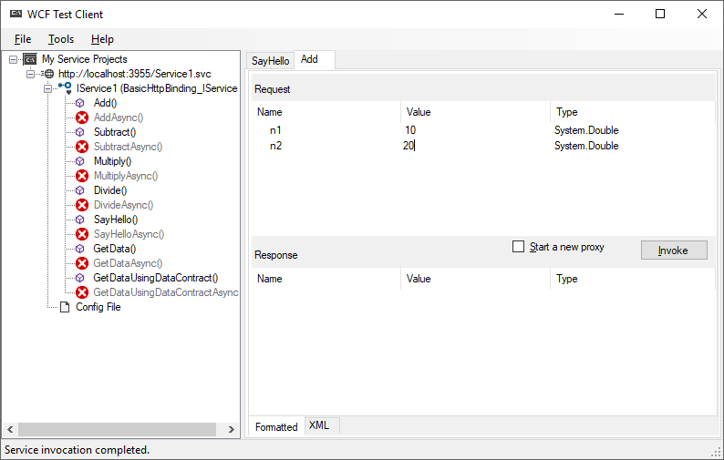

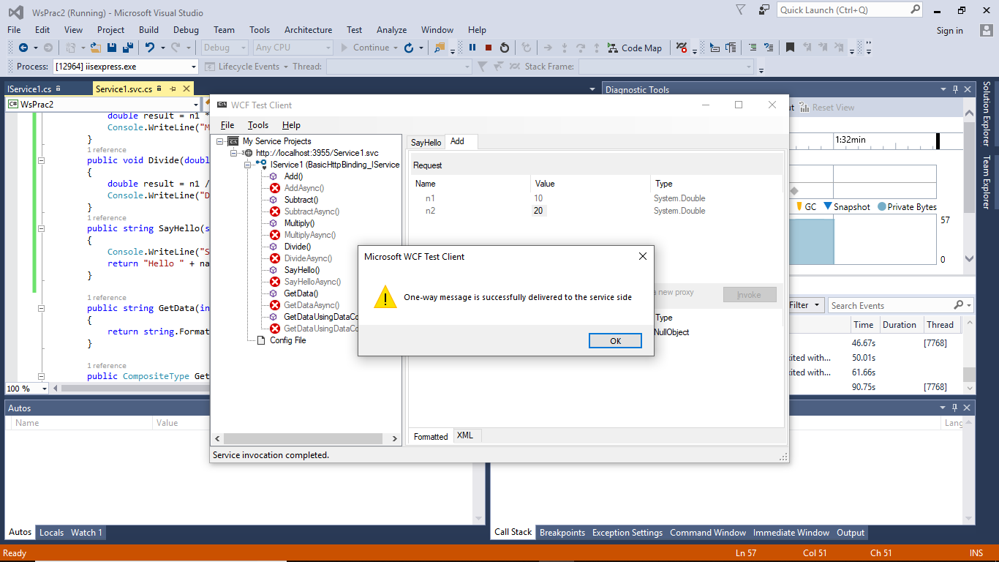

**2) Request and Response :**

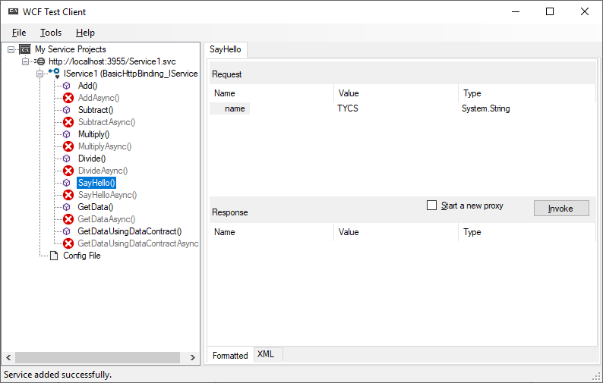

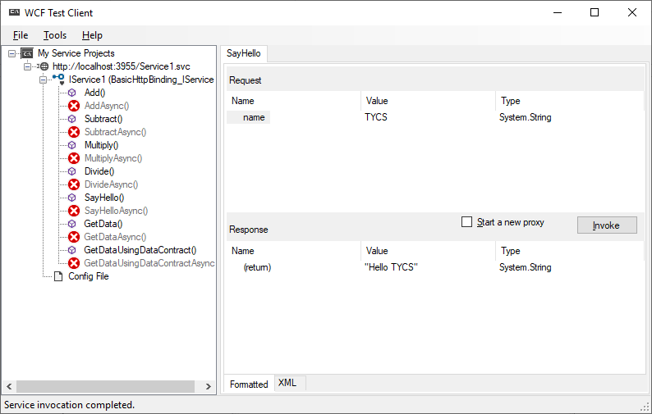

PRACTICAL NO 3

**Q.)Write a program to implement business UDDI Registry entry**

**Code :**

package uddisoapclient1;

import com.sun.istack.internal.logging.Logger;

import java.io.*;

import java.util.*;

import java.util.logging.Level;

public class UDDISoapClient1 {

private static final String DEFAULT_HOST_URL="http://localhost:8080/wasp/uddi/inquiry/";

private static final String DEFAULT_DATA_FILENAME="./Default.xml";

private static final String URI="";

private String m_hostURL;

private String m_dataFileName;

public UDDISoapClient1(String hostURL,String dataFileName)throws Exception{

m_hostURL=hostURL;

m_dataFileName=dataFileName;

System.out.println();

System.out.println("_______________________________________________________________");

System.out.println("Starting UDDISoapClient");

System.out.println("host url="+m_hostURL);

System.out.println("data File"+m_dataFileName);

System.out.println("_____________________________________________________________");

System.out.println();

}

public void sendSOAPMessage(){

try{

FileReader fr=new FileReader(m_dataFileName);

javax.xml.parsers.DocumentBuilder xdb=org.apache.soap.util.xml.XMLParserUtils.getXMLDocBuilder();

org.w3c.dom.Document doc=xdb.parse(new org.xml.sax.InputSource(fr));

if(doc==null){

throw new org.apache.soap.SOAPException(org.apache.soap.Constants.FAULT_CODE_CLIENT,"parsing error");

}

Vector bodyElements=new Vector();

bodyElements.add(doc.getDocumentElement());

org.apache.soap.Envelope envelope=new org.apache.soap.Envelope();

envelope.declareNamespace("idoox","http://idoox.com/uddiface");

envelope.declareNamespace("ua","http://idoox.com/uddiface/account");

envelope.declareNamespace("config","http://idoox.com/uddiface/congfig");

envelope.declareNamespace("attr","http://idoox.com/uddiface/attr");

envelope.declareNamespace("fxml","http://idoox.com/uddiface/formxml");

envelope.declareNamespace("inner","http://idoox.com/uddiface/inner");

envelope.declareNamespace("","http://idoox.com/uddiface/inner");

envelope.declareNamespace("uddi","urn-uddi-org:api_v2");

org.apache.soap.Body body=new org.apache.soap.Body( );

body.setBodyEntries(bodyElements);

envelope.setBody(body);

org.apache.soap.messaging.Message msg=new org.apache.soap.messaging.Message();

msg.send(new java.net.URL(m_hostURL),URI,envelope);

System.out.println("sent soap message with apache http soap client");

System.out.println("waiting for response");

org.apache.soap.transport.SOAPTransport st=msg.getSOAPTransport();

BufferedReader br=st.receive();

if(br.equals(null)){

System.out.println("HTTP POST was unsuccessful.\n");

}

else{

while(br.readLine()!=null){

System.out.println(br.lines());

}

}

}

catch(Exception ex){

System.out.println(ex);

}

}

public static void main(String[] args) {

try {

UDDISoapClient1 obj=new UDDISoapClient1(DEFAULT_HOST_URL,DEFAULT_DATA_FILENAME);

} catch (Exception ex) {

java.util.logging.Logger.getLogger(UDDISoapClient1.class.getName()).log(Level.SEVERE, null, ex);

}

}

}

**OUTPUT:**

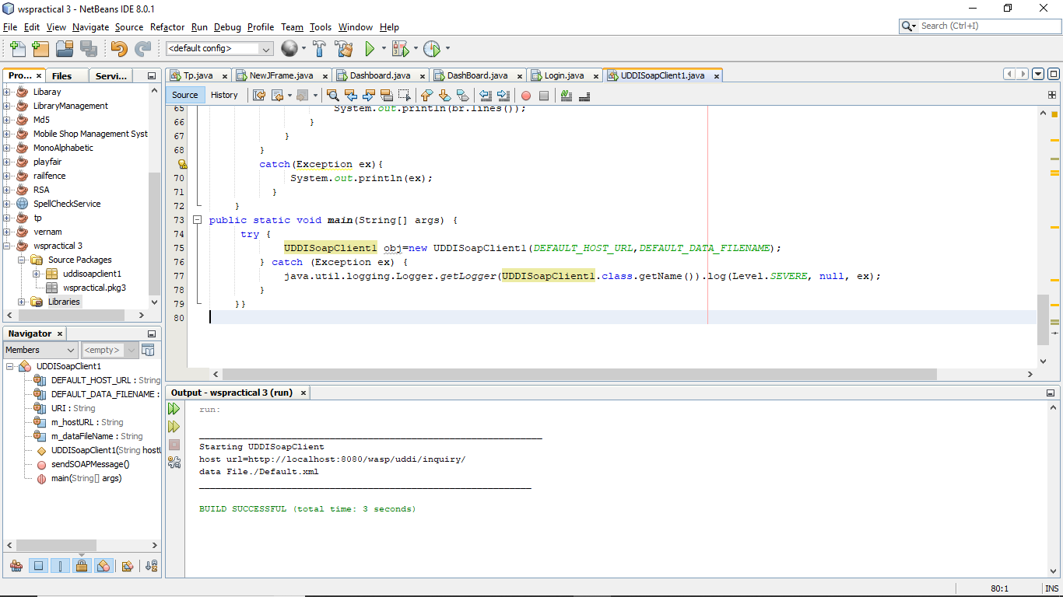

PRACTICAL NO 4

**Q.)Develop client which consumes web services developed in different platform.**

**Step 1): Create a New Project in asp.net**

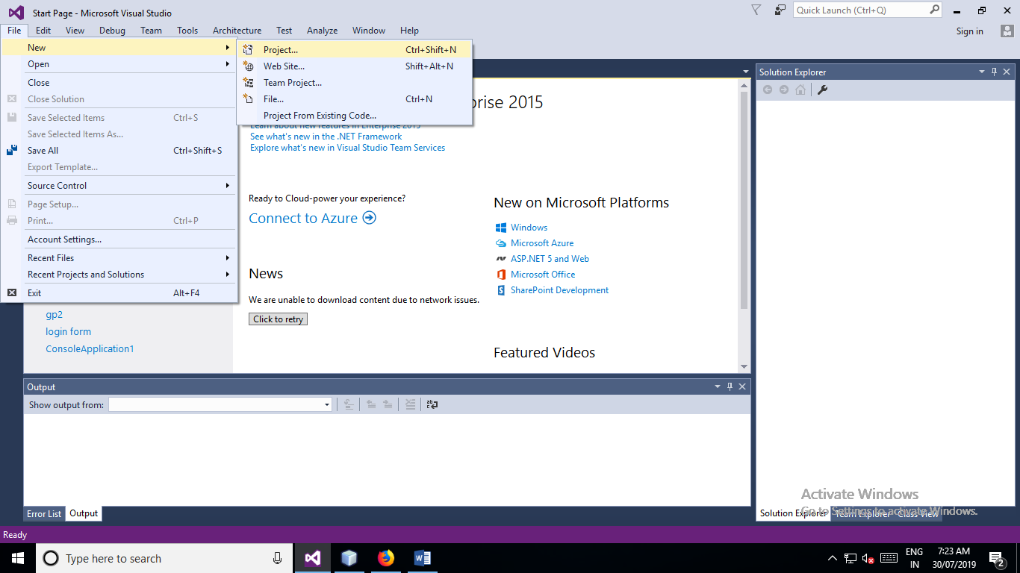

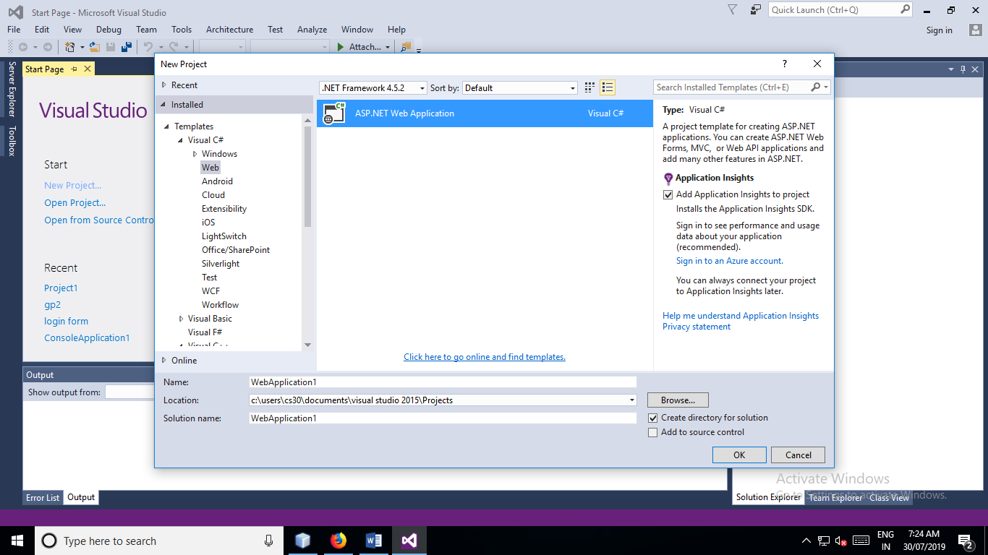

**Step 2) Add Web Service (ASMX) file:**

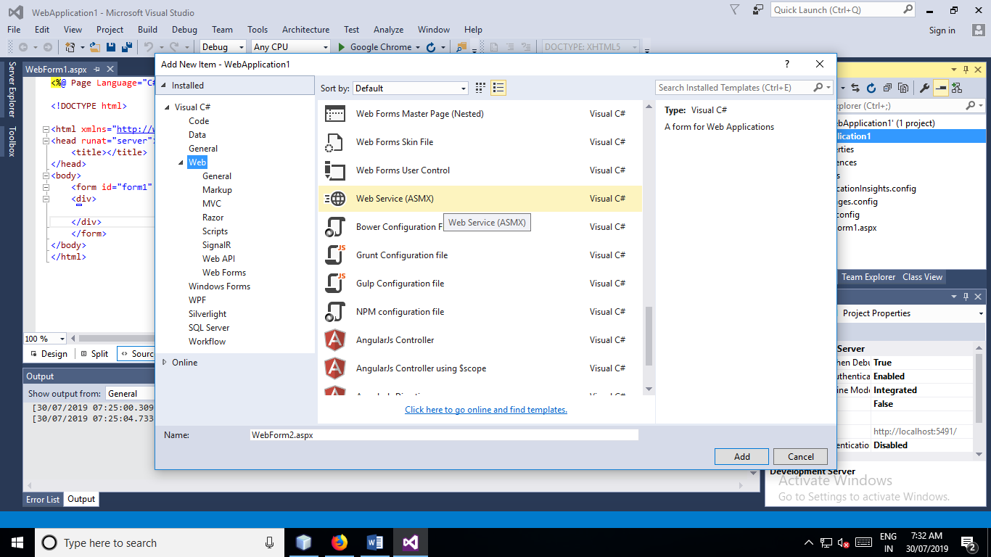

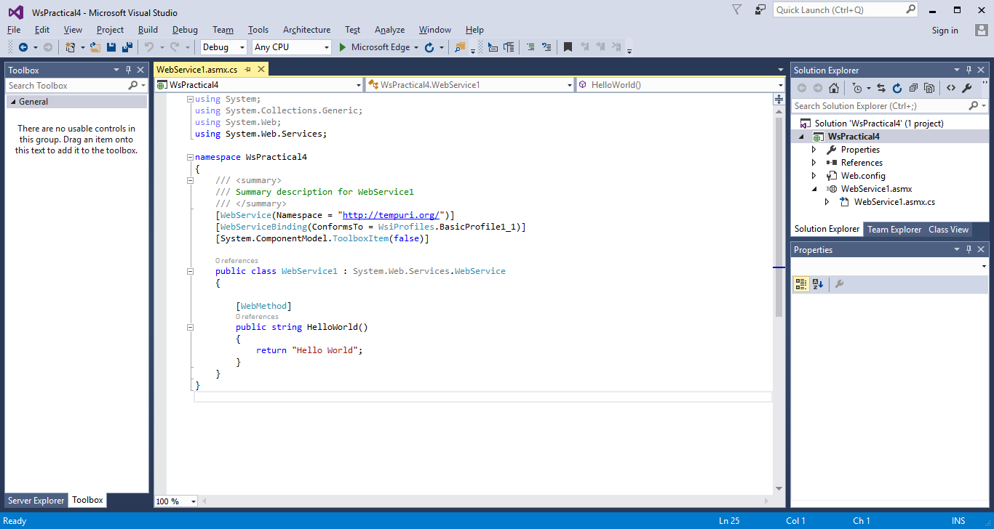

**Step 3) Add Following Code:**

using System;

using System.Collections.Generic;

using System.Web;

using System.Web.Services;

namespace WsPractical4

{

[WebService(Namespace = "http://tempuri.org/")]

[WebServiceBinding(ConformsTo = WsiProfiles.BasicProfile1_1)]

[System.ComponentModel.ToolboxItem(false)]

public class WebService1 : System.Web.Services.WebService

{

[WebMethod]

public string HelloWorld()

{

return "Hello World";

}

[WebMethod]

public int add(int x, int y)

{

return x + y;

}

[WebMethod]

public int sub(int x, int y)

{

return x - y;

}

[WebMethod]

public int mul(int x, int y)

{

return x * y;

}

[WebMethod]

public int div(int x, int y)

{

return x / y;

}

}

}

**Step 4) Run the project and see the output :**

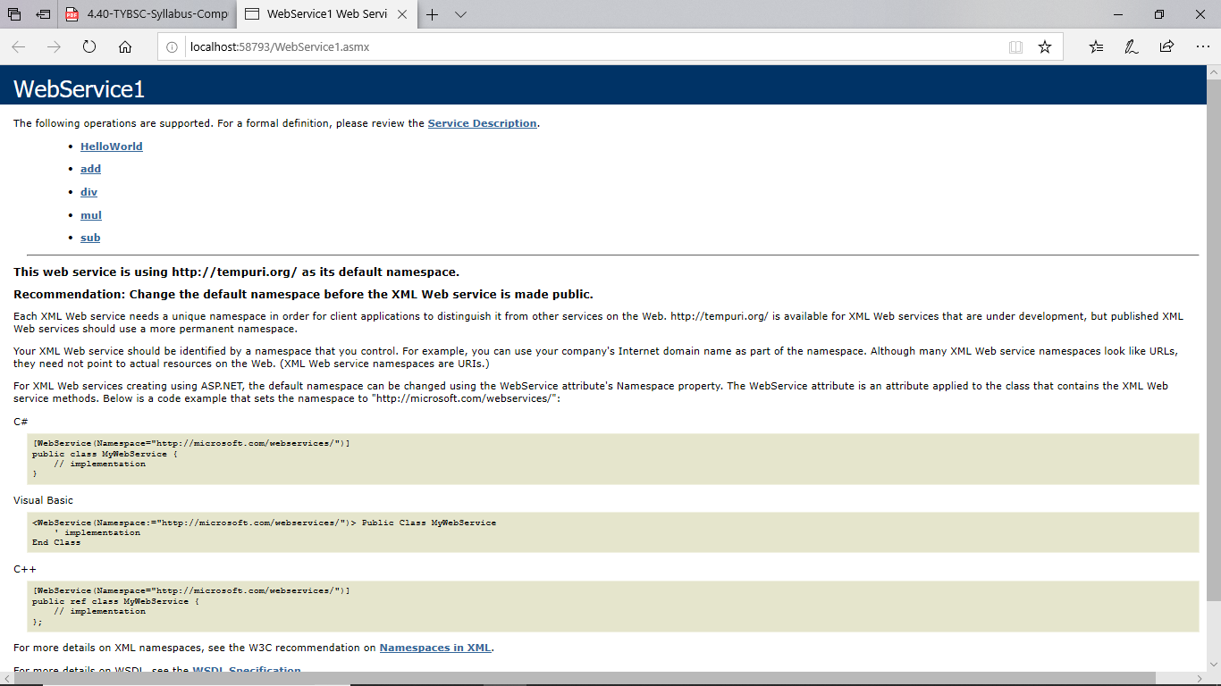

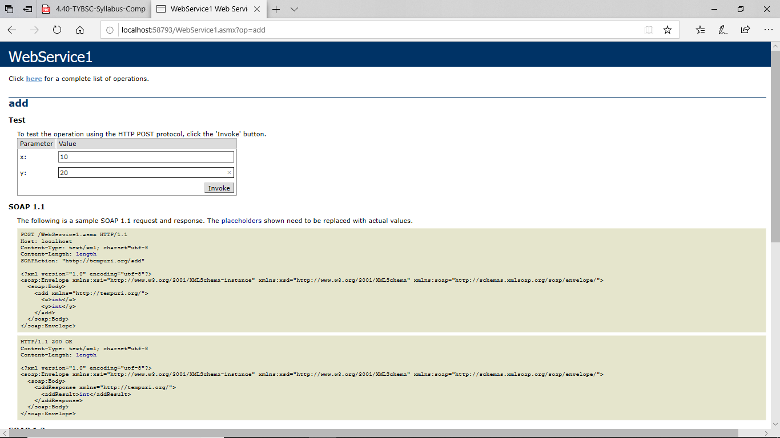

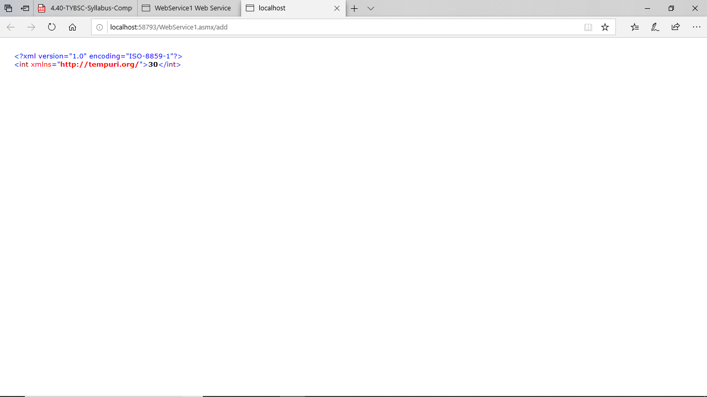



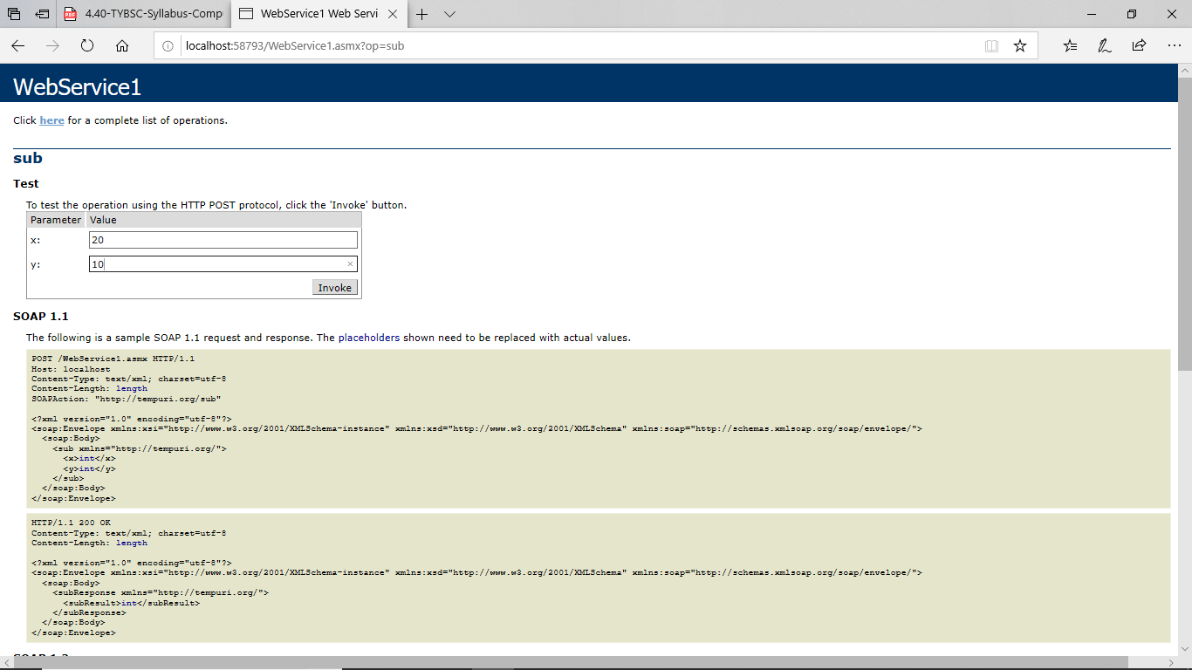

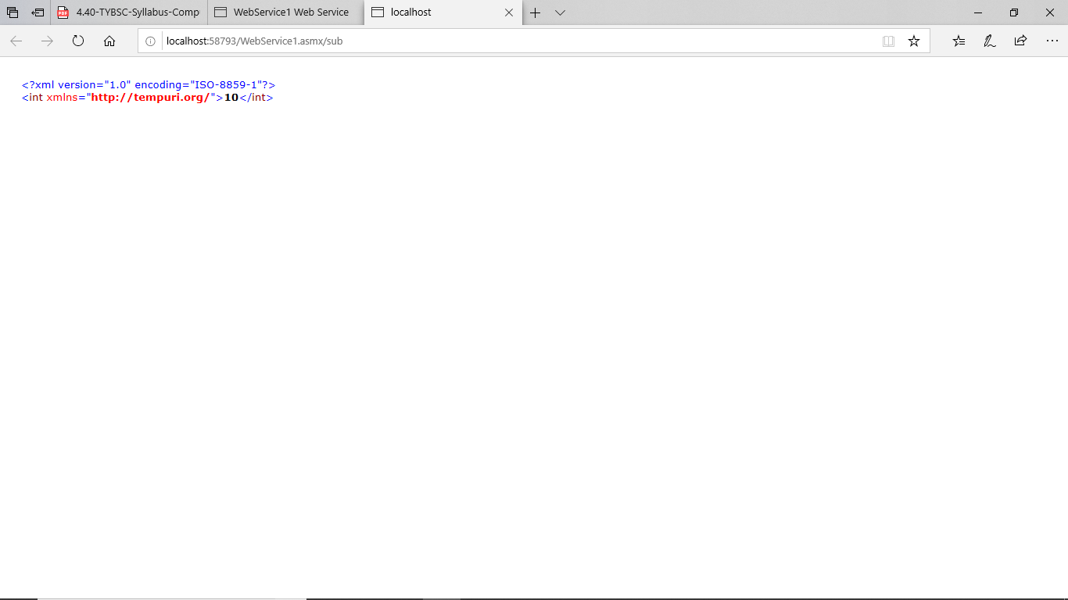



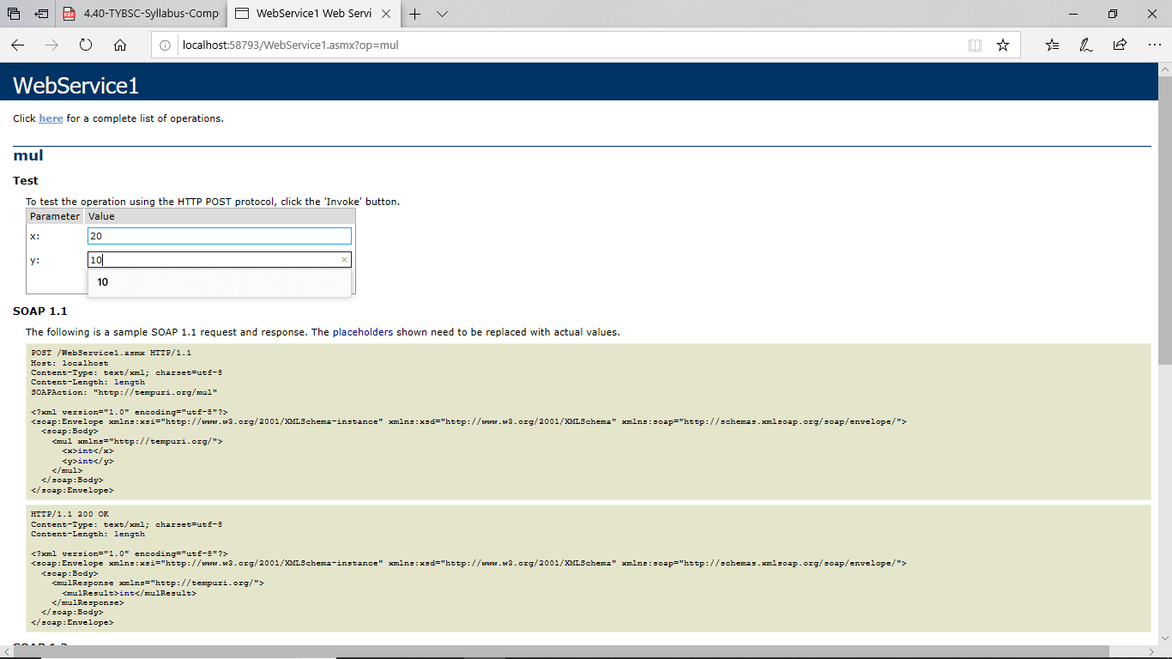

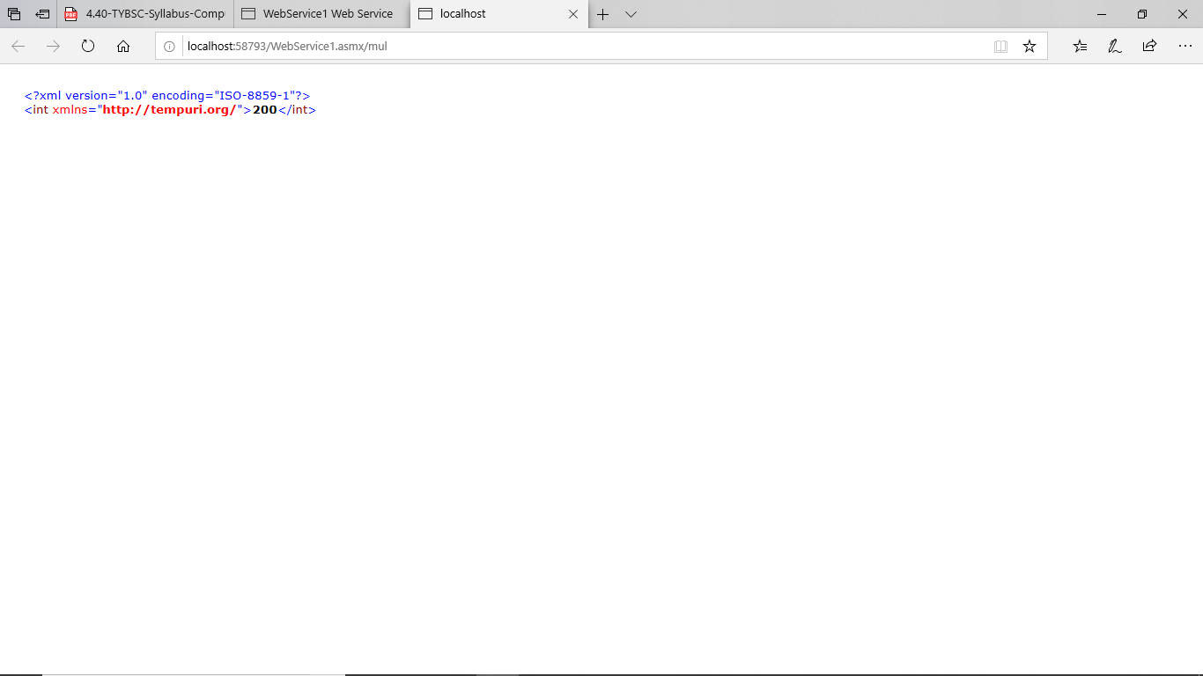



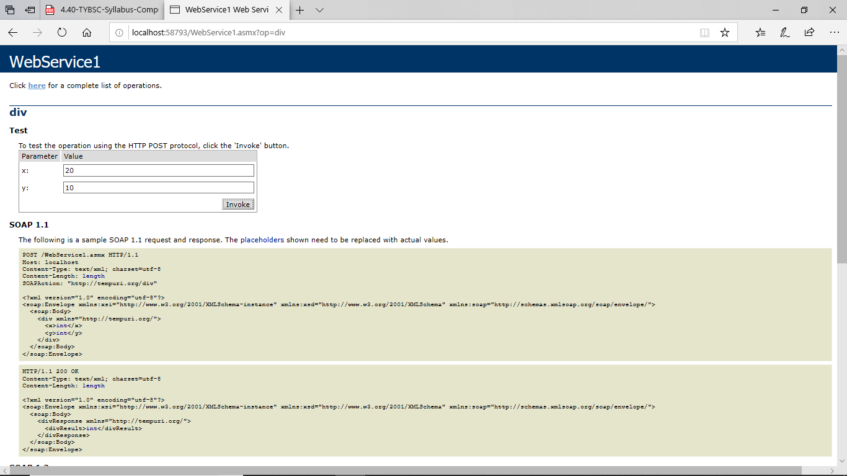

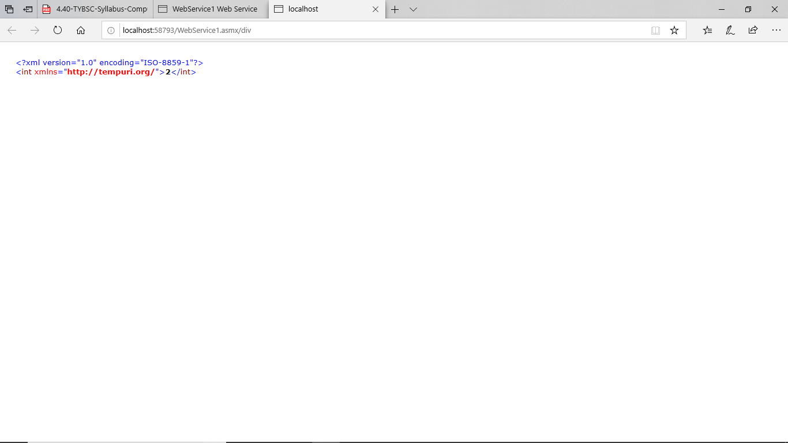

**Step 5) Create a folder client in your project folder**

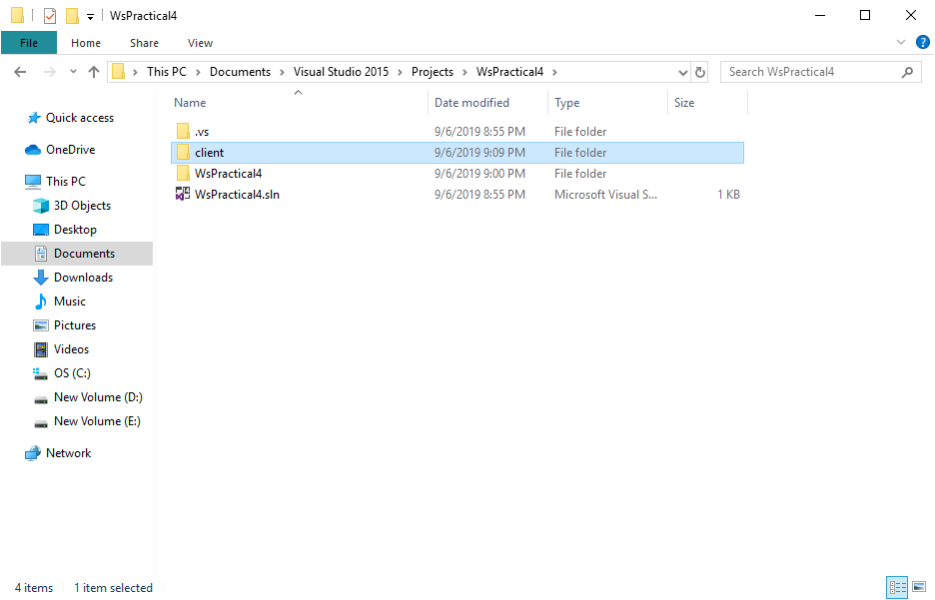

**Step 6) Go to cmd. In cmd go to file where you created a client folder**

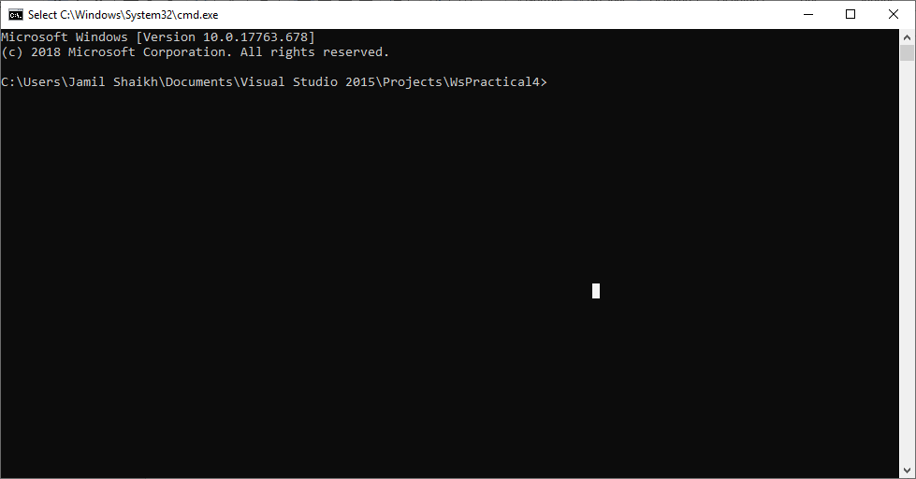

**Run command : wsimport –keep –p webPack.server <URL of server from browser>(http://localhost:58793/WebService1.asmx)**

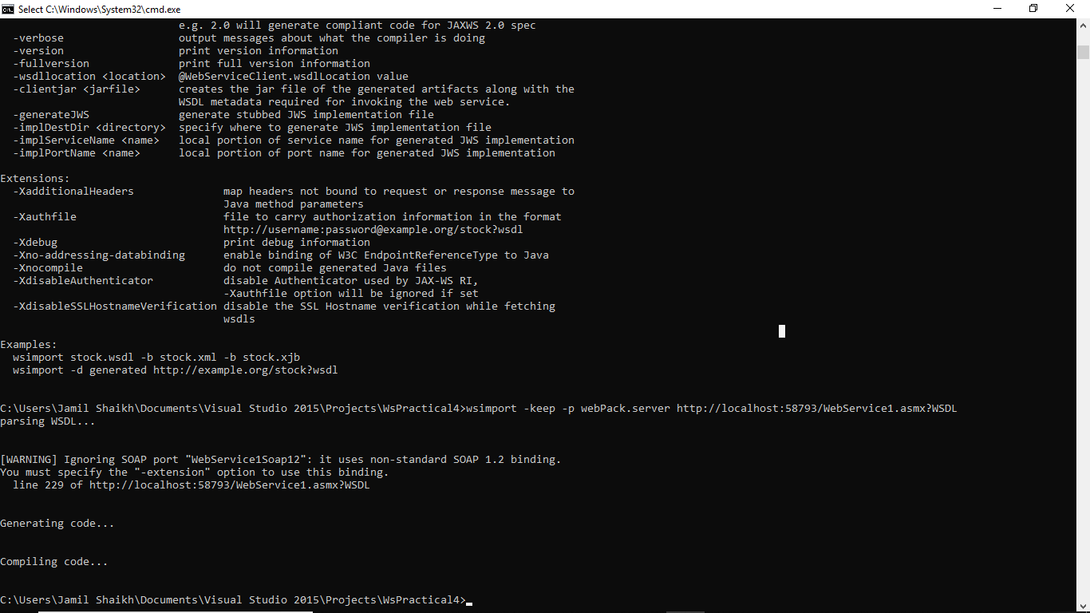

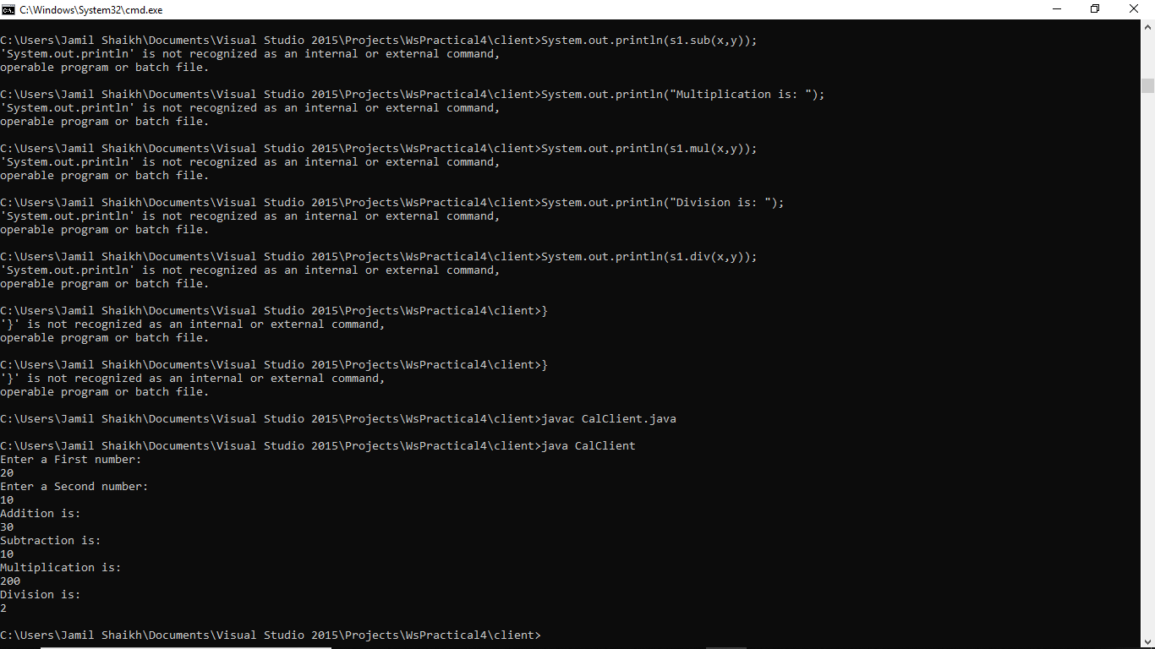

**2nd Method :**

**Step1) Create a web service file in .net framework**

**Code:**

using System;

using System.Collections.Generic;

using System.Linq;

using System.Web;

using System.Web.Services;

namespace WebApplication2

{

/// <summary>

/// Summary description for WebService1

/// </summary>

[WebService(Namespace = "http://tempuri.org/")]

[WebServiceBinding(ConformsTo = WsiProfiles.BasicProfile1_1)]

[System.ComponentModel.ToolboxItem(false)]

// To allow this Web Service to be called from script, using ASP.NET AJAX, uncomment the following line.

// [System.Web.Script.Services.ScriptService]

public class WebService1 : System.Web.Services.WebService

{

[WebMethod]

public string HelloWorld()

{

return "Hello TYCS";

}

}

}

**Step 2) Create a web application in netbeans:**

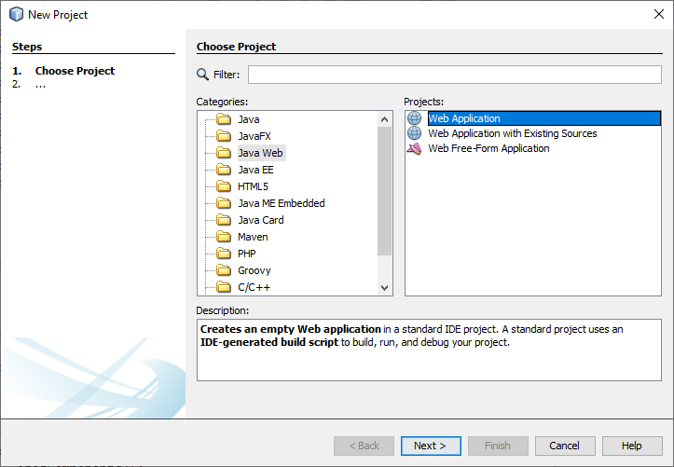

**Then add Package:**

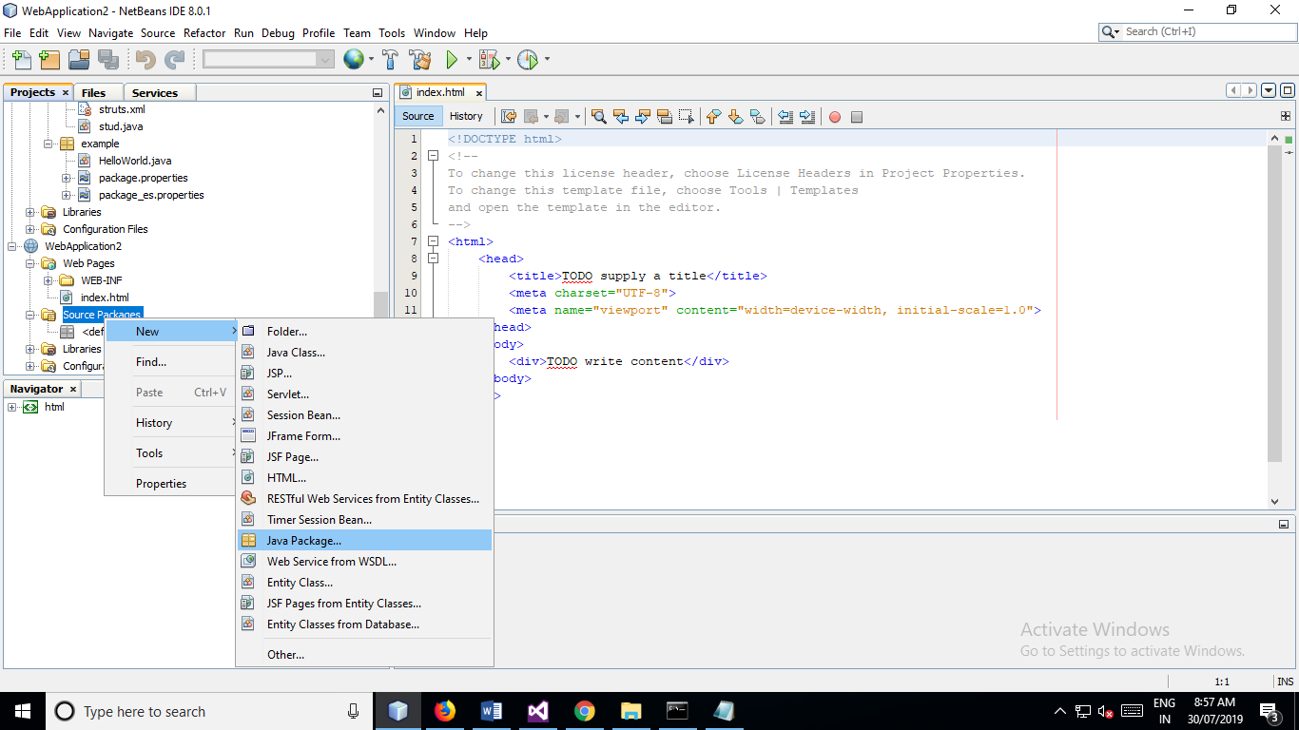

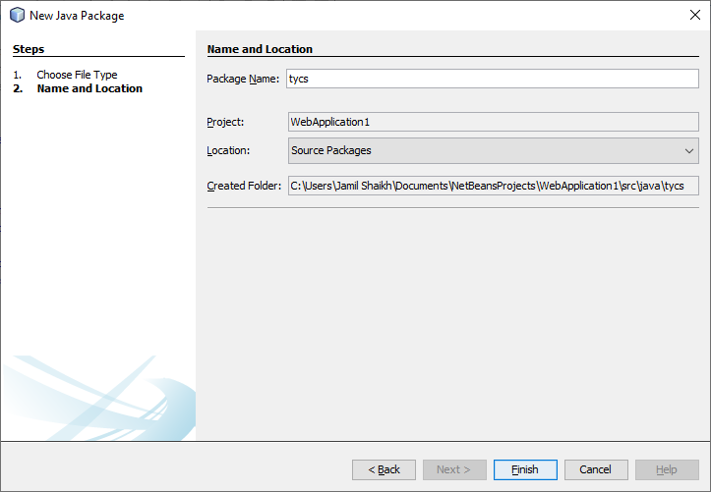

**Step 3) Then Add Web Service Client :**

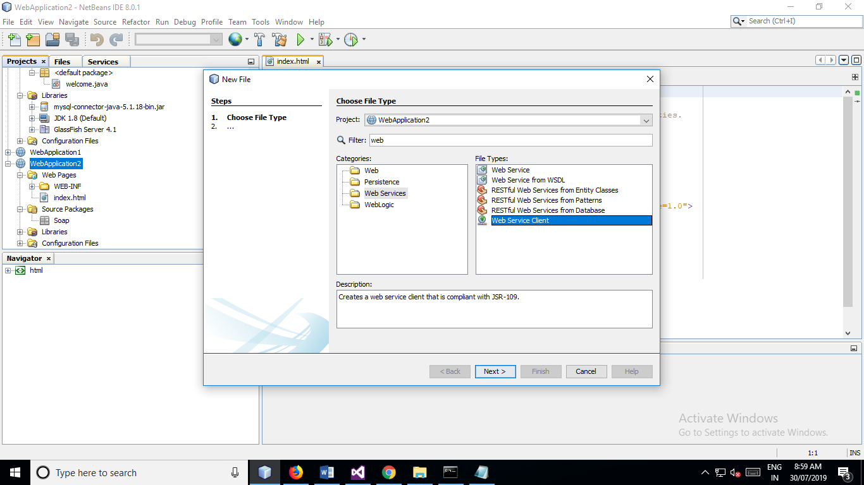

**Step 4) Paste WSDL URL of the web service**

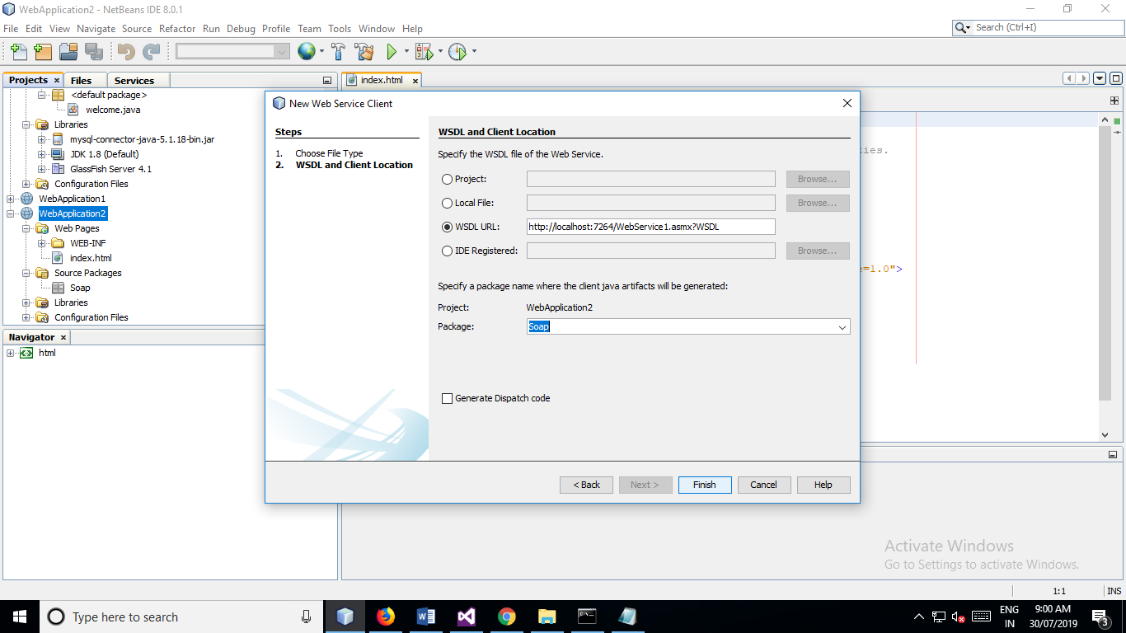

**Step 5) Add JSP page into WebApplication**

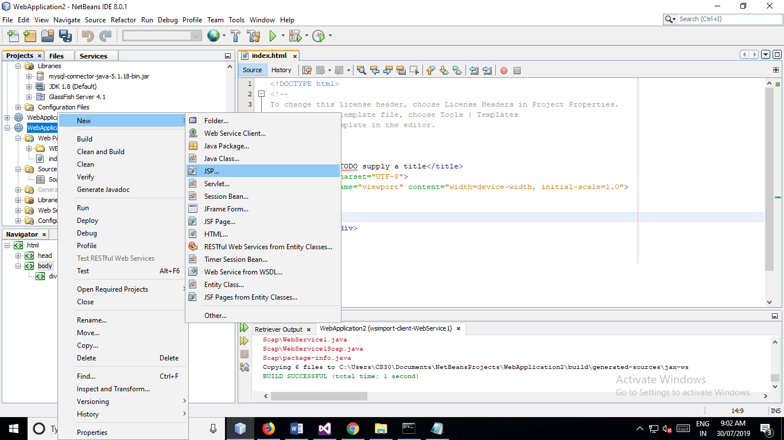

**Step 6) Right click on JSP page and select Web Service Client Resources :**

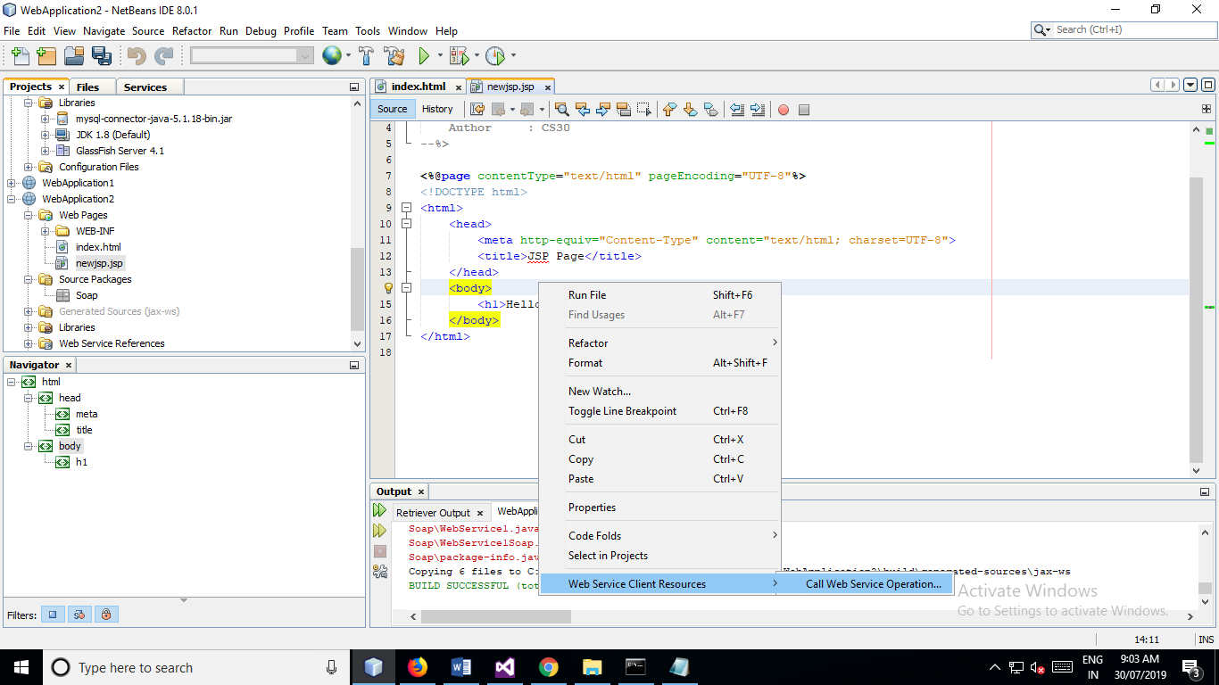

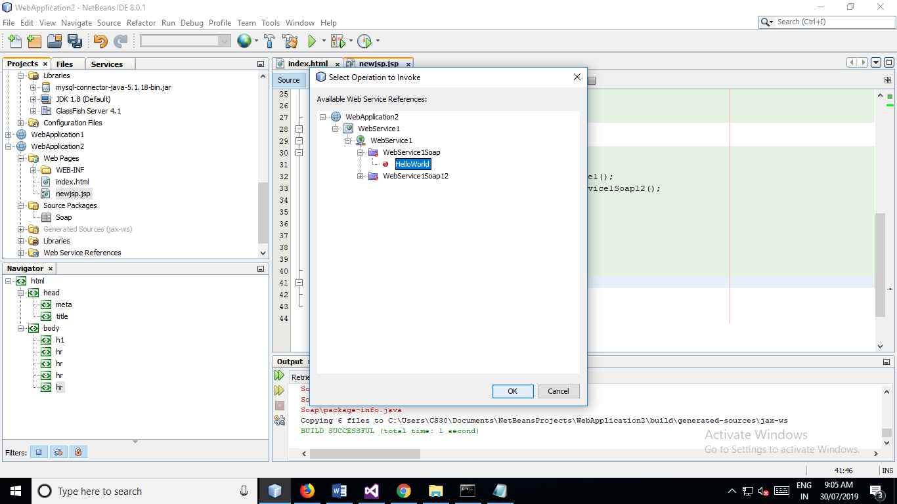

**OUTPUT:**

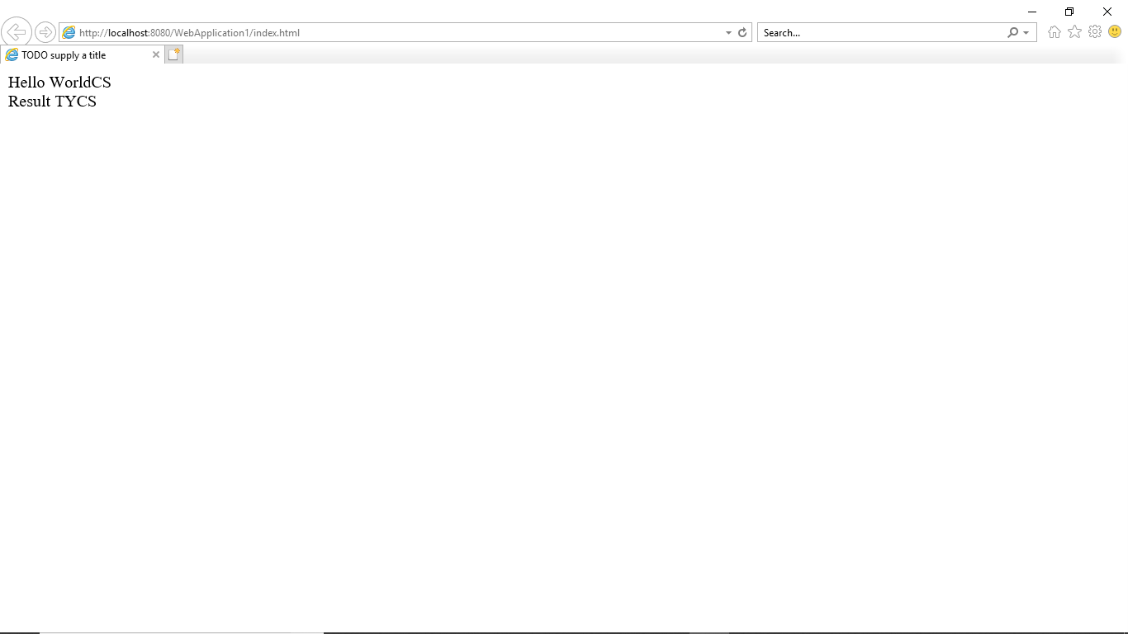

PRACTICAL NO 5

**Q.)Write a JAX-WS web service to perform the following operations. Define a Servlet / JSP that consumes the web service.**

**Step 1) Create a web Application in Netbeans**

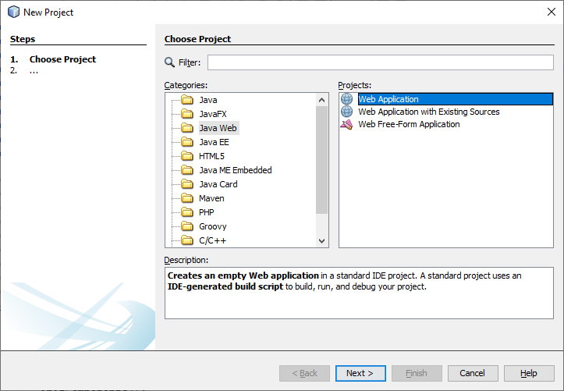

**Step 2) Add web service from right click the webApplication**

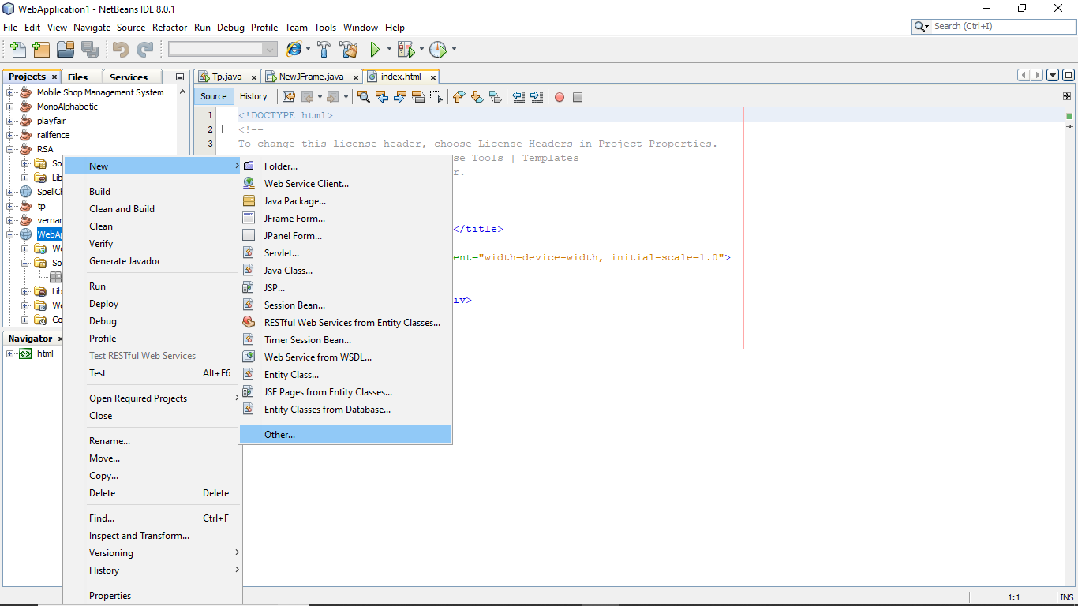

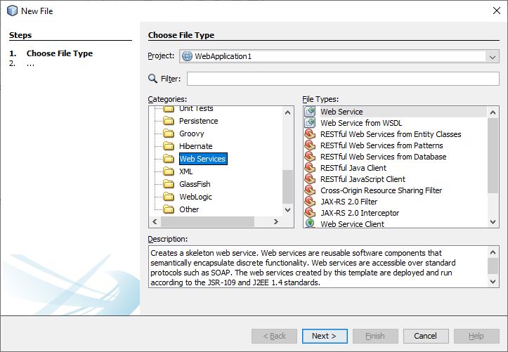

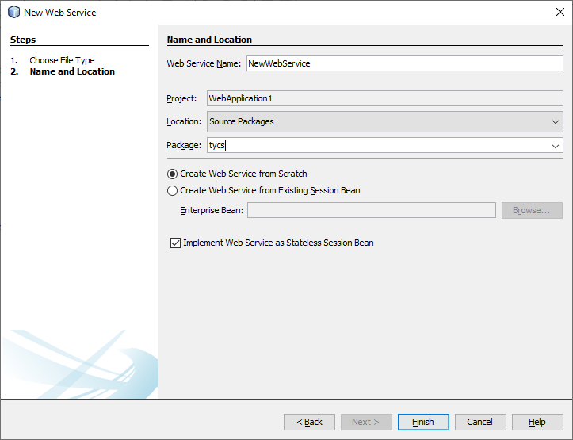

**Step 3) Add operation By right Click of the web Service**

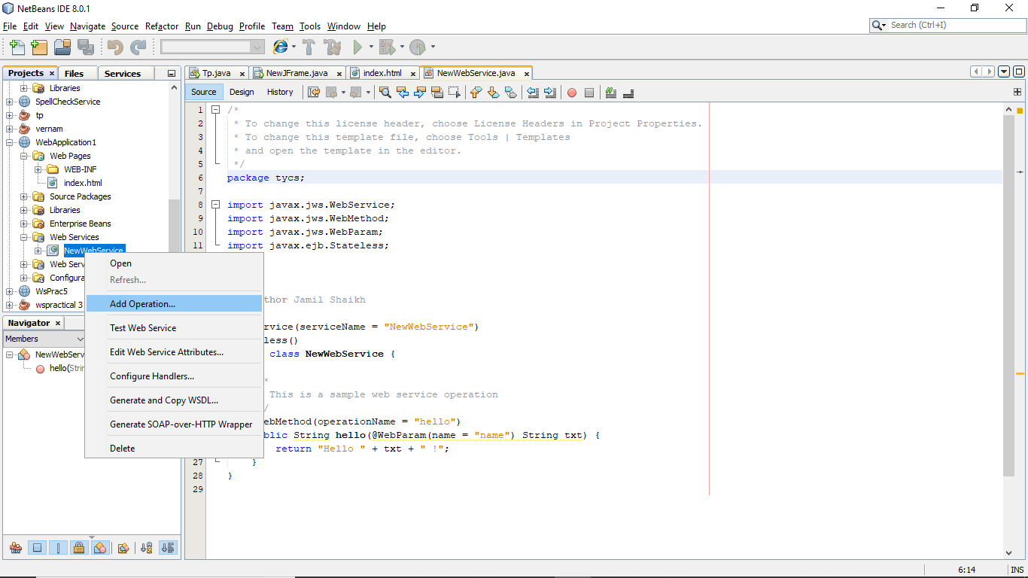

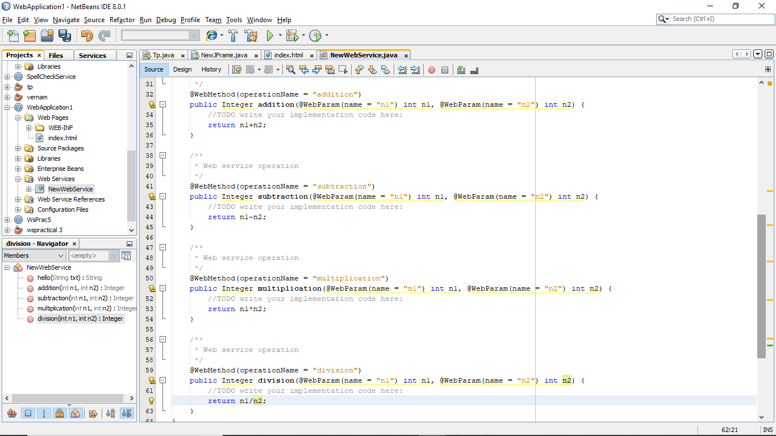

**Step4) Test the webService :**

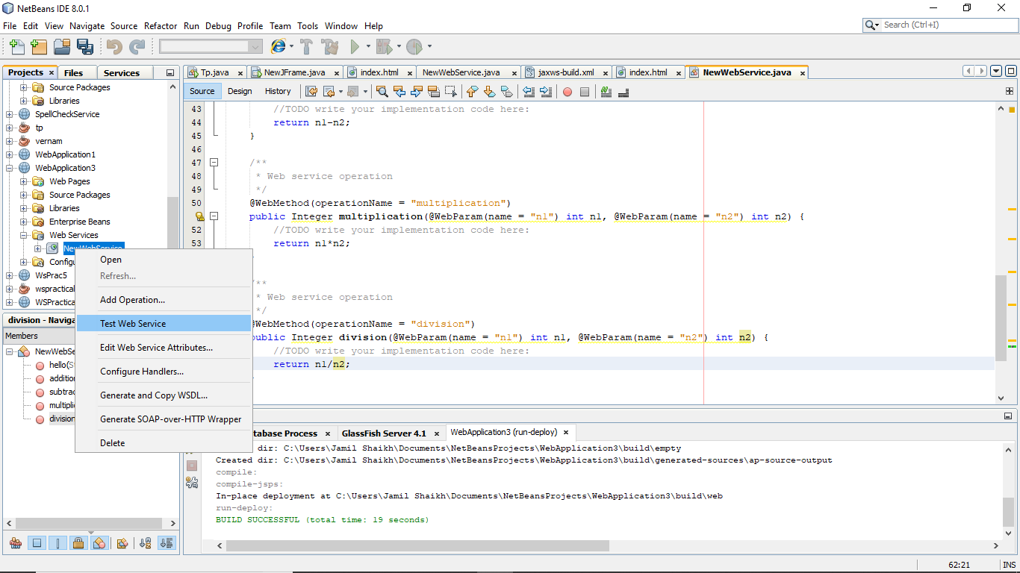

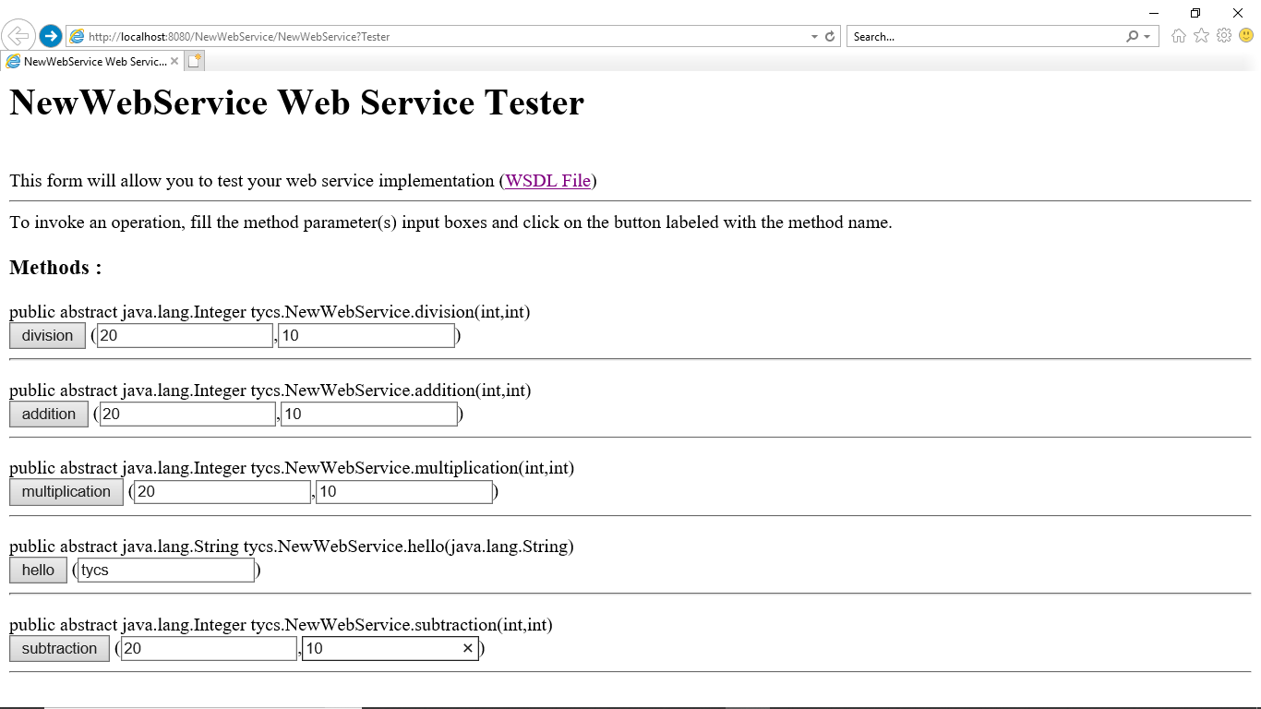

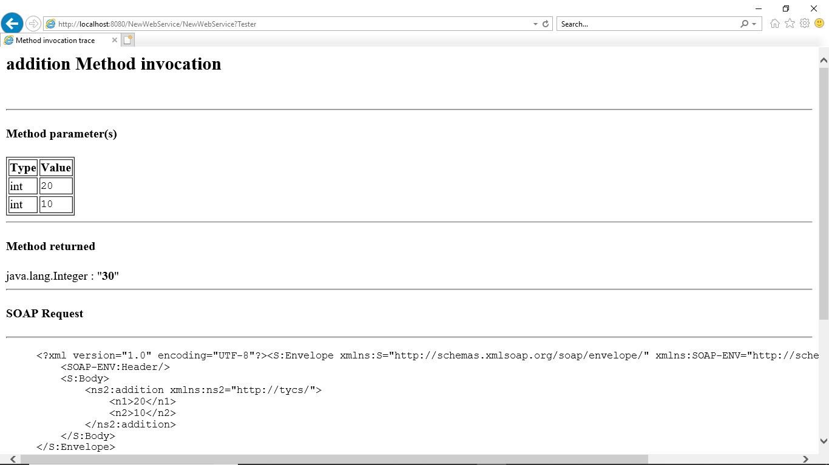

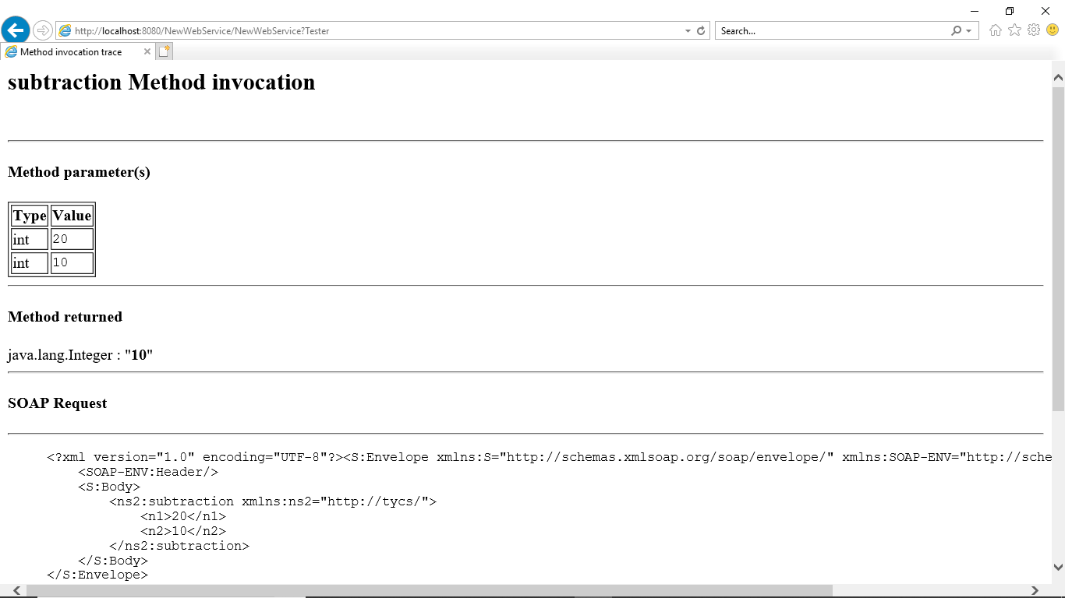

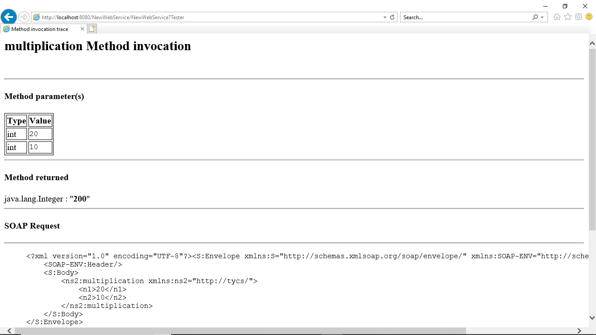

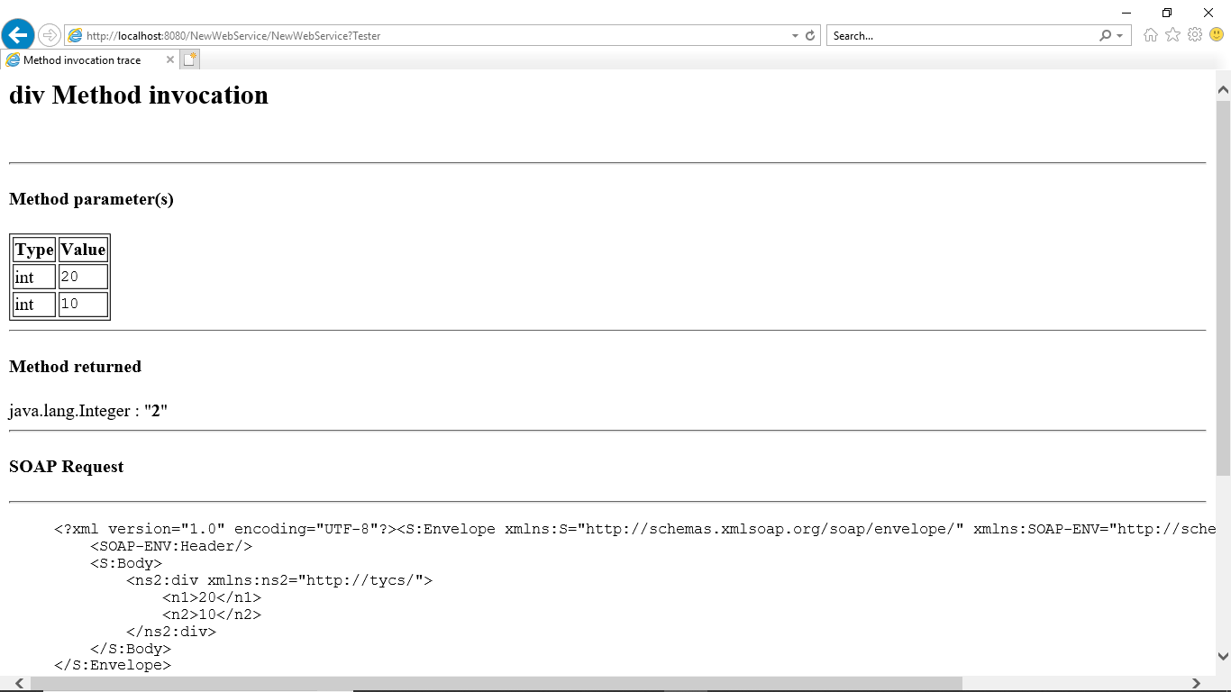

**To solve error of testing and deployment**

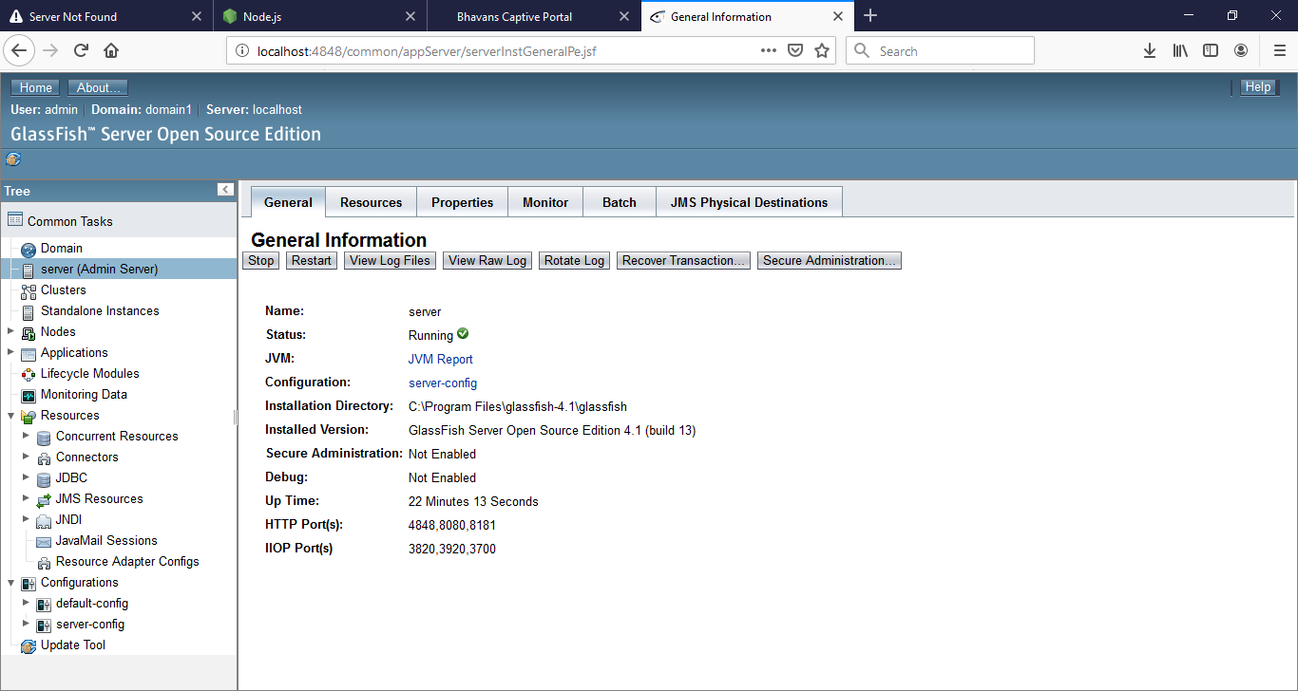

url: <http://localhost:4848/common/appServer/serverInstGeneralPe.jsf>

add

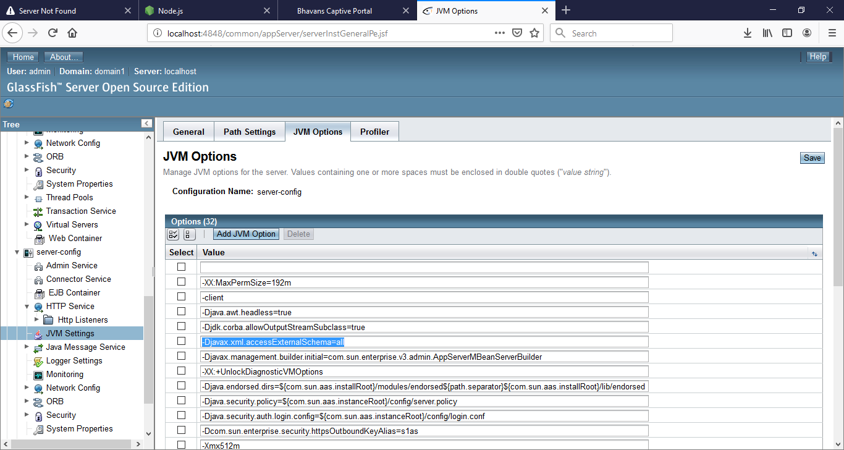

**Step5) Now Consuming The Web Service**

Create a new Web Application And add web service client

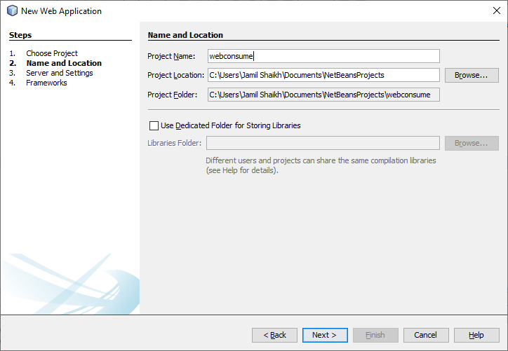

**Step 6) Adding web service client**

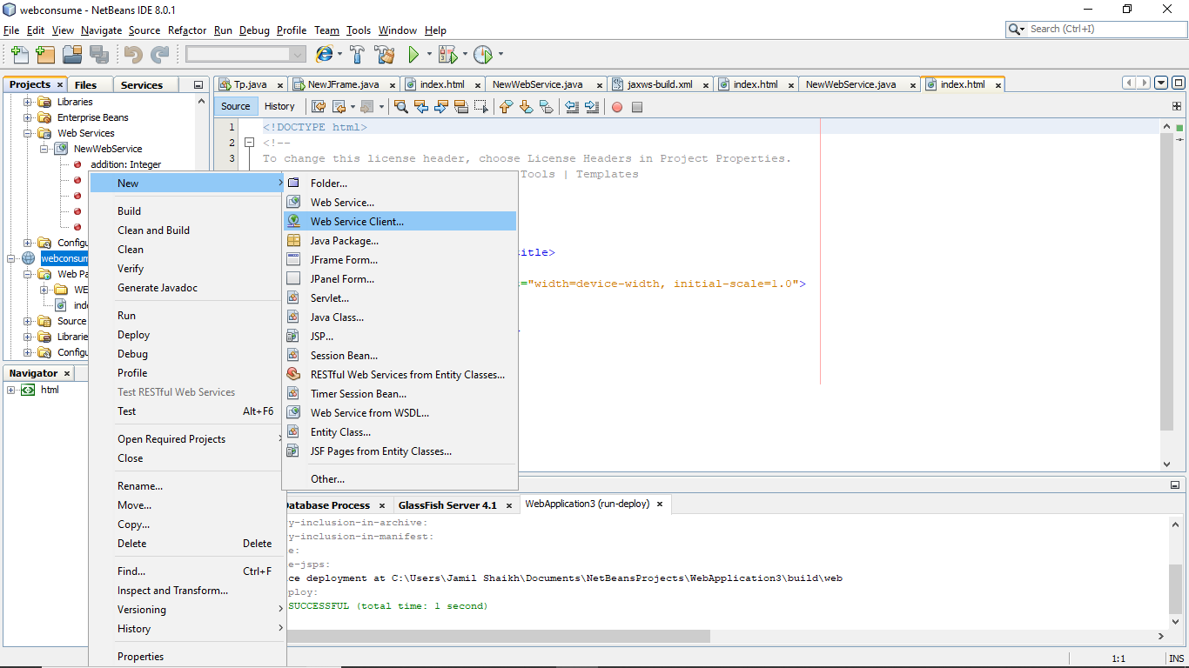

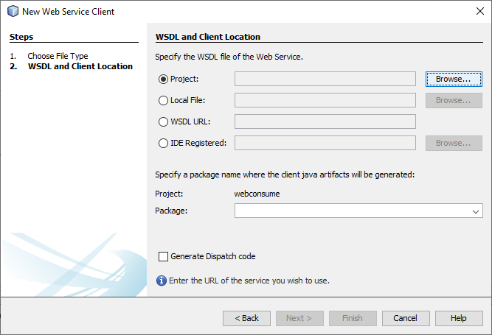

**Step 7) Browse the wsdl file and add into it :**

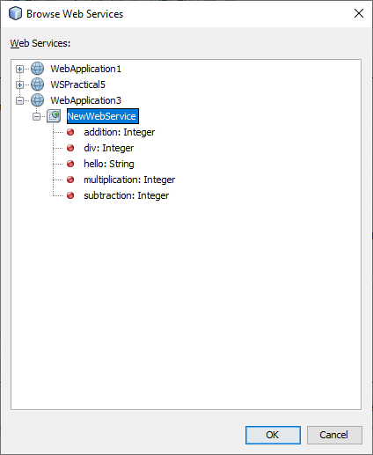

**Step 8) Now add servlet page into webconsume application:**

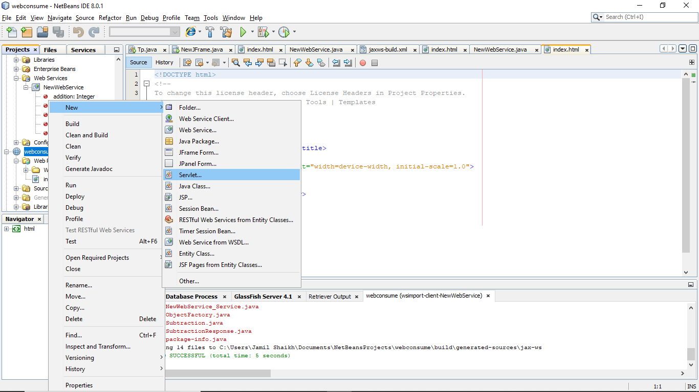

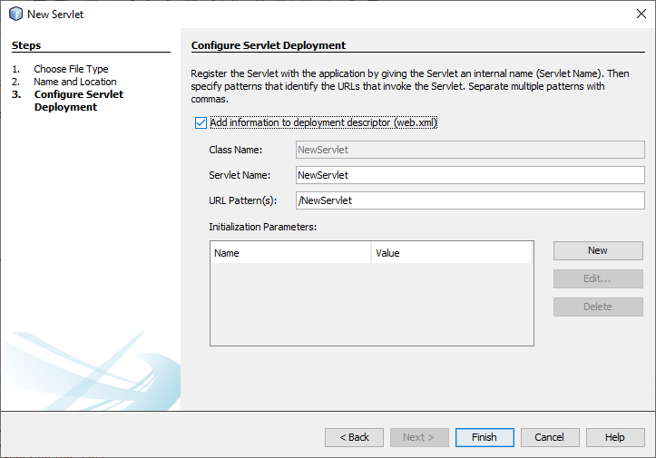

**Step 9) Inside the servlert Class do following things :**

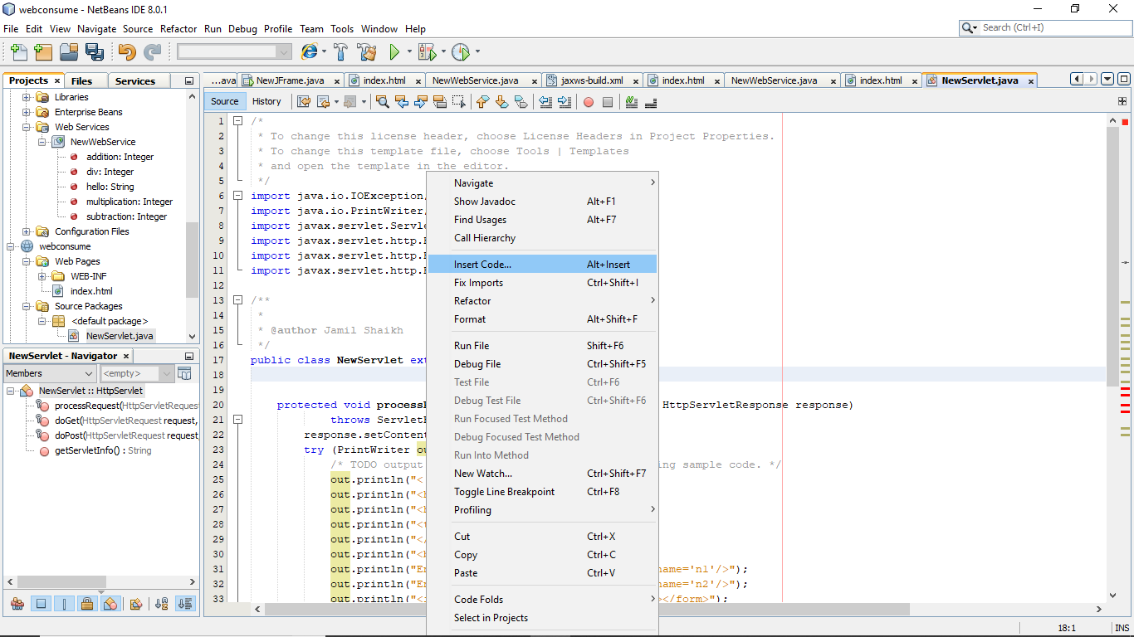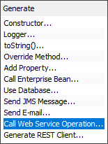

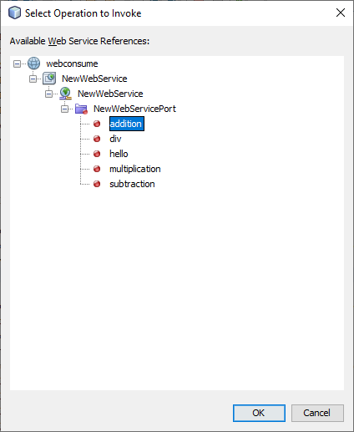

**Step 9) Add the following Code :**

**Index.html :**

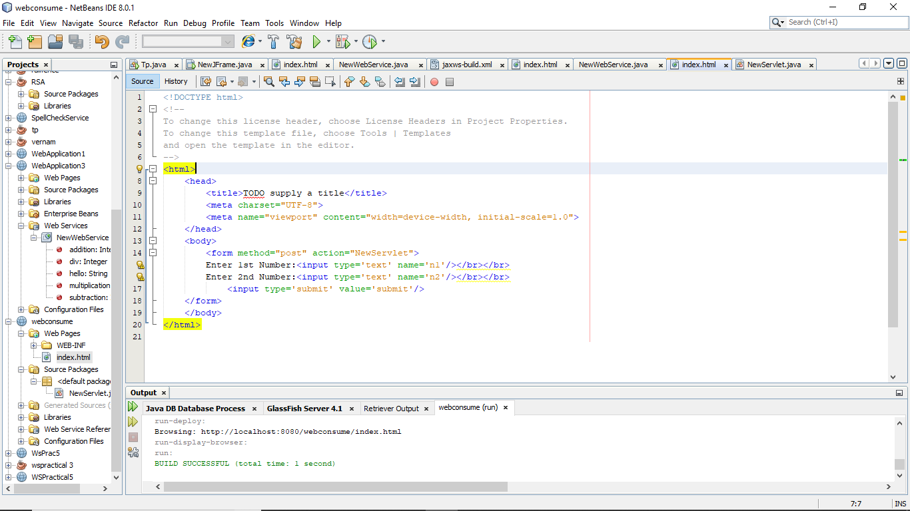

**Step 10) In servlet Page writhe the following code :**

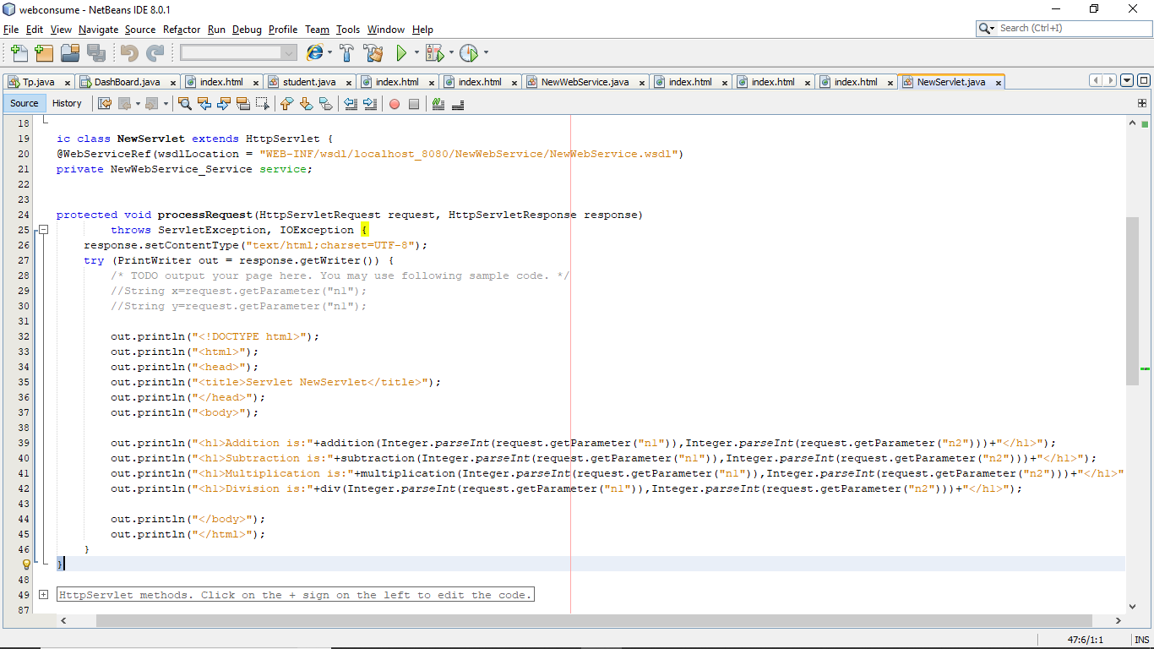

**Step 11) Run the Project :**

**OUTPUT:**

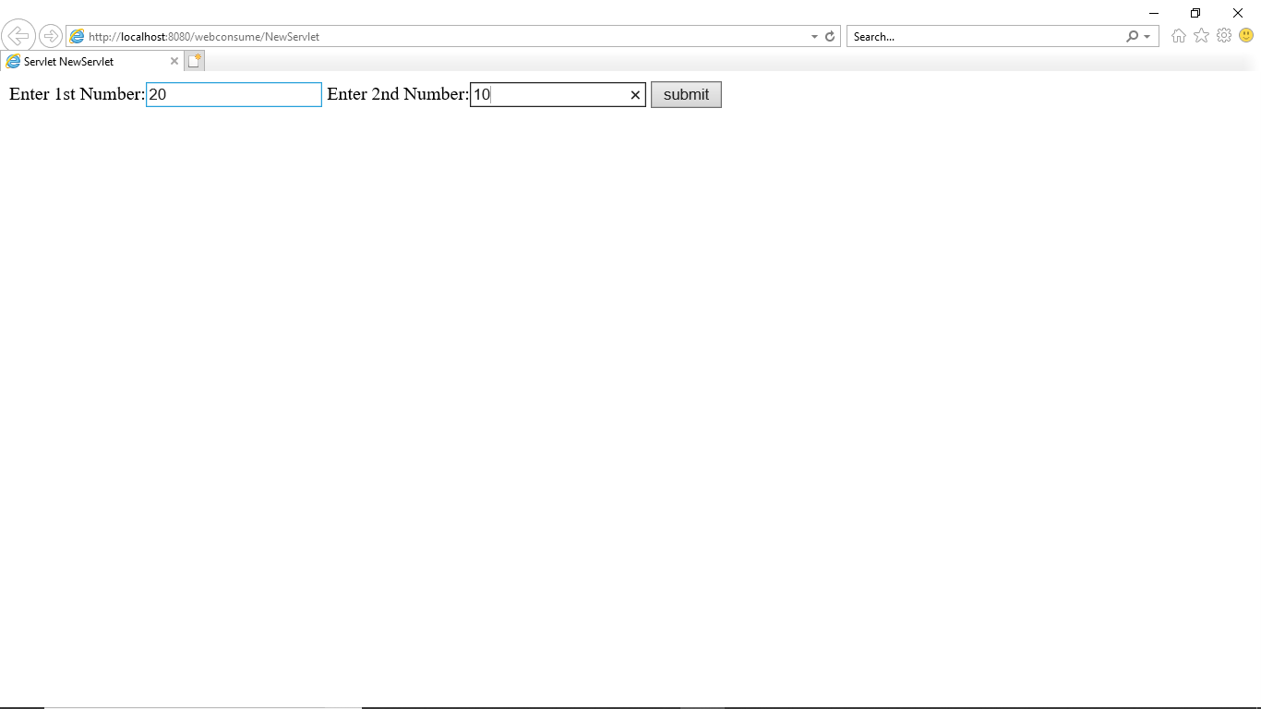

**OUTPUT:**

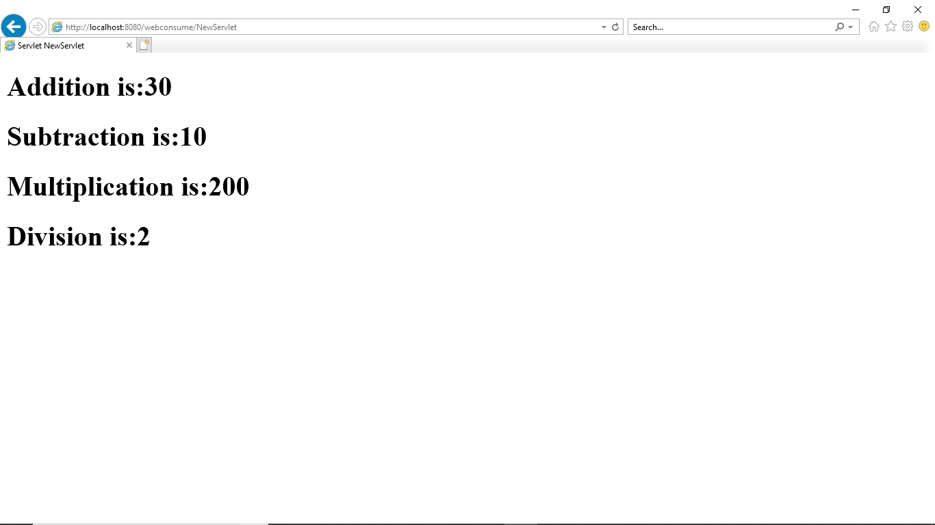

**PRACTICAL NO 6**

**Aim: Define a web service method that returns the contents of a database in a JSON string. The contents should be displayed in a tabular format**

**Step 1**: Create new project and select ASP.NET web Application.

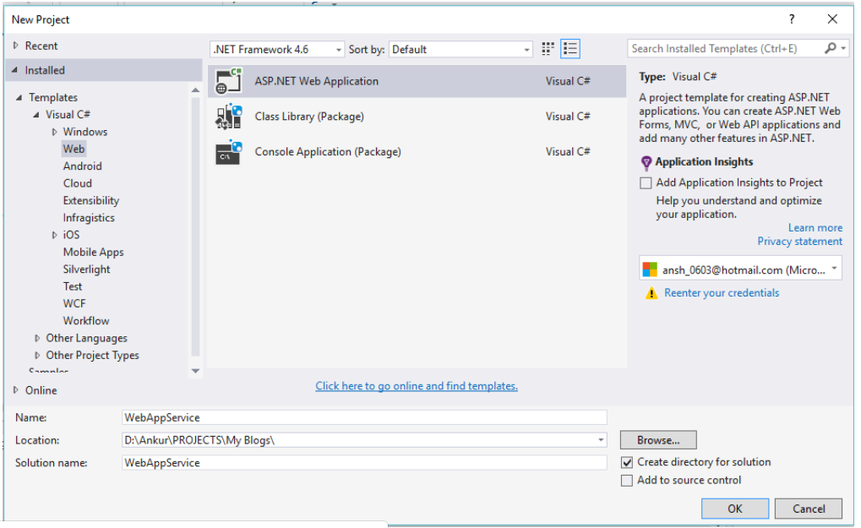

**Step 2:**Select **Empty**template and click **OK**.

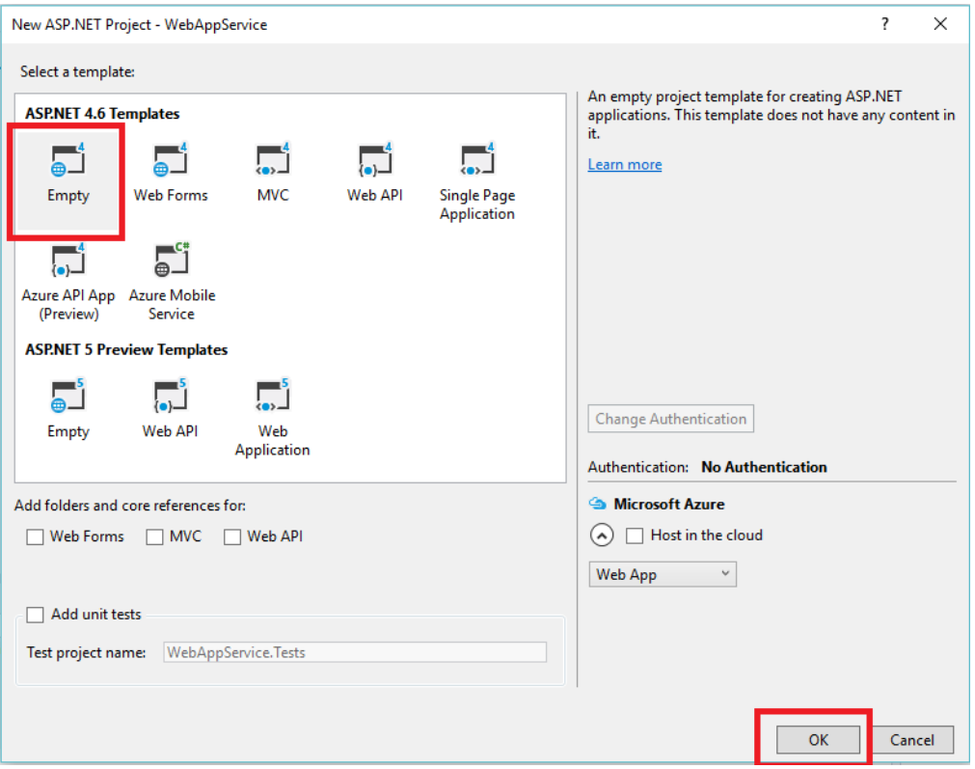

**Step 3:**Now add **Web Service** in project and give it name **webservice1.asmx**

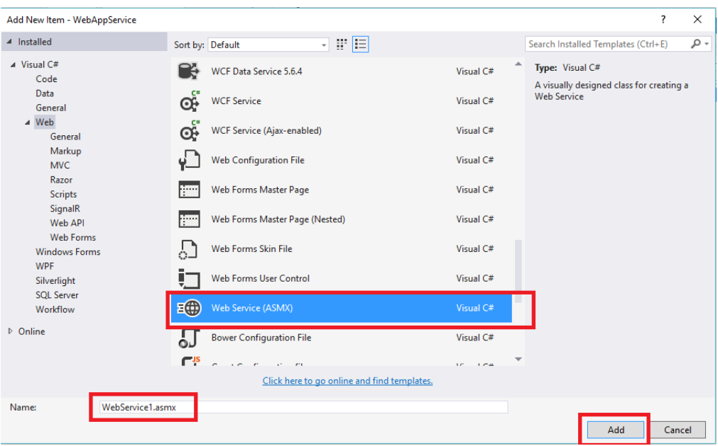

**Step 4:**Make sure you add the connection string in your web.config file as in the following screenshot,

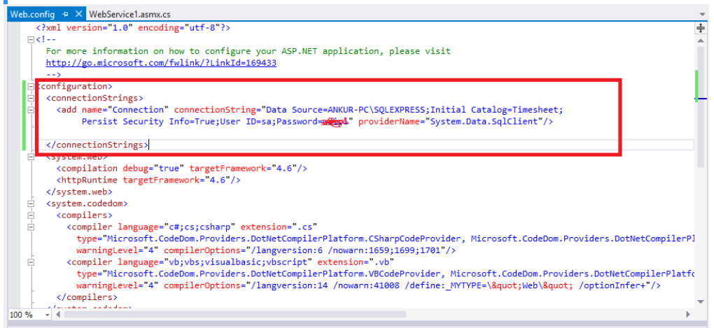

**Step 5:**Now add the references System.data, System.Data.SqlClient and System.configuration,

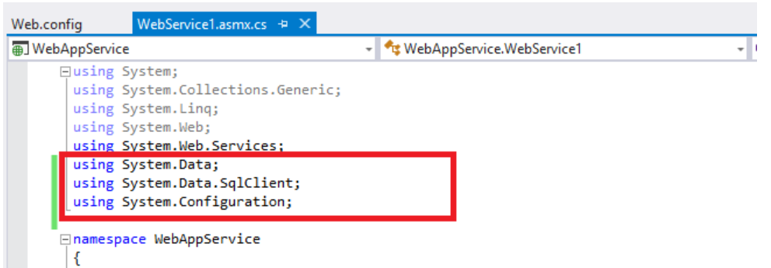

**Step 6**: Create Employee table and run the following script in your SQL query editor

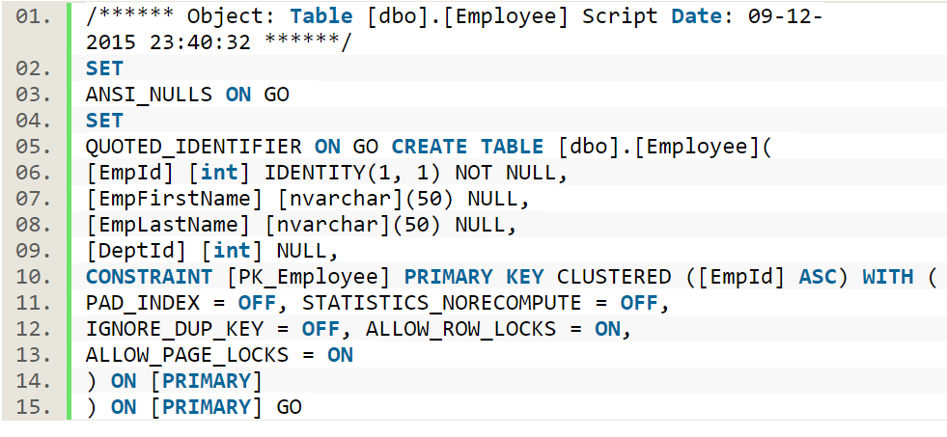

Now add the following method in your webservice1.asmx.cs file

[WebMethod]

public DataSet getEmp()

{

string sql = "SELECT [EmpId],[EmpFirstName],[EmpLastName],[DeptId] FROM Employee";

SqlDataAdapter da = new SqlDataAdapter(sql, ConfigurationManager.ConnectionStrings["Connection"].ToString());

DataSet ds = new DataSet();

da.Fill(ds);

return ds;

}

Write a SQL query, create a SqlDataAdapter object and pass the SQL query and connection string.

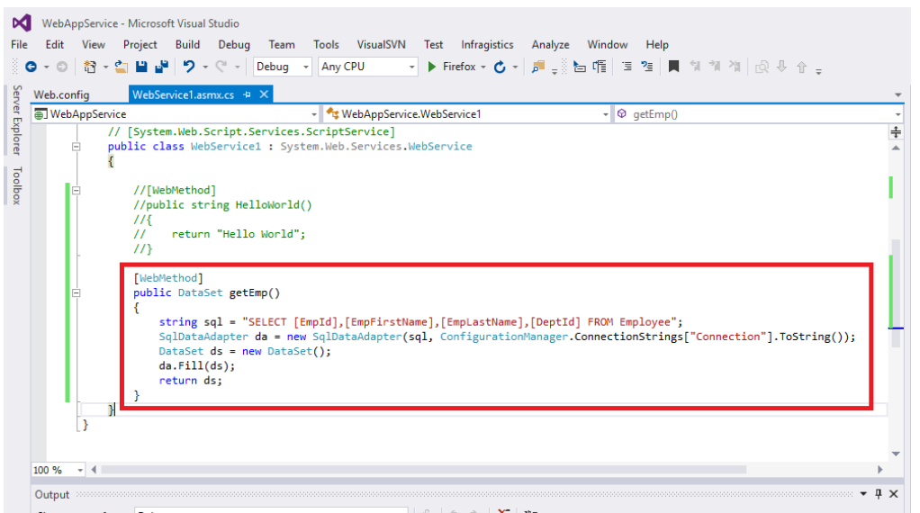

**Step 7**: Save and run the services  by clicking F5 and invoking **getEmp** method as in the following,

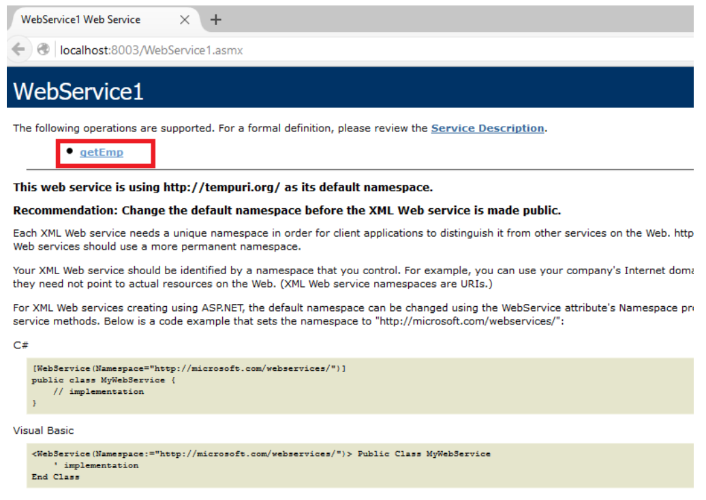

**Step 8 :** Click on **Invoke.**

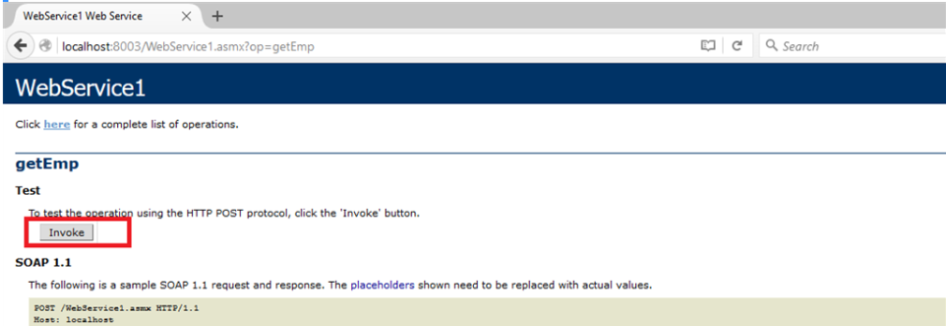

**Step 9**: It will return all the employees details in XML format.

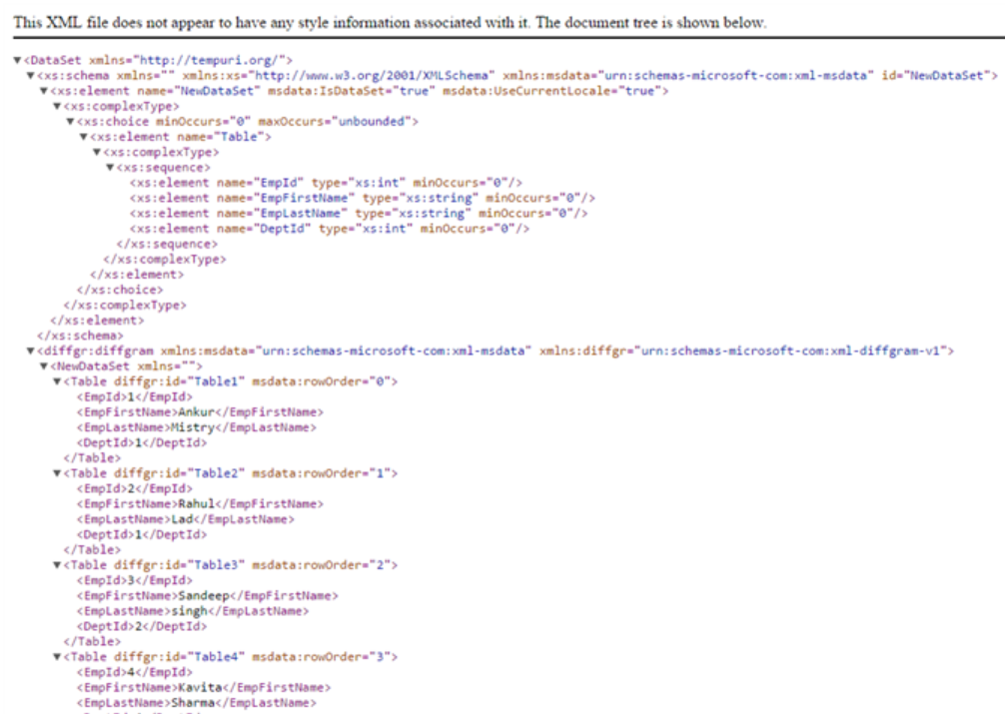

**Step 10**: Now for JSON return please add newtonsoft.json from the NuGet Manager. Go to Tools, then NuGet Package Manager and click on Package Manager console.

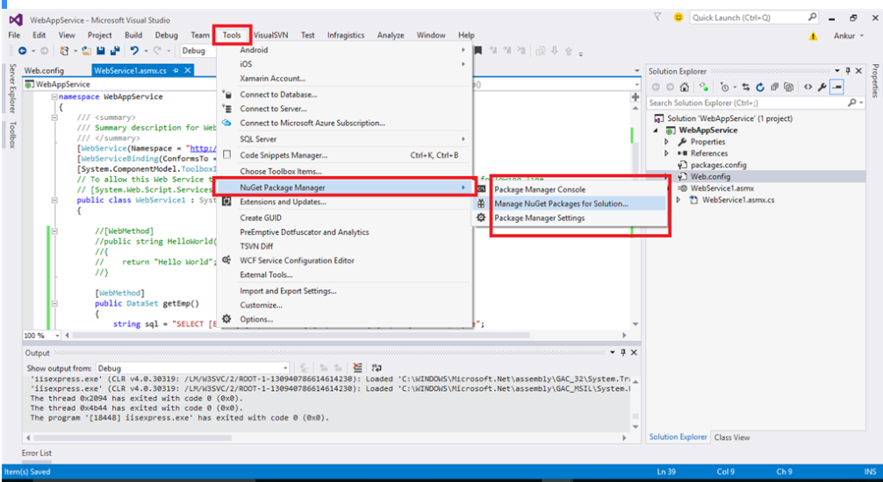

**Step 11**: Write PM> Install-Package Newtonsoft.Json. It will add the reference Newtonsoft.Json in our project.

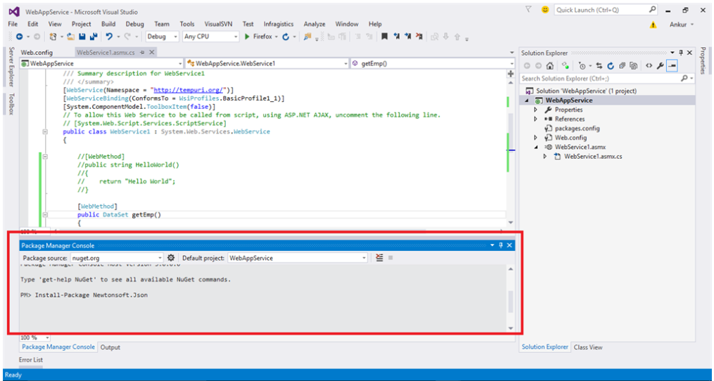

**Step 12**: It will display Success message as per the following screen, once you install the package.

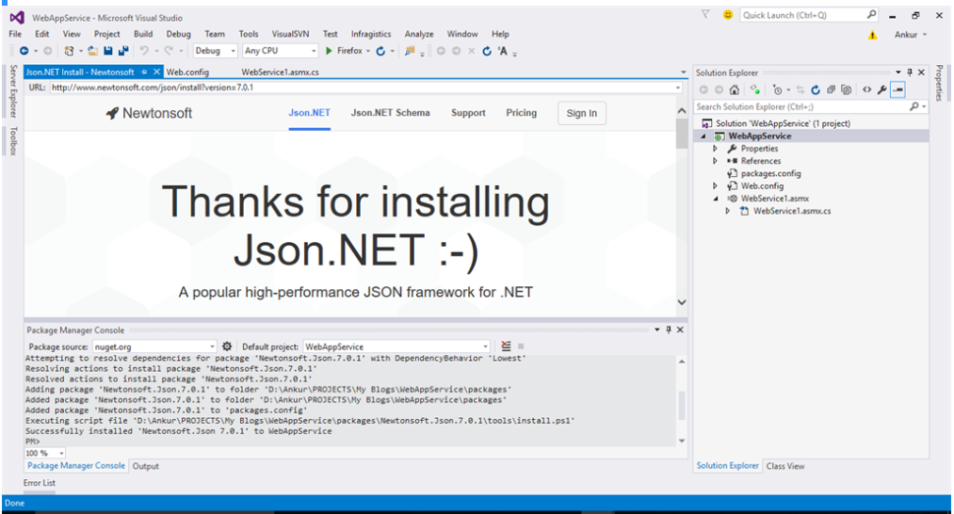

**Step 13**: Now add the reference **Newtonsoft.Json** in your code.

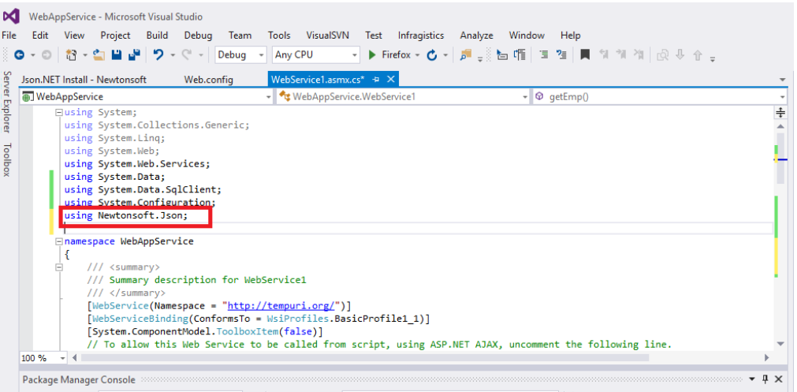

**Step 14**: Create the method '**getEmployee**' same as above method '**getEmp'**. The only difference here is we use jsonConvert.SerializateIbject to **serialize**the data.

[WebMethod]

public string getEmployee()

{

string sql = "SELECT [EmpId],[EmpFirstName],[EmpLastName],[DeptId] FROM Employee";

SqlDataAdapter da = new SqlDataAdapter(sql, ConfigurationManager.ConnectionStrings["Connection"].ToString());

DataSet ds = new DataSet();

da.Fill(ds);

return JsonConvert.SerializeObject(ds, Newtonsoft.Json.Formatting.Indented);

}

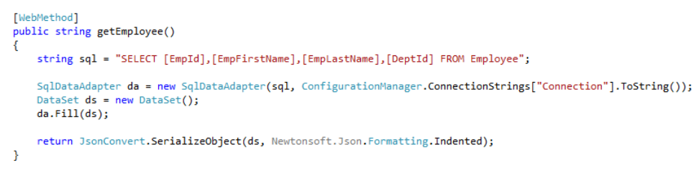

**Step 15**: Now run the service and invoke **getEmployee** method.

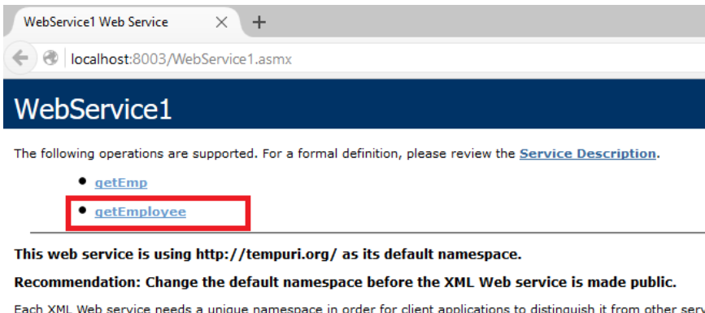

**Step 16**: It will return the same data but in JSON format.

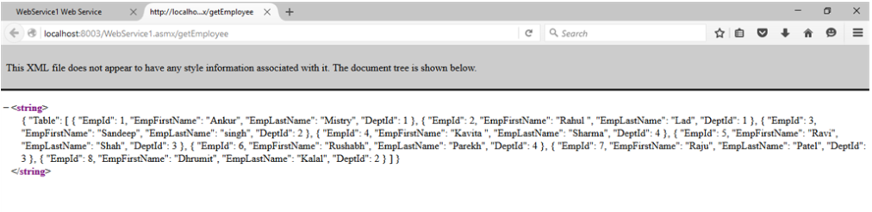

PRACTICAL NO 7

**Q.)Define a RESTful web service that accepts the details to be stored in a database and performs CRUD operation.**

**Step 1) Create a new WebApplication in NetBeans :**

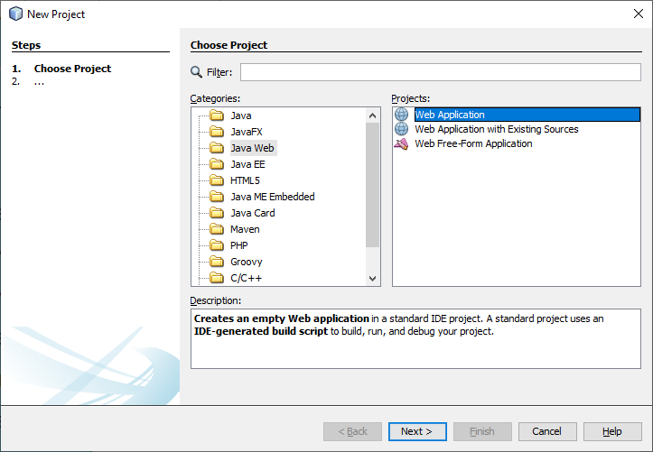

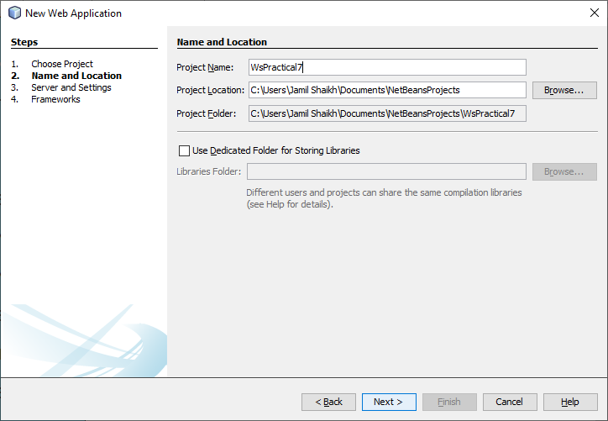

**Step2) Add Entity Class By right Click on Project WebApplication**

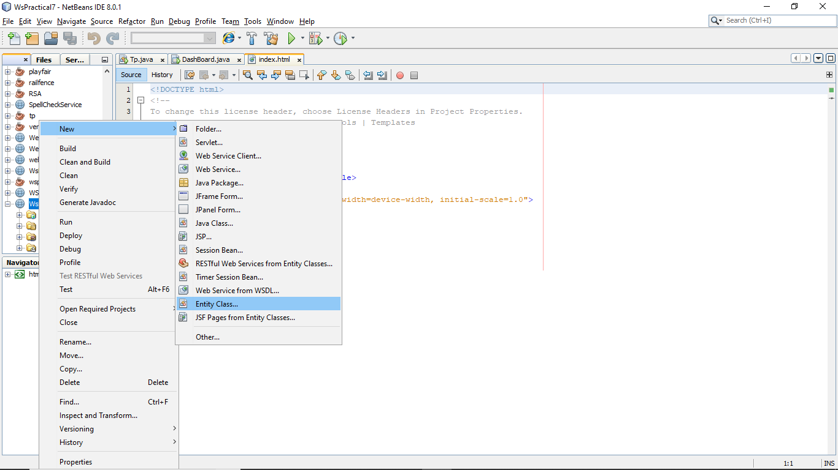

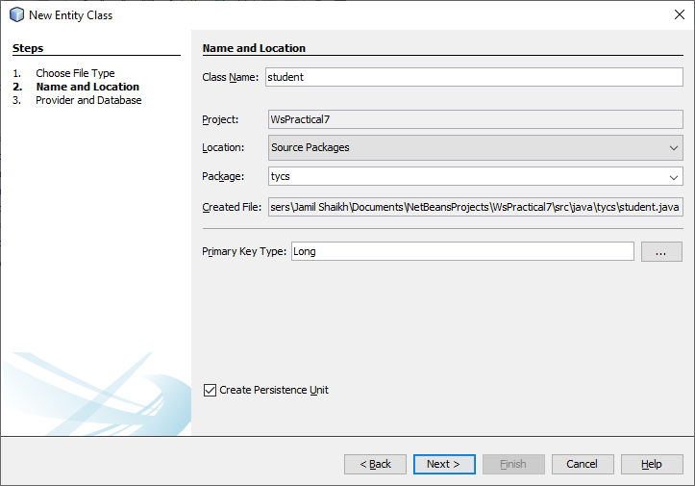

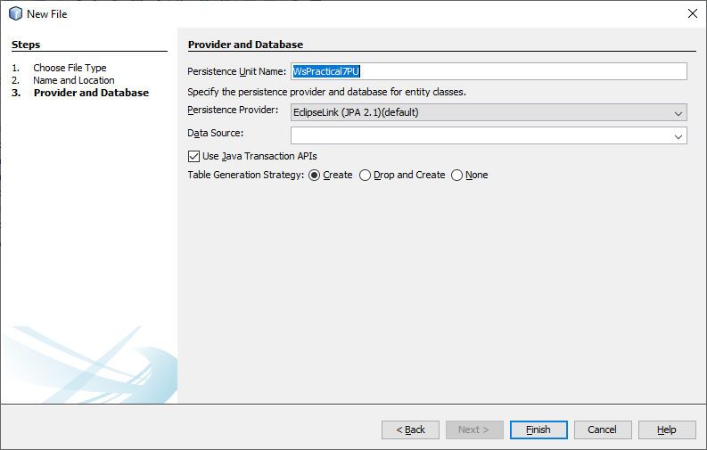

**You will see this screen :**

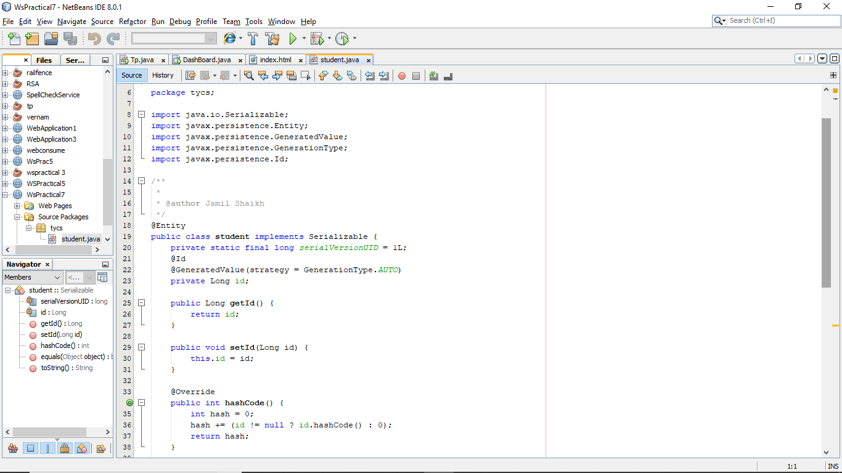

**Step 3) Add property inside the entity class :**

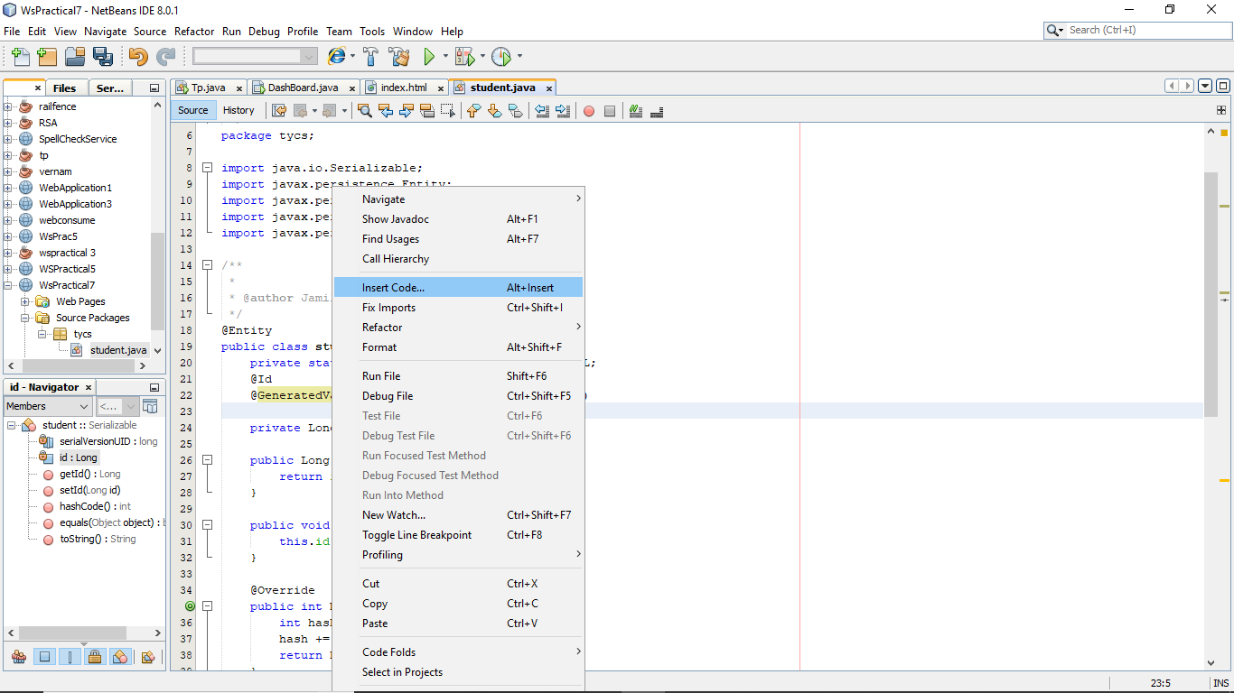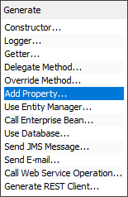

**Create a method sname in add property**

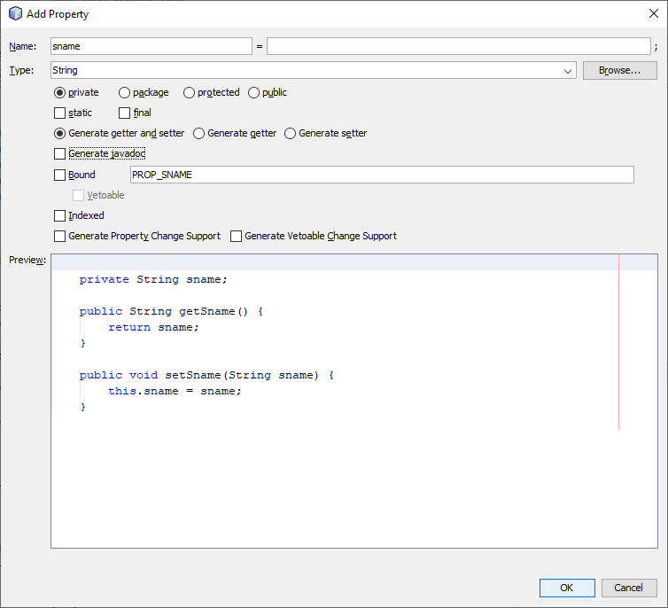

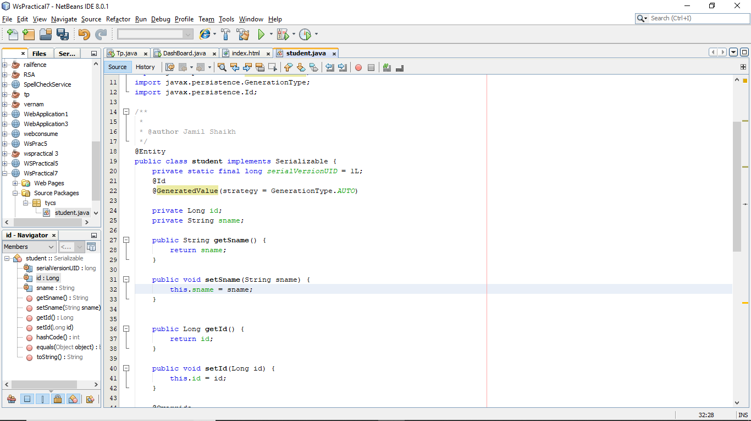

**Step 4) Add jsp pages from entity class by right clicking on WebApplication Project :**

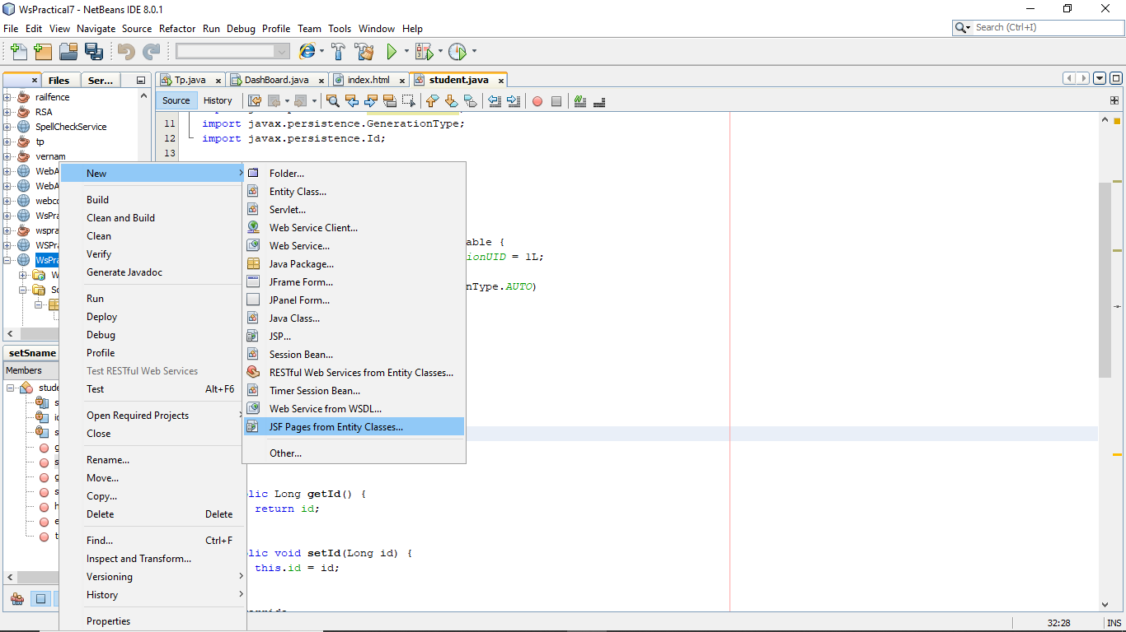

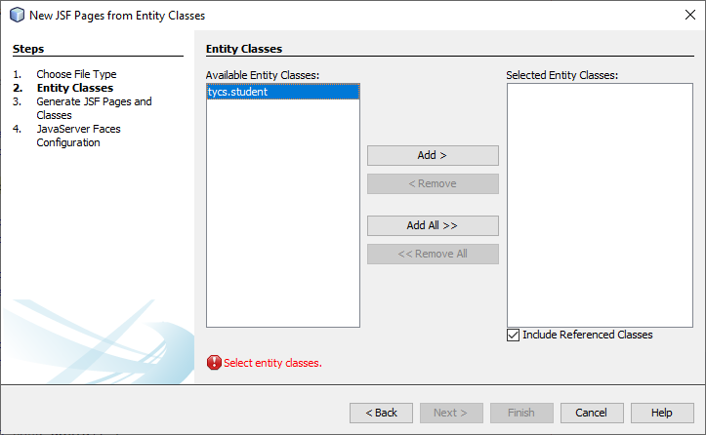

**Step 5) Select entity Class and Add you will see :**

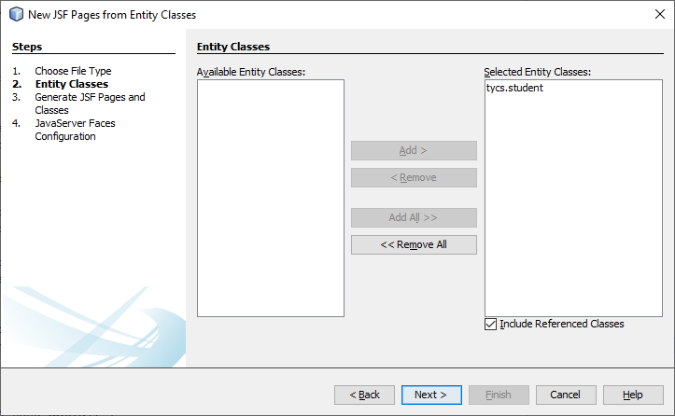

**Step 6) Add RestFull web service from client by right clicking on WebApplication Project :**

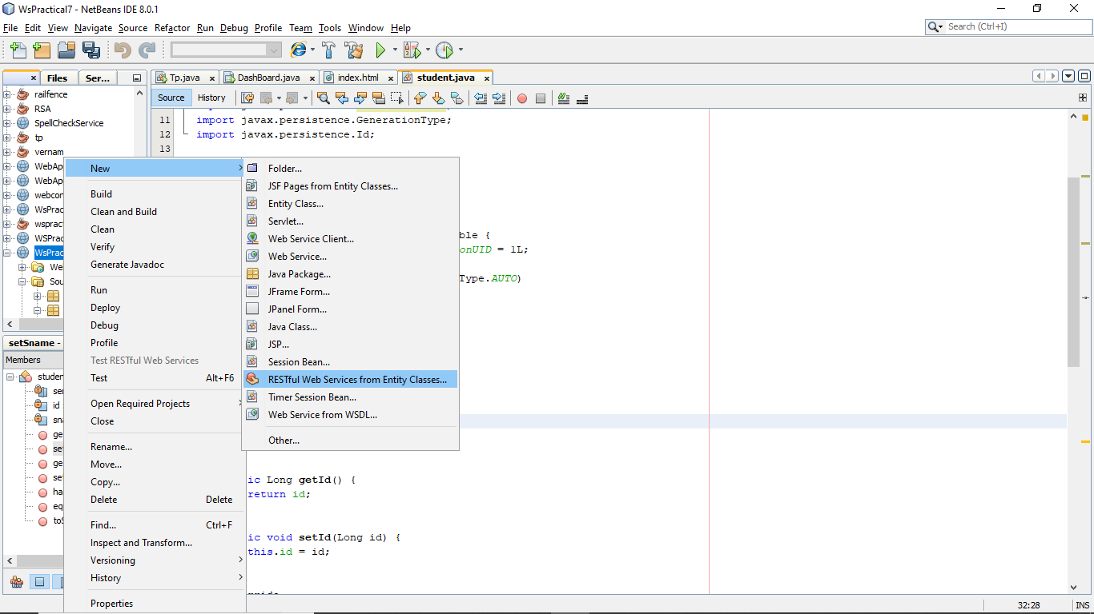



**Step 7) Select entity Class and Add you will see :**



**Step 8) First clean and build the project then deploy and then run**

**OUTPUT:**

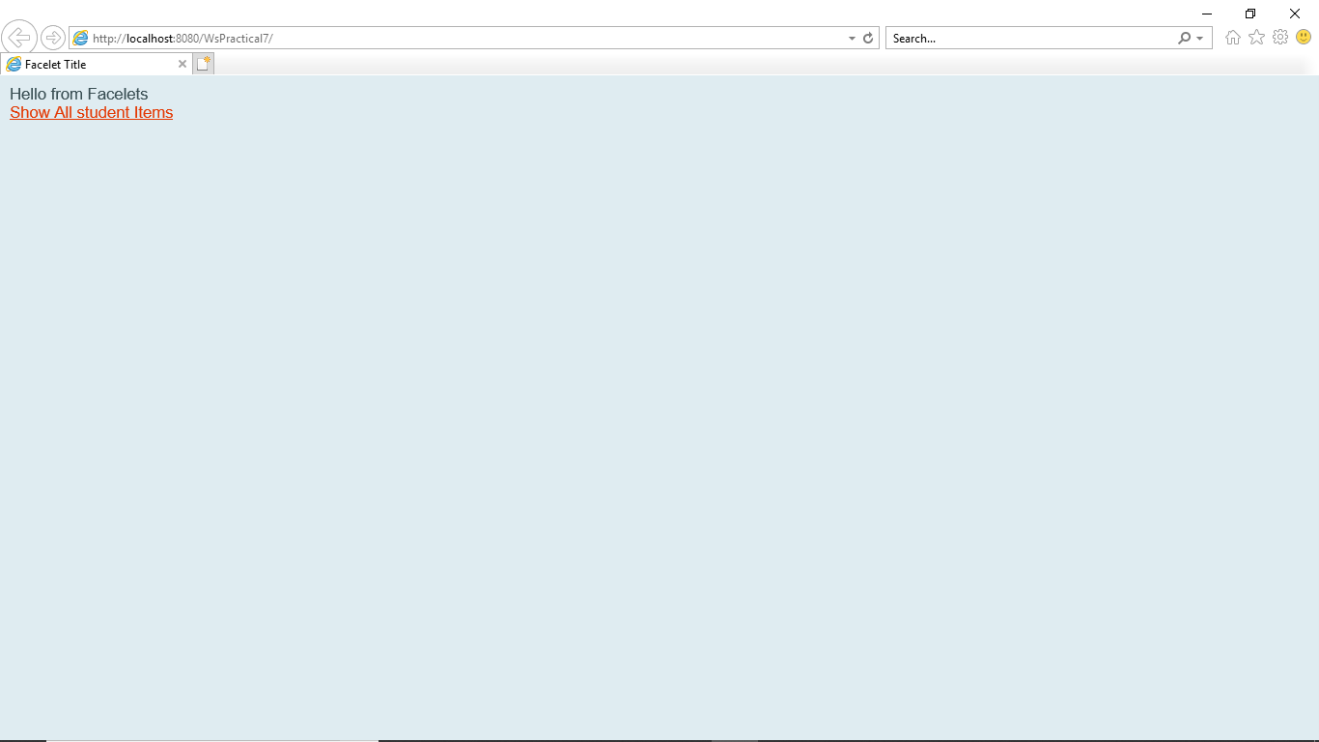

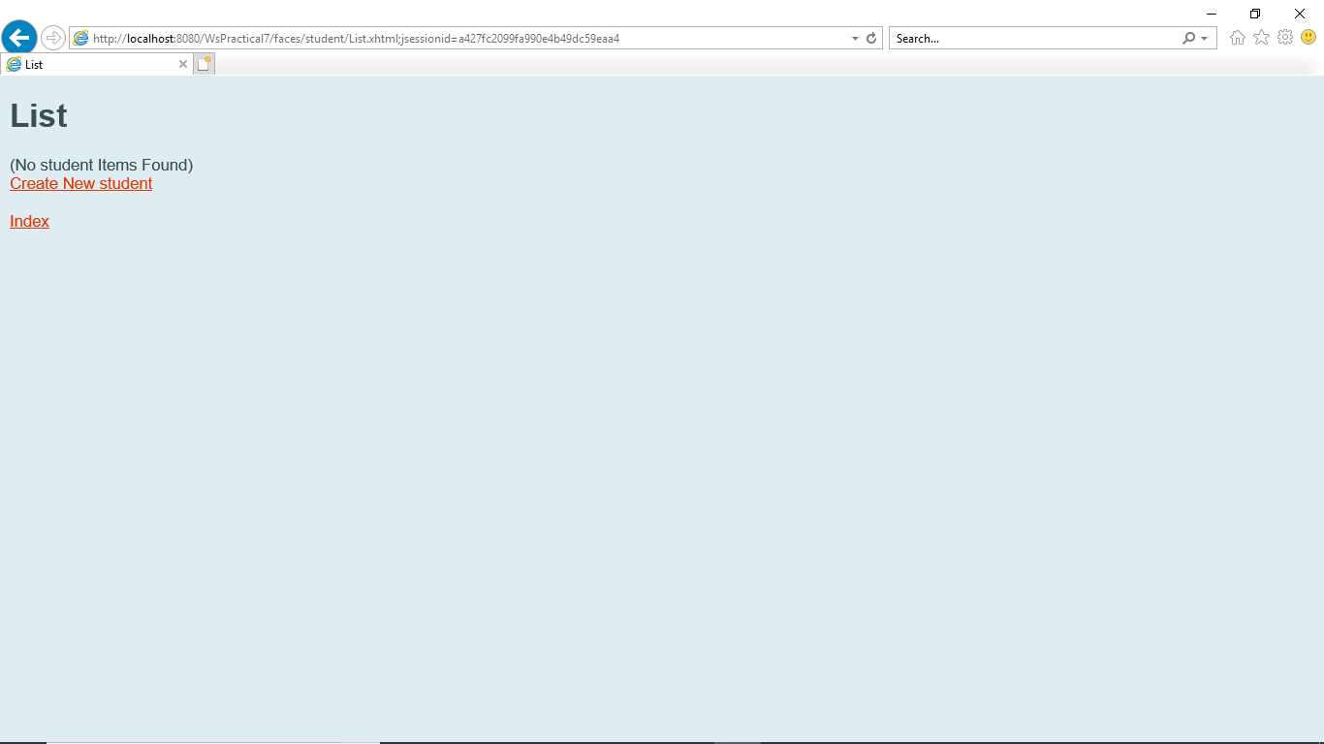

**Insert :**

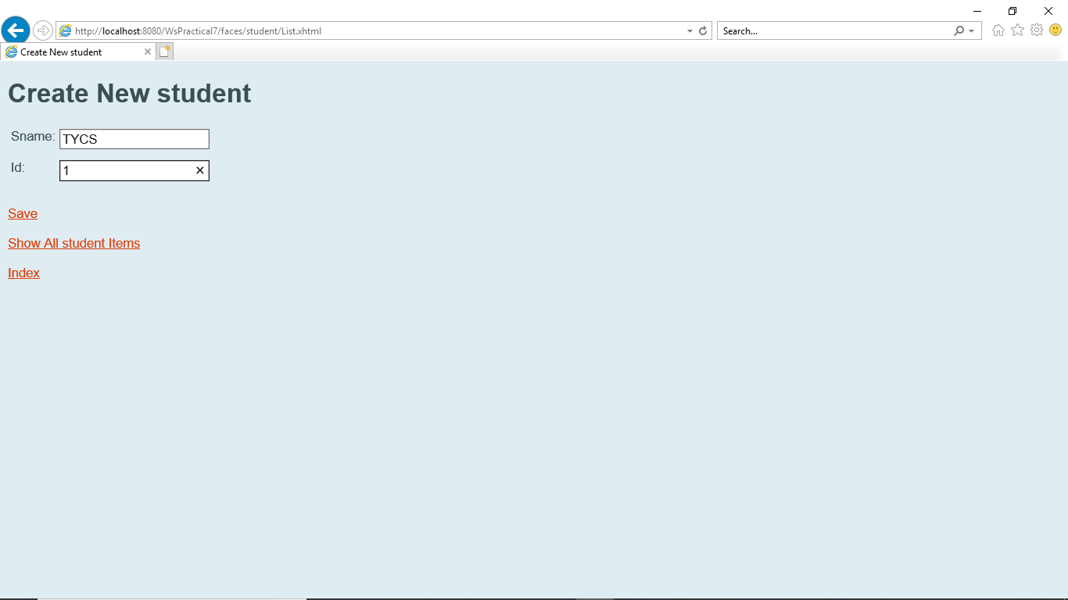

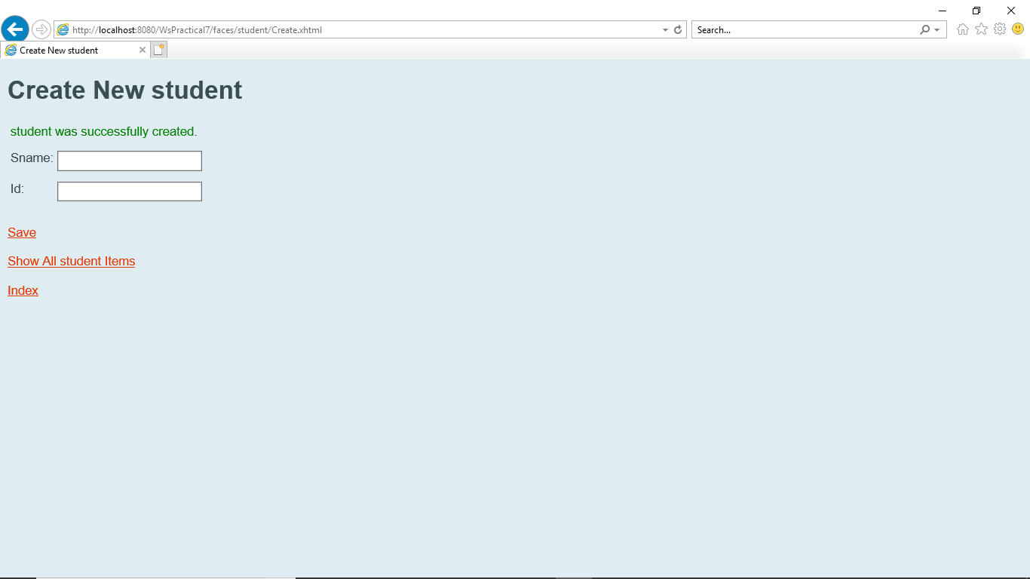

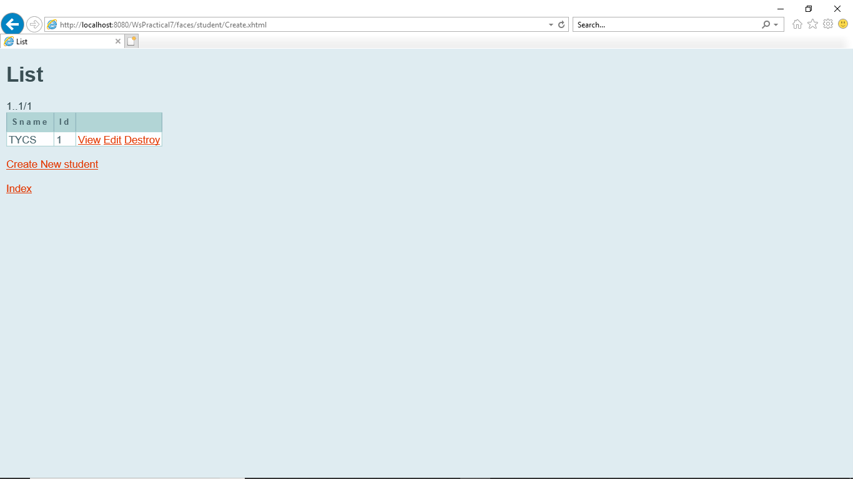

**Edit the Details :**

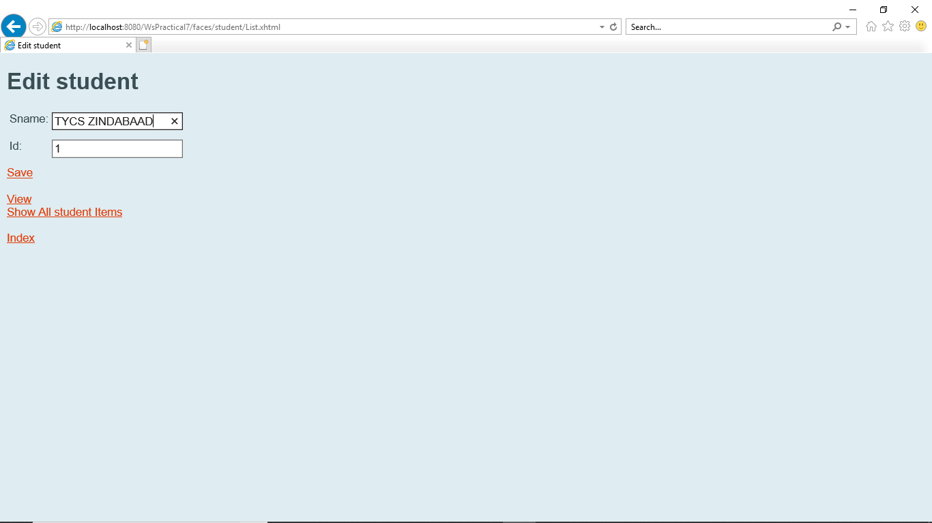

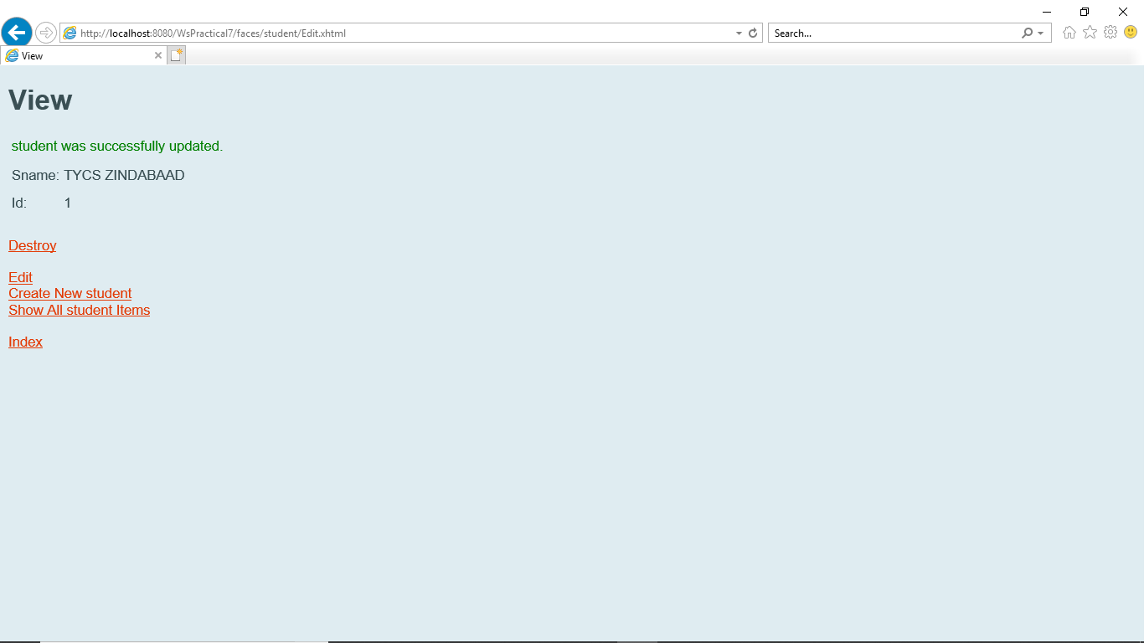

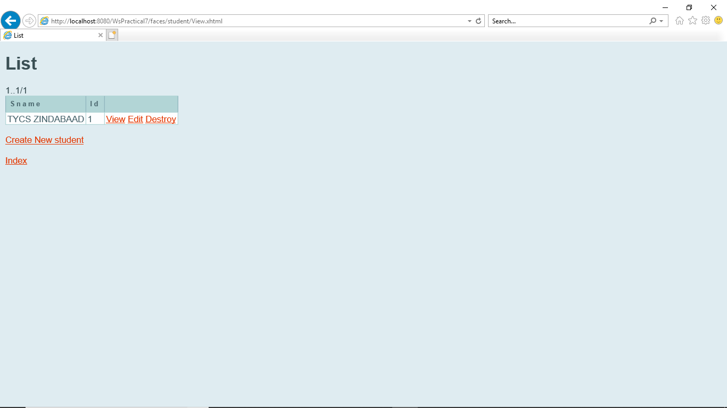

**Destroy :**

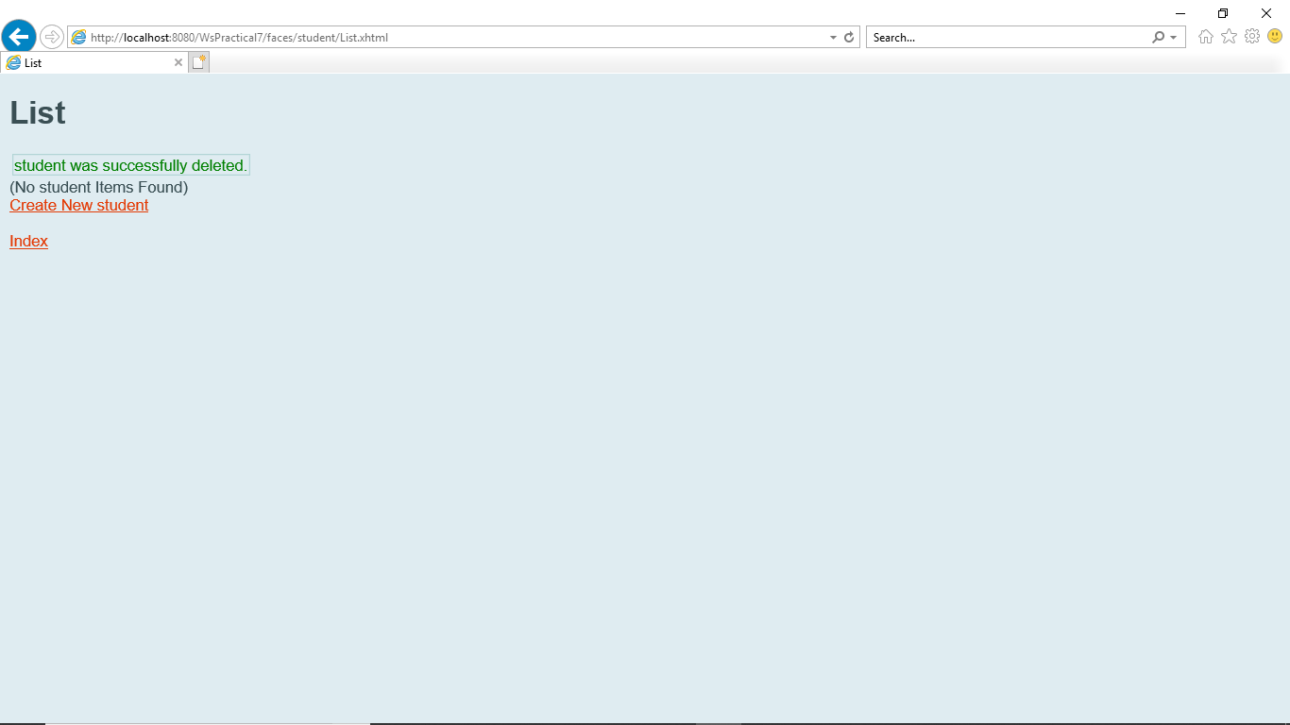

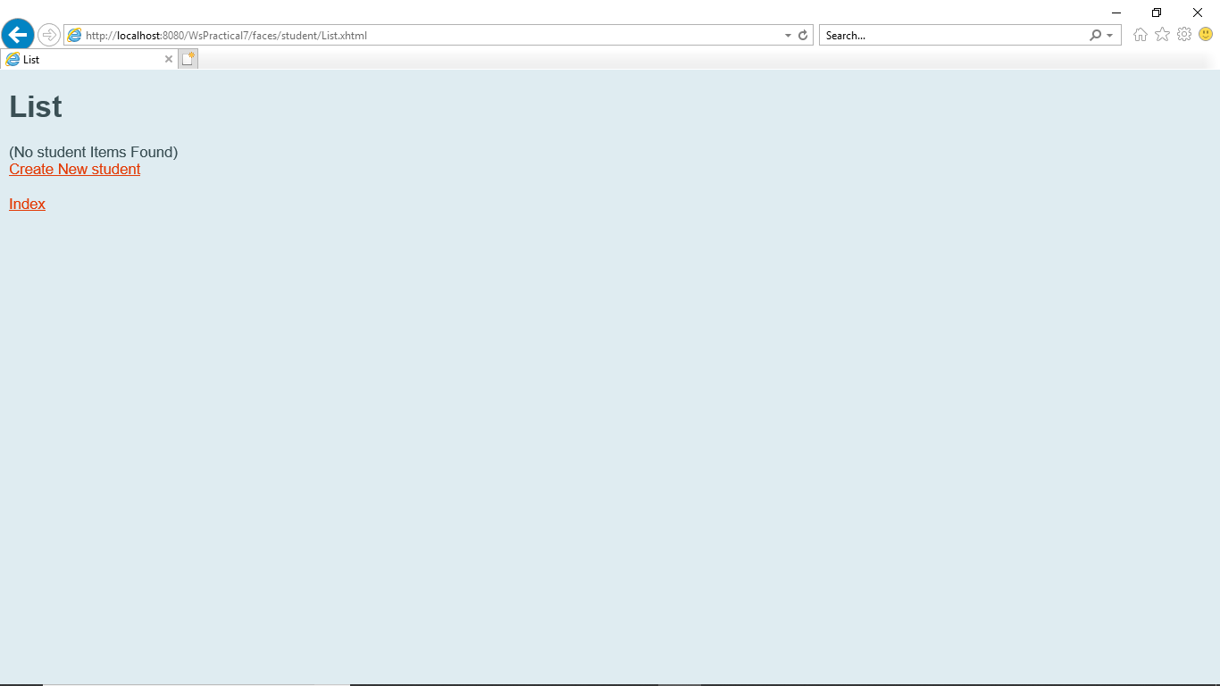

PRACTICAL NO 8

**Q.) Implement a typical service and a typical client using WCF.**

**Step 1) Create WCF Service**

File Menu > click New Project… > select Class Library – CalculatorService > click OK

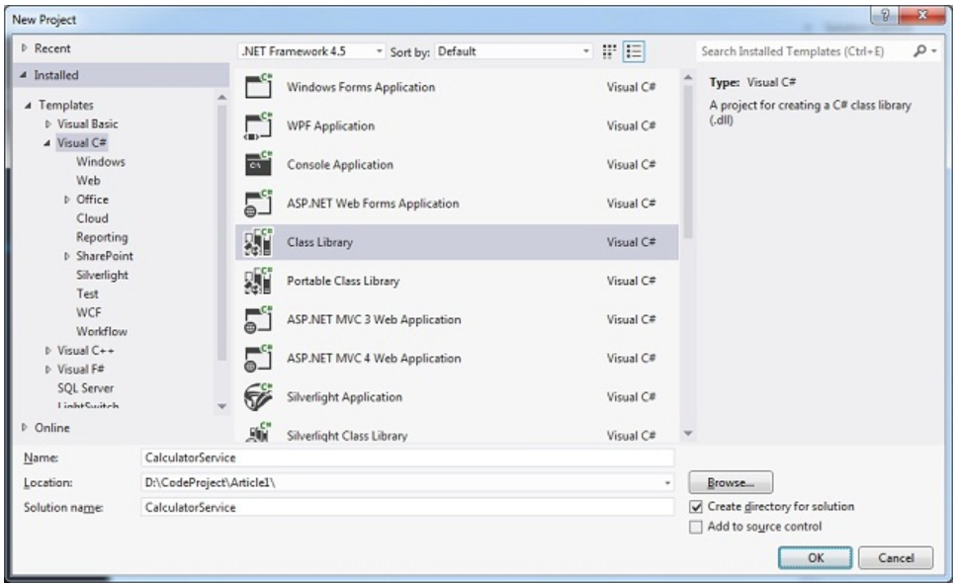

Delete the class - *Class1.cs* file that is auto-generated.

Right-click on CalculatorService project > Add > click New Item > select WCF Service > provide Name as CalculatorService > click Add button:

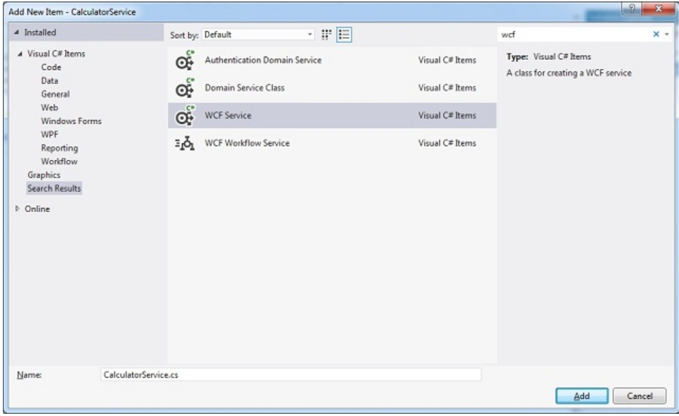

This will add the required assembly references (like, System.ServiceModel) along with a Service Contract Interface – *ICalculatorService.cs* and Service class – *CalculatorService.cs*

Modify *ICalculatorService.cs* as follows:

using System.ServiceModel;

namespace CalculatorService

{

[ServiceContract]

public interface ICalculatorService

{

[OperationContract]

int Add(int num1, int num2);

}

}

Modify *CalculatorService.cs* as follows:

namespace CalculatorService

{

public class CalculatorService : ICalculatorService

{

public int Add(int num1, int num2)

{

return num1 + num2;

}

}}

Build the solution by pressing [CTRL]+[SHIFT]+b or go to BUILD menu > click Build Solution option.

**Step 2: Host WCF Service in IIS**

Add a new web site to host Calculator Service in IIS.

Go to File Menu > Add > click New Web Site… > select WCF Service > provide a suitable name – CalculatorServiceIISHost > click OK:

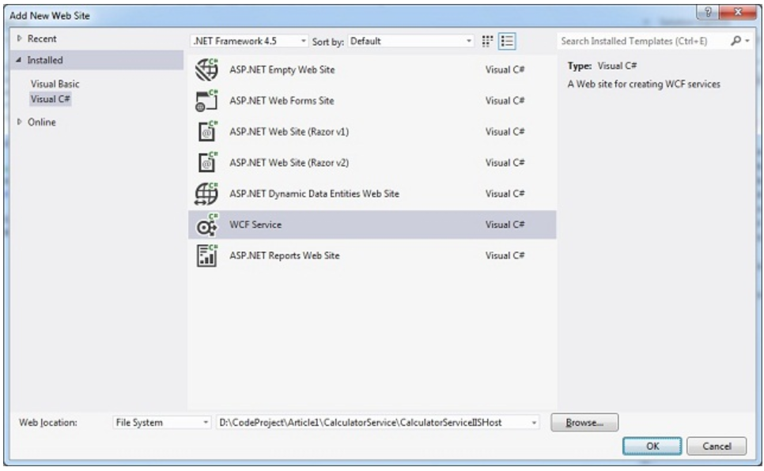

A new web site will be added with a service class - Service.cs and an interface - *IService.cs* within App_Code folder along with a *Service.svc* file. Since the service is already created, delete the auto created service class (Service.cs) and the interface (IService.cs) from App_Code folder.

Right-click on CalculatorServiceIISHost project > click Add Reference > select CalculatorService > click OK:

Open *Service.svc* file > Delete CodeBehind property:

<%@ ServiceHost Language="C#" Debug="true" Service="Service" CodeBehind="~/App_Code/Service.cs" %>

Modify Service property as shown below:

<%@ ServiceHost Language="C#" Debug="true" Service="CalculatorService.CalculatorService" %>

Modify *web.config* file to have the following settings:

<system.serviceModel>

<services>

<service name="CalculatorService.CalculatorService"

behaviorConfiguration="mex">

<endpoint address="CalculatorService" binding="basicHttpBinding"

contract="CalculatorService.ICalculatorService"></endpoint>

<host>

<baseAddresses>

<add baseAddress="http://localhost:8080/"/>

</baseAddresses></host>

</service>

</services>

<behaviors>

<serviceBehaviors>

<behavior name="mex">

<serviceMetadata httpGetBinding="true"/>

</behavior>

</serviceBehaviors>

</behaviors>

</system.serviceModel>

Now the service is ready to be hosted in IIS.

Open IIS > right-click on Default Web Site > click Add Application… > enter Alias name – calculator > select the Physical path of the service > click OK:

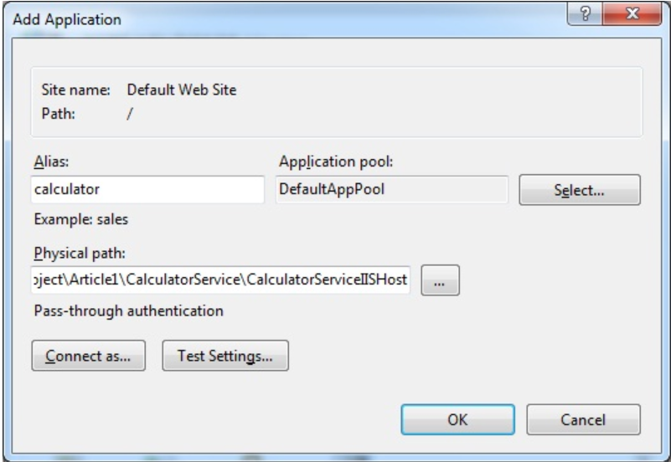

Enable Anonymous Authentication as shown below

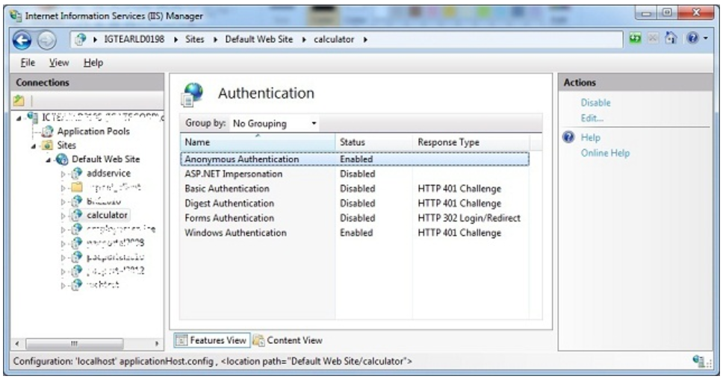

Go to Content View > right-click *Service.svc* > click Browse:

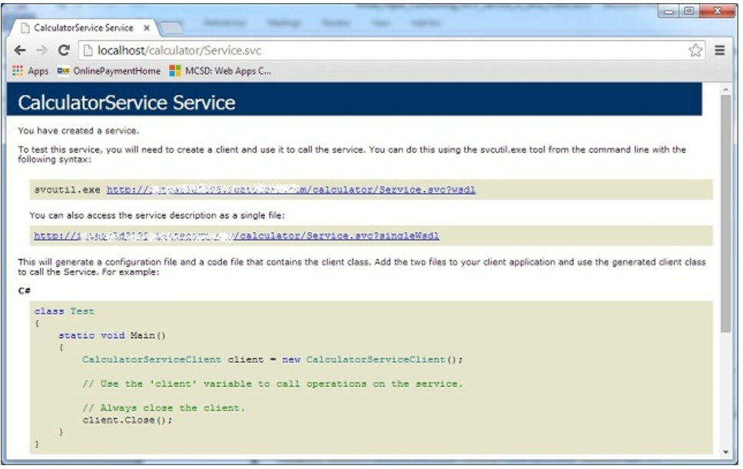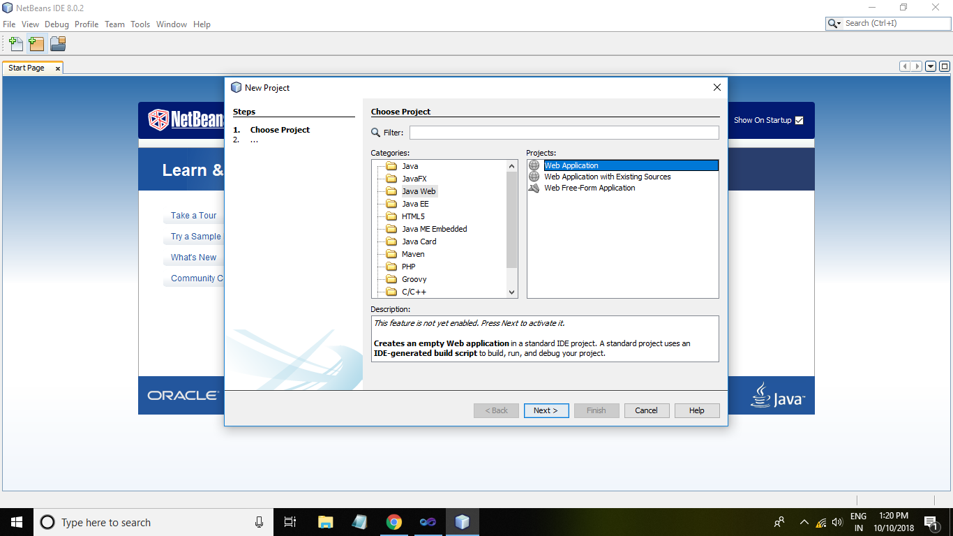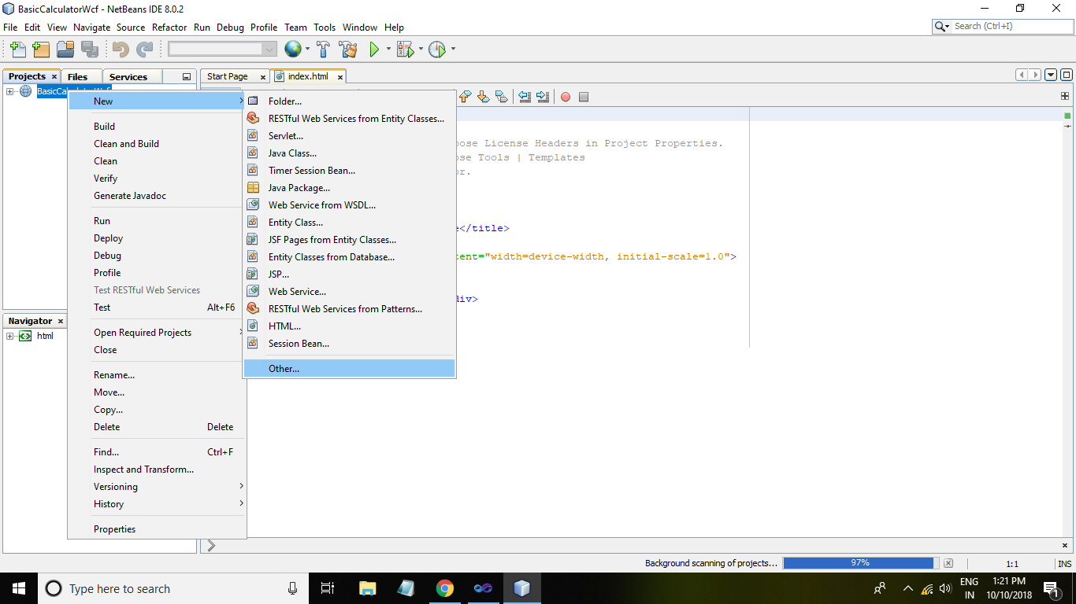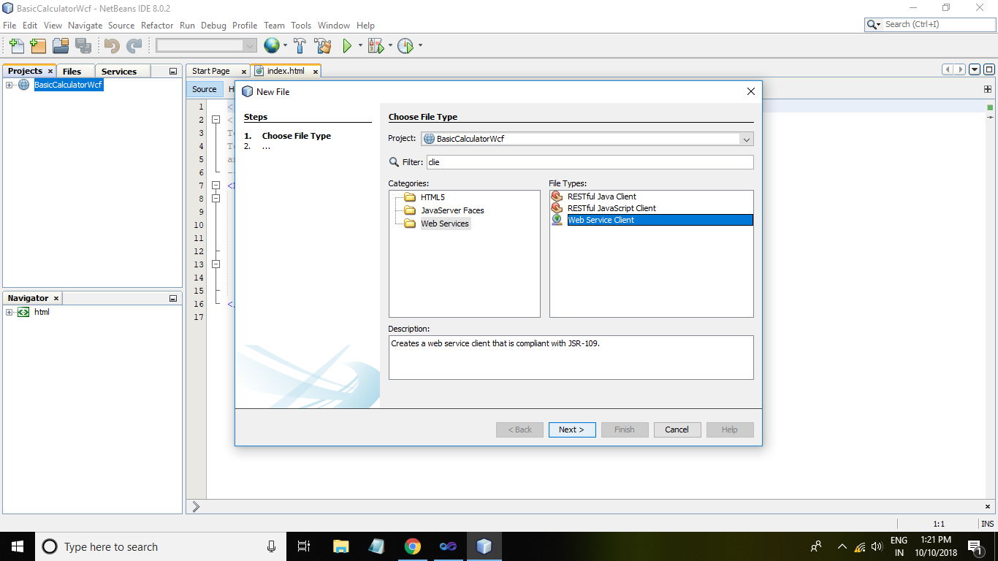

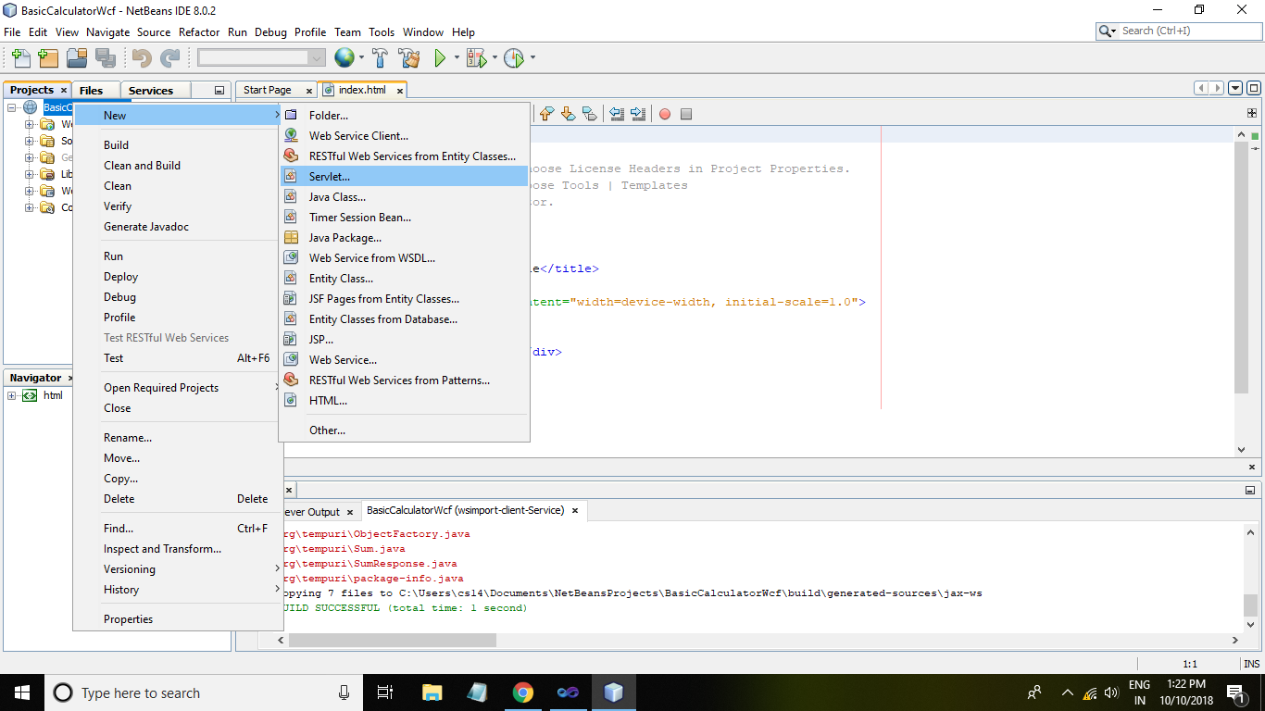

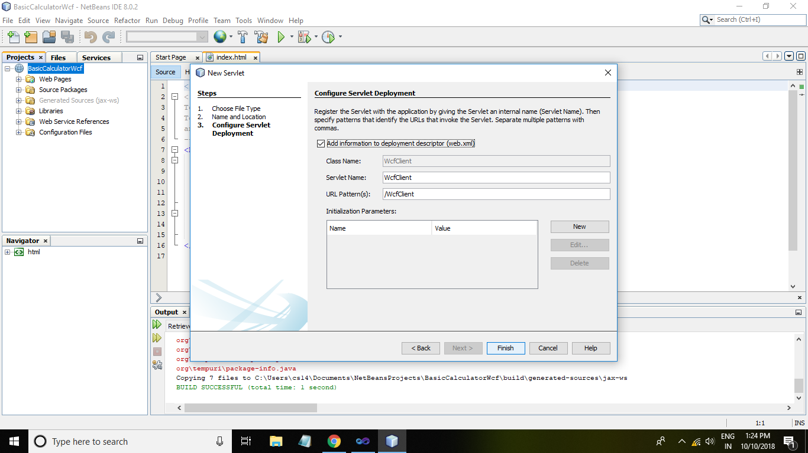

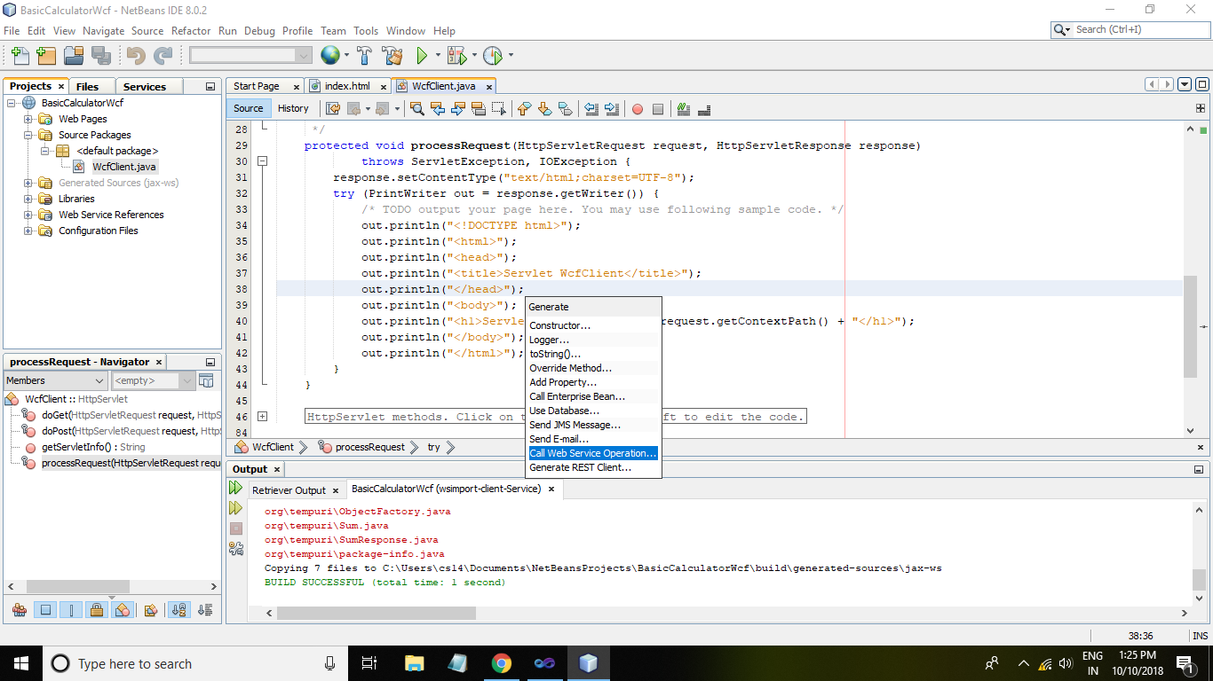

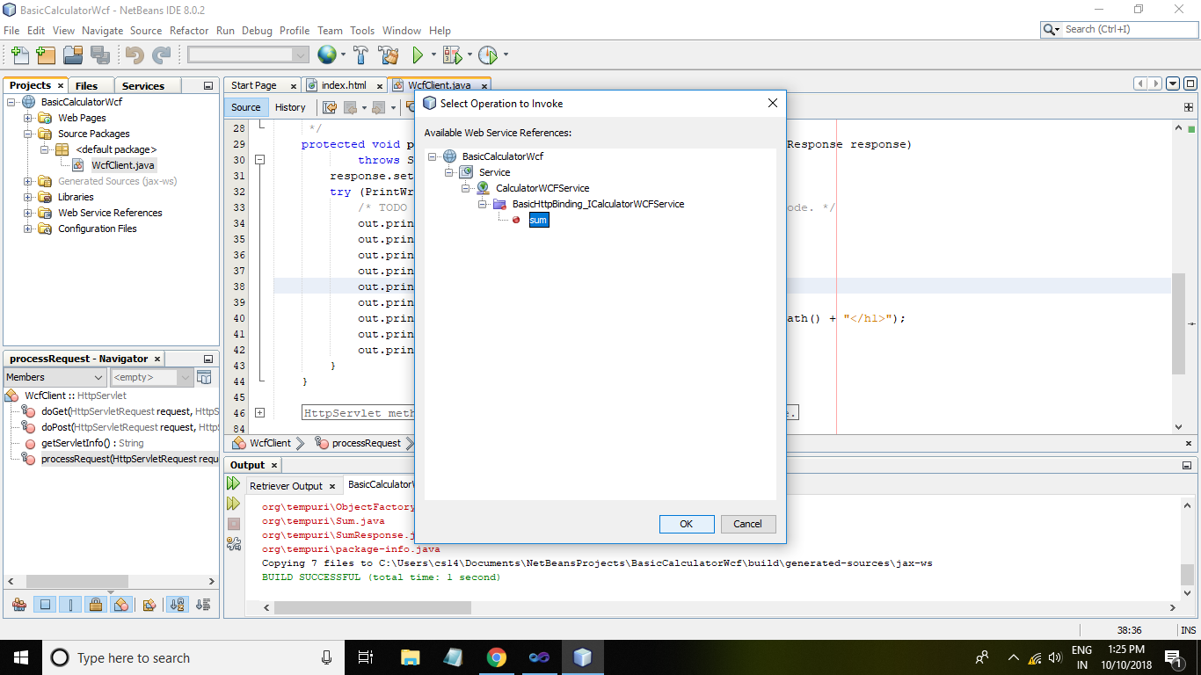

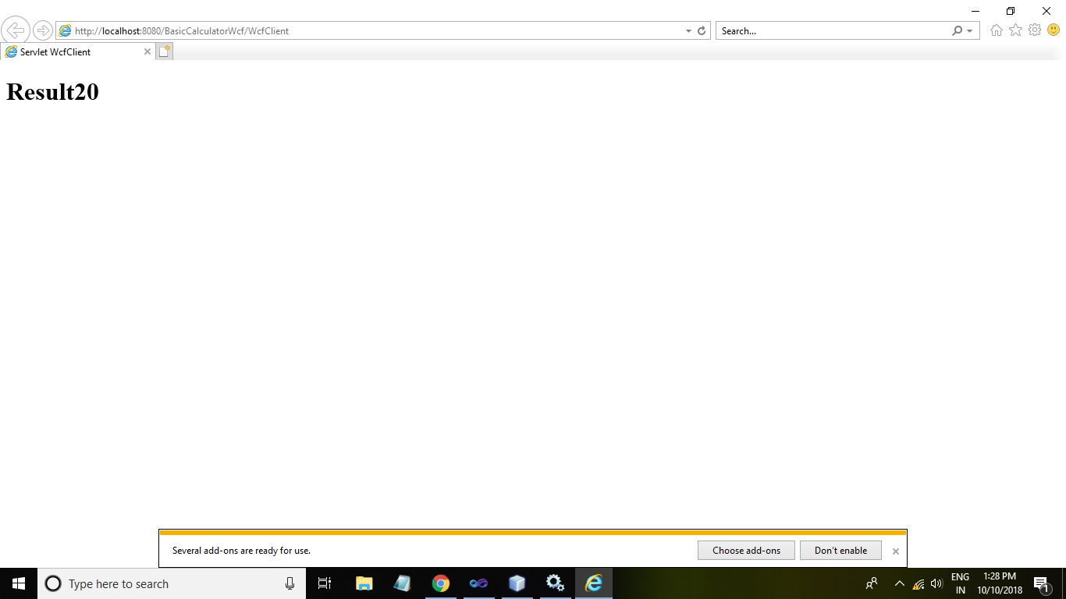

**PRACTICAL NO 9**

**AIM: Use WCF to create a basic Asp.net application which is asynchorous java –script & Xml Service(AJAX).**

**STEP 1:Add web Form**

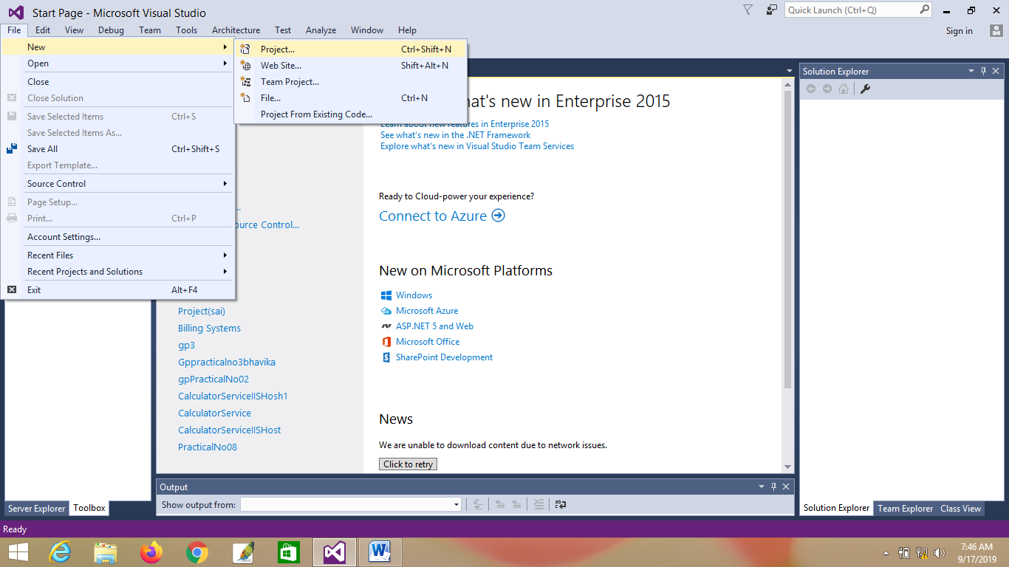

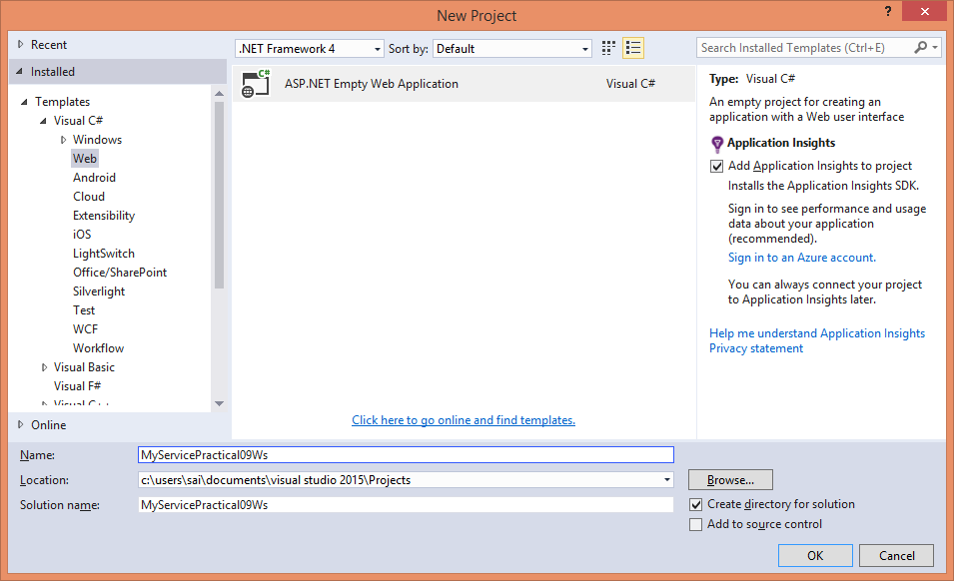

**STEP 2:Add Web Form.**

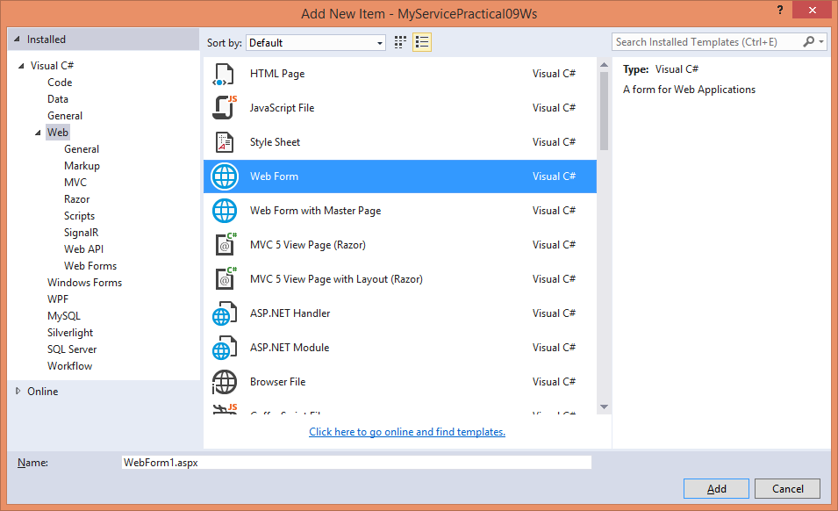

**STEP 3:Add WCF Service(Ajax-enabled)**

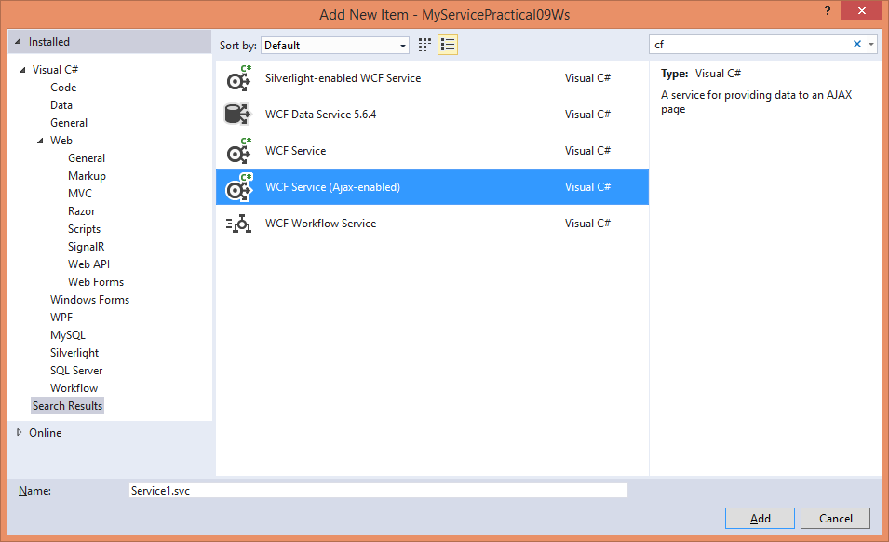

**STEP 4:Add Script Manager.**

<form id="form1" runat="server">

<div>

</div>

<asp:ScriptManager ID="ScriptManager1" runat="server">

</asp:ScriptManager>

</form>

**STEP 5:Add Java Script in head section.**

<script type= "text/javascript">

function Calculate() {

Service1.addToNumbers(10, 15, OnSucess);

}

function CalculateMul() {

Service1.MulToNumbers(10, 15, OnSucess);

}

function CalculateSub() {

Service1.SubToNumbers(10, 15, OnSucess);

}

function CalculateDiv() {

Service1.DivToNumbers(10, 15, OnSucess);

}

function OnSucess(result) {

var myres = $get("additionResult");

var myres1 = $get("additionResult1");

var myres2 = $get("additionResult2");

var myres3 = $get("additionResult3");

if (myres == additionResult) {

myres.innerHTML = result;

}

else if (myres1 == additionResult1) {

myres1.innerHTML = result;

}

else if (myres2 == additionResult2) {

myres2.innerHTML = result;

}

else {

myres3.innerHTML = result;

}

}

</script>

**STEP 6:Add Button in web form.**

<div>

<input type="button" value="Addition of 2 Numbers" onclick="Calculate()" /><br />

<input type="button" value="Multiplication of 2 Numbers" onclick="CalculateMul()" /><br />

<input type="button" value="Subtraction of 2 Numbers" onclick="CalculateSub()" /><br />

<input type="button" value="division of 2 Numbers" onclick="CalculateDiv()" /><br />

<span id="additionResult"></span>

<span id="additionResult1"></span>

<span id="additionResult2"></span>

<span id="additionResult3"></span>

</div>

**STEP 7:Service**

<asp:ScriptManager ID="ScriptManager1" runat="server">

<Services>

<asp:ServiceReference Path="~/Service1.svc" />

</Services>

</asp:ScriptManager>

**STEP 8:Service1.svc**

[OperationContract]

public double addToNumbers(int number1,int number2)

{

return number1 + number2;

}

[OperationContract]

public double MulToNumbers(int number1, int number2)

{

return number1 * number2;

}

[OperationContract]

public double SubToNumbers(int number1, int number2)

{

return number1 - number2;

}

[OperationContract]

public double DivToNumbers(int number1, int number2)

{

return number1 / number2;

}

**STEP 9:Run web form**

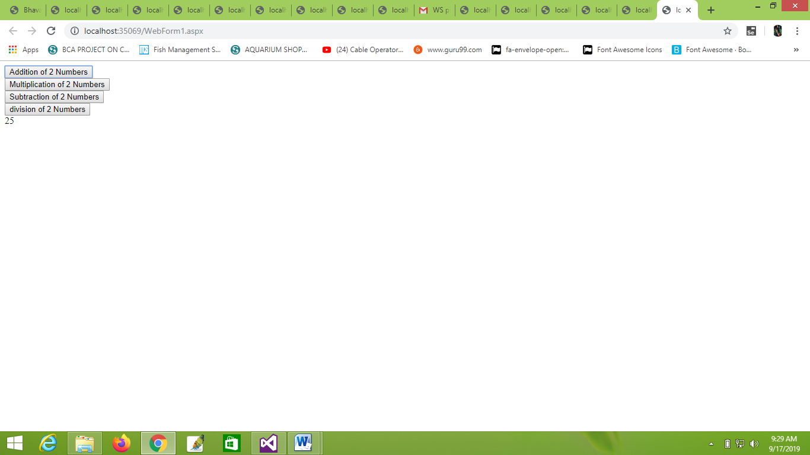

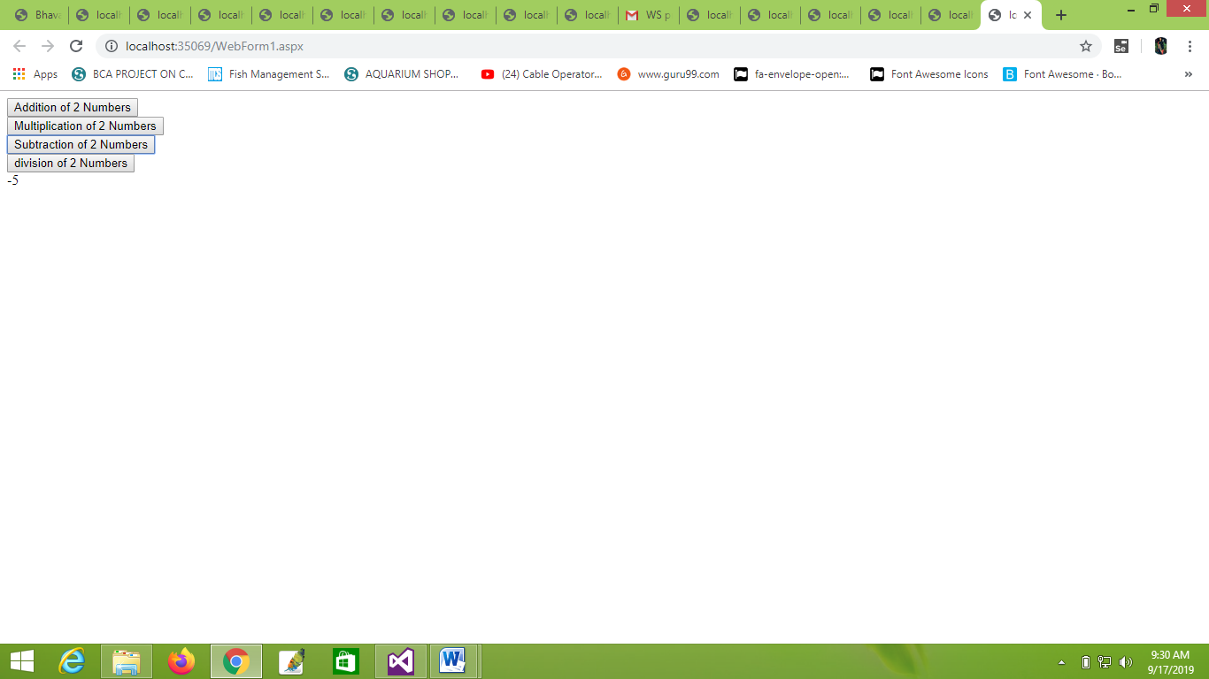

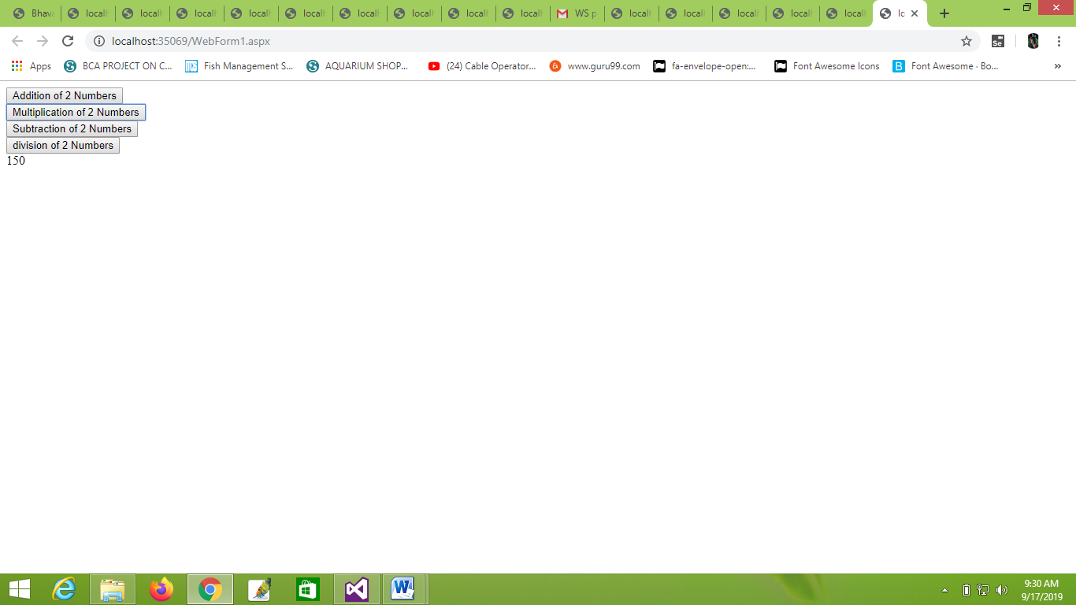

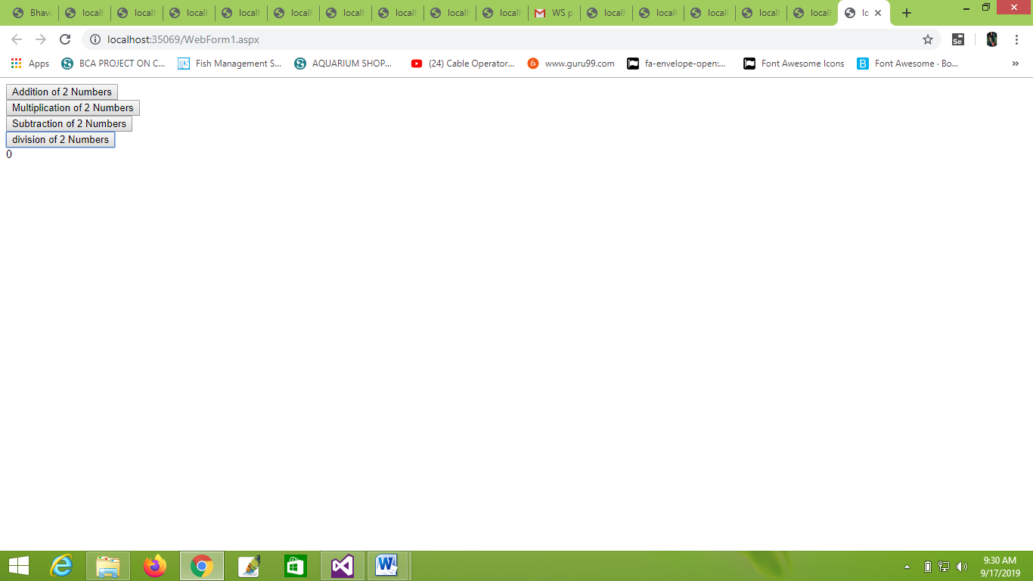

PRACTICAL NO 10

**Q.) Implement a typical service and a typical client using WCF.**

**Step 1) Create WCF Service**

File Menu > click New Project… > select Class Library – CalculatorService > click OK



Delete the class - *Class1.cs* file that is auto-generated.

Right-click on CalculatorService project > Add > click New Item > select WCF Service > provide Name as CalculatorService > click Add button:



This will add the required assembly references (like, System.ServiceModel) along with a Service Contract Interface – *ICalculatorService.cs* and Service class – *CalculatorService.cs*

Modify *ICalculatorService.cs* as follows:

using System.ServiceModel;

namespace CalculatorService

{

[ServiceContract]

public interface ICalculatorService

{

[OperationContract]

int Add(int num1, int num2);

}

}

Modify *CalculatorService.cs* as follows:

namespace CalculatorService

{

public class CalculatorService : ICalculatorService

{

public int Add(int num1, int num2)

{

return num1 + num2;

}

}}

Build the solution by pressing [CTRL]+[SHIFT]+b or go to BUILD menu > click Build Solution option.

**Step 2: Host WCF Service in IIS**

Add a new web site to host Calculator Service in IIS.

Go to File Menu > Add > click New Web Site… > select WCF Service > provide a suitable name – CalculatorServiceIISHost > click OK:



A new web site will be added with a service class - Service.cs and an interface - *IService.cs* within App_Code folder along with a *Service.svc* file. Since the service is already created, delete the auto created service class (Service.cs) and the interface (IService.cs) from App_Code folder.

Right-click on CalculatorServiceIISHost project > click Add Reference > select CalculatorService > click OK:

Open *Service.svc* file > Delete CodeBehind property:

<%@ ServiceHost Language="C#" Debug="true" Service="Service" CodeBehind="~/App_Code/Service.cs" %>

Modify Service property as shown below:

<%@ ServiceHost Language="C#" Debug="true" Service="CalculatorService.CalculatorService" %>

Modify *web.config* file to have the following settings:

<system.serviceModel>

<services>

<service name="CalculatorService.CalculatorService"

behaviorConfiguration="mex">

<endpoint address="CalculatorService" binding="basicHttpBinding"

contract="CalculatorService.ICalculatorService"></endpoint>

<host>

<baseAddresses>

<add baseAddress="http://localhost:8080/"/>

</baseAddresses></host>

</service>

</services>

<behaviors>

<serviceBehaviors>

<behavior name="mex">

<serviceMetadata httpGetBinding="true"/>

</behavior>

</serviceBehaviors>

</behaviors>

</system.serviceModel>

Now the service is ready to be hosted in IIS.

Open IIS > right-click on Default Web Site > click Add Application… > enter Alias name – calculator > select the Physical path of the service > click OK:



Enable Anonymous Authentication as shown below



Go to Content View > right-click *Service.svc* > click Browse:











